Smoked Mushroom Stroganoff with Scallion-Hash Brown Crumble
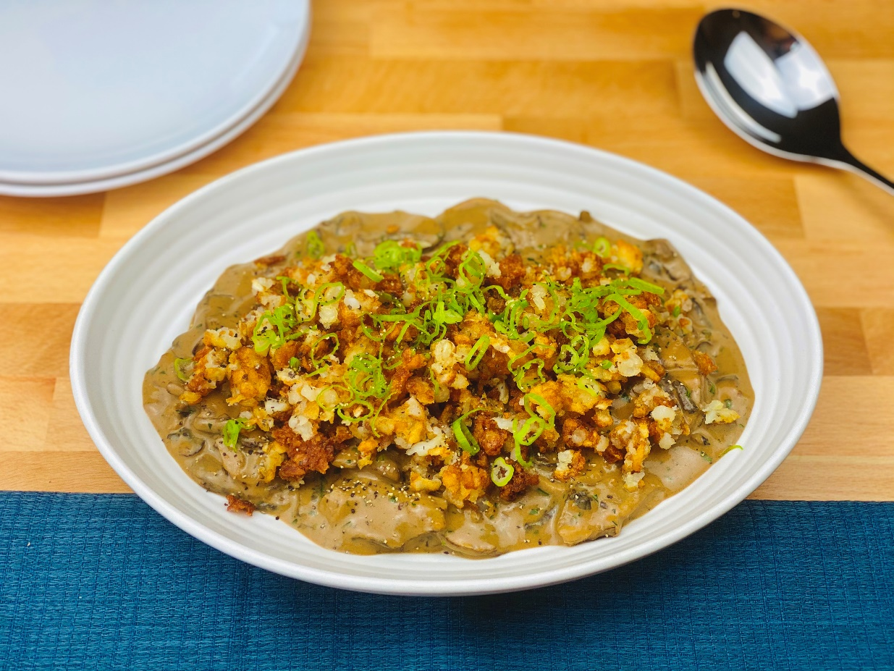
Description: Roasted mushrooms in a smoky cream sauce, topped with crispy bits of hash brown potatoes, cracked black pepper, and green onions.
Servings: 8
Preparation Time: 20 minutes
Cooking Time: 35 minutes
Total Time: 55 minutes
Potato Type: Frozen Hash Brown Potatoes
Course: Entrée, Side Dish

Ingredients
Mushroom Stroganoff:
- 3 pounds (1.4kg) Assorted Mushrooms (Oyster Mushrooms, Shiitake, Cremini, Trumpet, Enoki, etc.)
- 2 tablespoons (30ml) Vegetable Oil (any neutral oil can be subbed: grapeseed, canola, avocado, etc.)
- 2 teaspoons (3g) Kosher Salt
- 2 tablespoons (28.5g) Unsalted Butter
- ½ cup (75g) Shallots, sliced thin, rinsed in cold water
- 2 each (10g) Garlic Cloves, sliced thin
- 2 tablespoons (34g) All Purpose Flour
- ½ cup (120ml) Dry Red Wine
- 2 cups (480ml) Beef Stock (Mushroom Stock from soaking dried mushrooms is also a great option)
- 3 tablespoons Hoisin Sauce* (Optional, but adds a good kick of umami)
- 1-2 sprigs Fresh Thyme
- 2 teaspoons (10ml) Liquid Smoke* (Optional, if not using simply smoke the mushrooms in a smoker, or use a smoke gun when they are done roasting)
- ½ cup (120ml) Sour Cream
Scallion-Hash Brown Crumble:
- ¾ pound (340g) Frozen Hash Brown Patties, thawed and crumbled
- ½ teaspoon (1g) Sea Salt
- 1/3 cup (25g) Green Onions, thinly sliced
- 2 teaspoons Coarsely ground Black Pepper

Preparation
- Clean the mushrooms and place them onto a baking sheet. Drizzle them with the oil and lightly toss to combine. Sprinkle them with salt and place into the oven for 25-30 minutes.
- While the mushrooms are roasting make the sauce. In a large Dutch oven or sauté pan, heat the butter over medium heat until it is slightly foaming. Add the shallots and cook for 2-3 minutes, stirring constantly. Add the garlic and cook for another 1-2 minutes. When the shallots and garlic are soft and translucent with just the subtle hint of brown caramelization, add the flour.
- The raw flour needs about 1-2 minutes to cook in the butter, shallots and garlic. Stir constantly so it doesn’t burn.
- Add the red wine and stir until thick. Slowly whisk in the beef stock and bring the sauce to a boil, before reducing to a simmer. Once thick, add hoisin, thyme, and liquid smoke if using, then stir to combine. Add the roasted mushrooms from the oven. And allow them to simmer in the sauce for about 5 minutes.
- Turn the heat off and stir in the sour cream.
- Adjust the seasoning if desired with salt and pepper.
- Keep the mushrooms warm while you make the hash brown crumble. Fry the crumbled hash browns in a fine mesh strainer at 375 °F (190 °C) for 4-5 minutes or until golden and crispy. Alternatively, you can bake the hash brown crumbles in a 425 °F (218 °C) oven for 20-25 minutes, stirring halfway through so they brown evenly.
- Drain the hash browns of any oil by placing them on some paper towel briefly. Transfer the hash browns to a large bowl and season them with the salt, green onions, and black pepper.
- To plate, spoon some of the mushrooms onto a serving plate, and top with the hash brown crumble. Portion and enjoy.
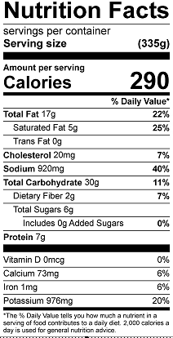
Vitamin C: 4.8 mg

