New England Fish Pie with Duchess Potatoes
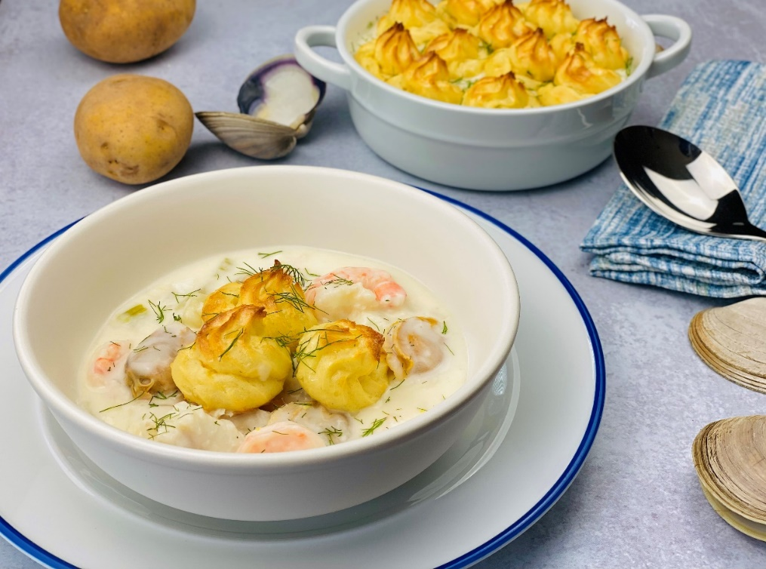
Description: Clams, Cod, Shrimp, and Scallops slow simmered in a fragrant lemon and herb cream sauce topped with light and pillowy whipped potato pastry puffs.
Servings: 12
Preparation Time: 30 minutes
Cooking Time: 45 minutes
Total Time: 75 minutes
Potato Type: Dehydrated Potato Flakes
Course: Entrée

Ingredients
Seafood Filling:
- 1 pound (454g) Cod Filets, cut into 2-inch pieces
- 1 pound (454g) Shrimp, peeled and deveined
- 1 pound (454g) Scallops, cleaned and prepped
- 2 dozen *2 pounds (908g) Littleneck Clams
- 3 tablespoons (42.5g) Unsalted Butter
- 1 cup (150g) Leeks, washed and chopped ½ inch pieces
- 1 cup (150g) Fennel, chopped ½ inch
- 1 cup (150g) Celery, chopped ½ inch
- 3 tablespoons (27g) All Purpose Flour
- 1 cup (240ml) White Wine
- 4 cups (960ml) Fish/Seafood Stock or Clam Juice
- 1 cup (240ml) Heavy Cream
- 2 teaspoons (2g) Sea Salt
- 2 each Lemons, juiced and zested
- 2 tablespoons (3g) Fresh Parsley, chopped
- 1 tablespoon (1g) Fresh Chives, chopped
- 2 teaspoons (~1g) Fresh Dill, chopped
Duchess Potato Puffs:
- 5-1/3 cups (86g) Dehydrated Potato Flakes
- 5 cups (1.2L) Water
- 3 tablespoons (42.5g) Unsalted Butter
- 2 teaspoons (2g) Sea Salt
- 1-1/2 cups (360ml) Whole Milk
- 3 each (60g) Egg yolks
- 1 each (5g) Garlic Clove, grated
- 1/4 cup (60ml) Heavy Cream
- ½ teaspoon (~1g) Nutmeg, freshly grated
- 1 teaspoon (~1g) Ground White Pepper
Egg Wash:
- 1 each Large Egg
- 1 tablespoon (15ml) Whole Milk

Preparation
- Preheat the oven to 425 °F (218 °C)
- To make the seafood filling, prep, clean the seafood: for the cod, simply filet and cut into 2-inch pieces. For the shrimp, peel and devein. For the scallops, remove the adductor muscle, this is the little flap of meat on the side of the scallop, these may already be removed from the scallop but still check for them. For the clams, place the whole clams into a fresh water for 20 minutes, then lightly scrub each clam with a brush to remove any barnacles or sand. Rinse the clams and steam for 3-5 minutes or until they pop open. Remove the meat, save the liquor from the clams, and discard the shells. Hold the all the prepped seafood over ice until ready to use.
- In a large heavy bottomed pot, heat the butter over medium-high heat, add the leeks, fennel, and celery. Stirring frequently, cook the vegetables for 3-5 minutes or until the veggies are slightly translucent.
- Sprinkle the flour over the top of the veggies in an even layer and stir to combine. The butter and flour in the pan will create a roux which will thicken the sauce. Cook the flour and the veggies for another 1-2 minutes to remove the “raw” taste from the flour, then gradually add the fish/seafood stock or clam juice while stirring. Add the heavy cream and stir until the sauce is slightly thickened. Add the seafood and bring to a simmer. Cook the seafood in the sauce for 5-7 minutes or until the shrimp is opaque and the cod is just barely flakey.
- Adjust the seasoning with the salt and white pepper. Add the lemon juice, lemon zest, and herbs. Stir very gently, so the seafood does not break up too much, and remove from the heat. Keep warm.
- Next make the duchess potatoes by placing the potato flakes into a large bowl. In a medium sauce pot, bring the water, butter, and salt to a boil. Remove from the heat and stir in the milk. Pour the liquid over the potatoes and stir to combine. Allow the potatoes to sit for 2-3 minutes and stir again. Fold in the egg yolks, garlic, heavy cream, and nutmeg until well incorporated.
- Transfer the potatoes into a piping bag fitted with a star tip, pipe the potatoes into little spiral stars on a silicon lined baking sheet or a regular baking sheet lightly sprayed with non-stick spray. Lightly brush them with the egg wash mixture, by simply mixing the whole egg together with the milk.
- Place the potatoes into the preheated 425 F (218 C) oven and bake for 15-20 minutes or until the potatoes are golden brown.
- Carefully transfer the seafood filling to a serving bowl or large casserole dish and arrange the duchess potatoes on top. Additionally, you can choose to garnish the top of the casserole with any additional freshly chopped herbs. Serve immediately and enjoy!
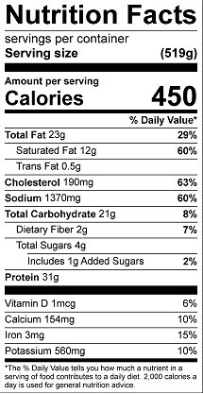
Vitamin C: 15.8 mg

