Beef Pot Roast Casserole with Crispy Parmesan and Herb Potatoes
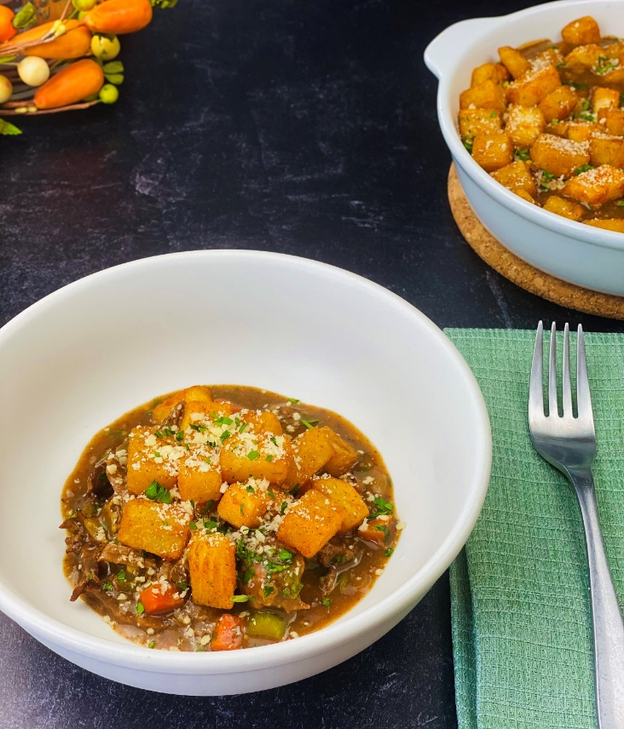
Description: Slow braised beef in a savory brown gravy with aromatic vegetables and crispy potatoes dusted with parmesan and fresh herbs.
Servings: 10
Preparation Time: 40 minutes
Cooking Time: 180 minutes
Total Time: 220 minutes
Potato Type: Frozen Diced Potatoes
Course: Entree
Ingredients
Pot Roast Filling:
- 3 pounds (1.4kg) Beef Brisket or Chuck
- 1 tablespoon (5g) Kosher Salt
- 2 teaspoons (3g) Freshly Ground Black Pepper
- 2 tablespoons (30ml) Vegetable Oil (Any neutral oil, with a high smoke point will work)
- 6 each (30g) Garlic Cloves, smashed
- 1.5 cups (360ml) Dry Red Wine
- 3 cups (720ml) Beef Stock
- ¼ cup (60ml) Worcestershire Sauce
- 1 cup (130g) Pearl Onions, peeled
- ½ cup (75g) Celery, diced ½ inch
- ½ cup (75g) Carrots, diced ½ inch
- 1 each (2g) Fresh Rosemary Sprig
Crispy Parmesan Potato Crust:
- 1-1/2 pounds (680g) Frozen Diced Potato
- 1 teaspoon (2g) Sea Salt
- 1/3 cup Grated Parmesan Cheese
- ¼ cup (4g) Fresh Parsley, chopped

Preparation
- Preheat the oven to 375 °F (190 °C)
- Season the beef with salt and pepper.
- In a large Dutch oven or roasting pan, add the oil over high heat and sear the beef as soon as the oil begins to smoke lightly. Sear the on all sides and then remove the beef from the pan and place it on a cutting board for a moment.
- In the roasting pan, add the garlic and sauté the crushed cloves until they are just sightly brown. Deglaze the pan by adding the red wine, when the red wine is reduced in the pan by half, add the beef stock and Worcestershire. Add the beef back to the pan and cover. Place the covered pan in the oven.
- Cook the roast for about 2-1/2 hours. Add the onions, celery, carrots, and rosemary. Place the lid back on, and return the roast to the oven for about 30 minutes or until the beef reaches an internal temperature of 205 °F.
- Allow the beef to rest out of the liquid for about 20-30 minutes. When the beef has finished resting, carefully shred the beef and return it to the sauce and the vegetables.
- To prepare the potatoes, fry them at 375 °F (190 °C) for 4-6 minutes or until they are golden. Transfer the potatoes to a large bowl and season them with salt, parmesan, and parsley.
- Place the shredded pot roast and vegetables into a large casserole pan or oven-safe baking dish. Arrange the crispy potatoes on top and place the dish in a 375 °F (190 °C) oven for 5 minutes or until it’s bubbling. Portion and enjoy.
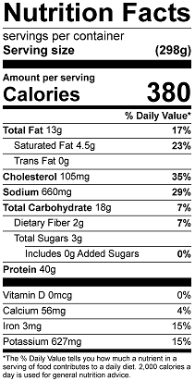
Vitamin C: 8 mg

