Baked Chicken Gnocchi Alfredo
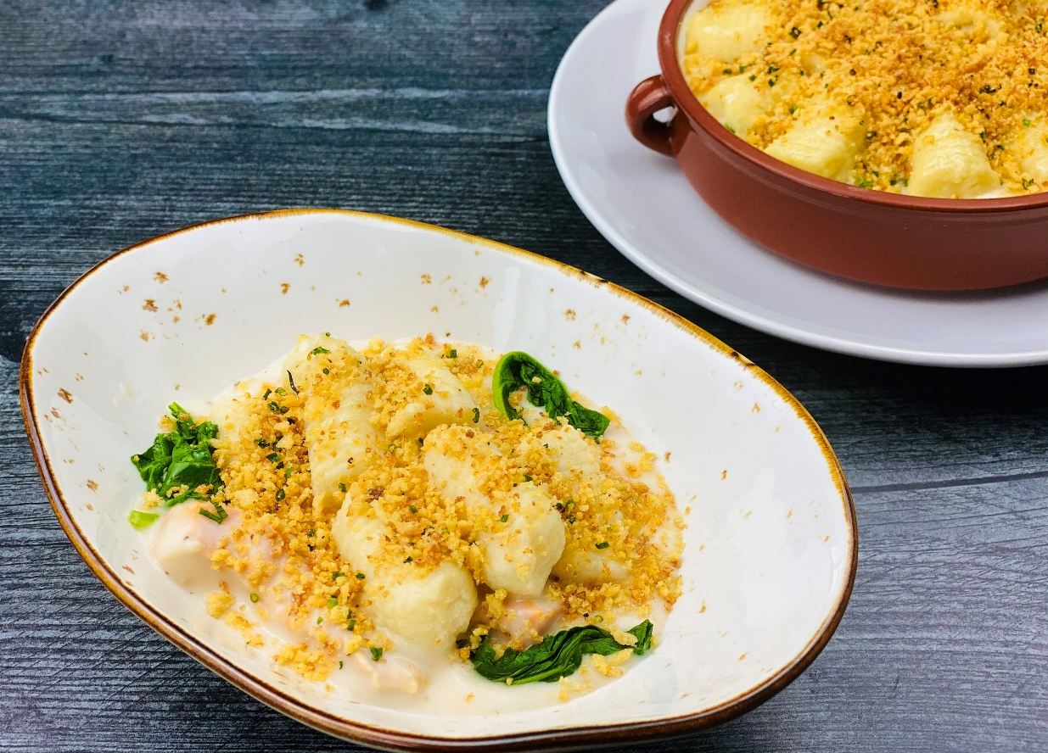
Description: Tender pieces of chicken in a creamy parmesan and garlic cream sauce with baby kale, topped with light and fluffy potato gnocchi and baked with crispy herbed breadcrumbs.
Servings: 16
Preparation Time: 45 minutes
Cooking Time: 40 minutes
Total Time: 85 minutes
Potato Type: Dehydrated Potato Flakes
Course: Entree
Ingredients
Gnocchi:
- 3 cups (720ml) Water
- 3 cups (45g) Dehydrated Potato Flakes
- 3 each Large Eggs, slightly beaten
- 4-1/2 cups (540g) All Purpose Flour
- As Needed Semolina Flour, for dusting
- ½ teaspoon (~1g) Sea Salt
- 3 tablespoons (45ml) Extra Virgin Olive Oil
Chicken Alfredo:
- 1 cup (226g) Unsalted Butter
- 9 each (45g) Garlic Cloves, chopped
- 3 tablespoons (27g) All Purpose Flour
- 4 cups (960ml) Whole Milk
- 2 cups (480ml) Heavy Cream
- 2 cups (180g) Parmesan Cheese, grated
- ½ tablespoon (1g) Freshly Ground Black Pepper
- 2 cups (60g) Baby Kale
- 3 pounds (1.4kg) Grilled Chicken Breast, fully cooked
Herb Breadcrumbs:
- ¼ cup (60ml) Olive Oil
- 2 tablespoons (20g) Shallots, finely chopped
- 1-1/2 cups (180g) Panko Breadcrumbs
- 2 teaspoons (2g) Kosher Salt
- 1 teaspoon (1g) Freshly Ground Black Pepper
- ¼ cup (10g) Chives, chopped fine
To Plate:
- 1 cup (90g) Parmesan Cheese, grated

Preparation
- Preheat the oven to 425 °F (218 °C)
- To make the potato gnocchi, bring the water to a boil, and add it to the dehydrated potato flakes in a large bowl. Stir to combine. Allow the potatoes to cool slightly about 5-7 minutes. Stir in the eggs, and carefully fold in the flour until it is all incorporated.
- To shape the gnocchi, on a floured work surface portion the dough into 12 even pieces. Roll each of those pieces into logs about 1 inch in diameter. Cut the logs into 1-inch pieces and using a gnocchi board or the back of a fork roll each gnocchi gently to create grooves. Hold the gnocchi on a baking sheet, lightly dusted with semolina flour.
- Bring a large pot of water to a boil and add the salt.
- Add the gnocchi in batches to the boiling water, do not cook all the gnocchi at once or they make stick to the bottom of the pan or each other. When the gnocchi float (about 3-4 minutes) remove them from the water using a slotted spoon or spider. Place the gnocchi onto a lightly oiled baking sheet and hold in the refrigerator until ready to use.
- To make the chicken alfredo, heat the butter over medium heat until melted and slightly foaming. Add the garlic and cook for about 2-3 minutes. The garlic should become fragrant but not browned. Add the flour and stir until combined. Cook for an additional 1-2 minutes makings sure there is no color on the flour. Gradually whisk in the milk, until completely incorporated and bring the mixture to a simmer. Add the cream, and continue to cook until the mixture is thick, about 3-5 minutes. Remove the sauce from the heat and stir in the cheese and black pepper.
- Fold in the kale and cooked chicken breast. Set aside while you make the breadcrumbs.
- In a large sauté pan or skillet. Heat the olive oil over medium high heat. Add the shallots and cook for 2-3 minutes. Add the breadcrumbs and while stirring constantly cook for 3-4 minutes or until the breadcrumbs are golden brown.
- Transfer the chicken alfredo into a casserole dish or serving dish. Arrange the cooked gnocchi on top. Sprinkle the top with the herb breadcrumbs, and place into the preheated 425 °F (218 °C) oven for 5-7 minutes or until the casserole is bubbling, and the crust is golden brown. Serve immediately and enjoy!
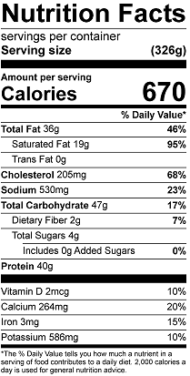
Vitamin C: 4.7 mg

