BBQ Pork Carnitas with Masa Whipped Potatoes
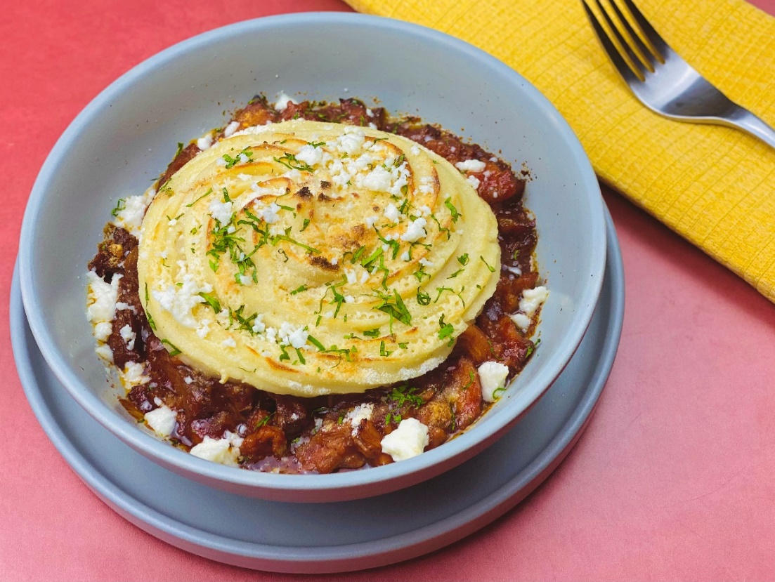
Description: Braised pork slow simmered in a spicy and smoky BBQ sauce, topped with fluffy potatoes whipped together with corn masa and toasted.
Servings: 16
Preparation Time: 20 minutes
Cooking Time: 180 minutes
Total Time: 200 minutes
Potato Type: Dehydrated Potato Flakes
Course: Entrée

Ingredients
Carnitas:
- 4.4 pounds (2kg) Pork Shoulder, boneless, cut into 2-inch pieces
- 1.1 pounds (500g) Pork Belly, cut into 1-inch pieces
- 2 cups (480ml) Chicken Stock
- 1 tablespoon (3g) Kosher Salt
- 2 teaspoon (2g) Freshly Ground Black Pepper
- 1 each (131g) Orange, cut in half
- 1 each (10g) Mexican Cinnamon Stick (regular cinnamon stick can be subbed)
- 2 tablespoons (8g) Oregano (Mexican Oregano is preferred, but Italian oregano can be subbed)
- 1 each Star Anise
- 1 each Bay Leaf
- ¼ cup (15g) Chipotle Pepper in Adobo
- 48 fluid ounces (1.4L) Prepared BBQ Sauce
Masa Whipped Potatoes:
- 5-1/3 cup (1.28L) Hot Water
- 2 teaspoons (2g) Salt
- ½ cup (114g) Unsalted Butter
- 2-2/3 cup (640ml) Whole Milk, cold
- 5-1/3 cup (90g) Dehydrated Potato Flakes
- ½ cup (40g) Masa Harina
- 1 cup (240ml) Sour Cream
- 1 cup (80g) Shredded Cheddar Cheese

To Plate:
- ½ cup (40g) Queso Fresco, crumbled
- As Needed Cilantro Leaves
Preparation
- Arrange the pork in a large Dutch oven, roasting pan, or rondeau. Add the stock, salt, and pepper. Cover the pot and bring to a boil over medium-high heat. Reduce the heat and allow the pork to simmer for about 2 hours. Uncover the pot and allow the pork to continue to cook for about 10-15 minutes, the liquid should reduce but not completely. Remove from the heat and discard the orange, spices, and bay leaf.
- Transfer the pork and the juices to a large skillet. Cook over high heat until the juices evaporate and all that’s left is the pork and the fat. Be careful not to stir the pork up too much, instead allow it to get crispy in the fat stirring occasionally.
- Using a slotted spoon transfer the pork to a baking sheet lined with paper towel. Continue until all the pork is crispy. Transfer the pork to a heavy bottomed, oven safe dish.
- Combine the BBQ sauce and the chipotle peppers in a blender or food processor and process until smooth.
- Pour the BBQ sauce over the carnitas and stir gentle to combine. Allow the meat to rest in the sauce for about an hour before serving.
- To make the masa whipped potatoes. Combine the water, salt, and butter in a medium pot over high heat until the butter is melted, and the salt is dissolved.
- Add the potato flakes, milk, and masa harina. Stir the mixture until everything is combined and allow it to sit for about 30 seconds. Add the sour cream and cheese, then gently fold them together. Transfer the potatoes to a pastry bag fitted with a star tip.
- When ready to plate, spoon some of the carnitas and sauce into an oven safe dish. Pipe some of the potatoes on top of the carnitas and place under the broiler for about 2-3 minutes or until its toasted and golden. Be careful to watch the plat under the broiler as the BBQ sauce can burn easily.
- To garnish, sprinkle the top of the dish with some of the queso fresco and cilantro. Serve immediately and enjoy.
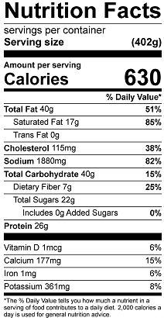
Vitamin C: 9.3 mg

