Tres Leches Potato Poundcake with Fresh Berries and Sea Salt Caramel
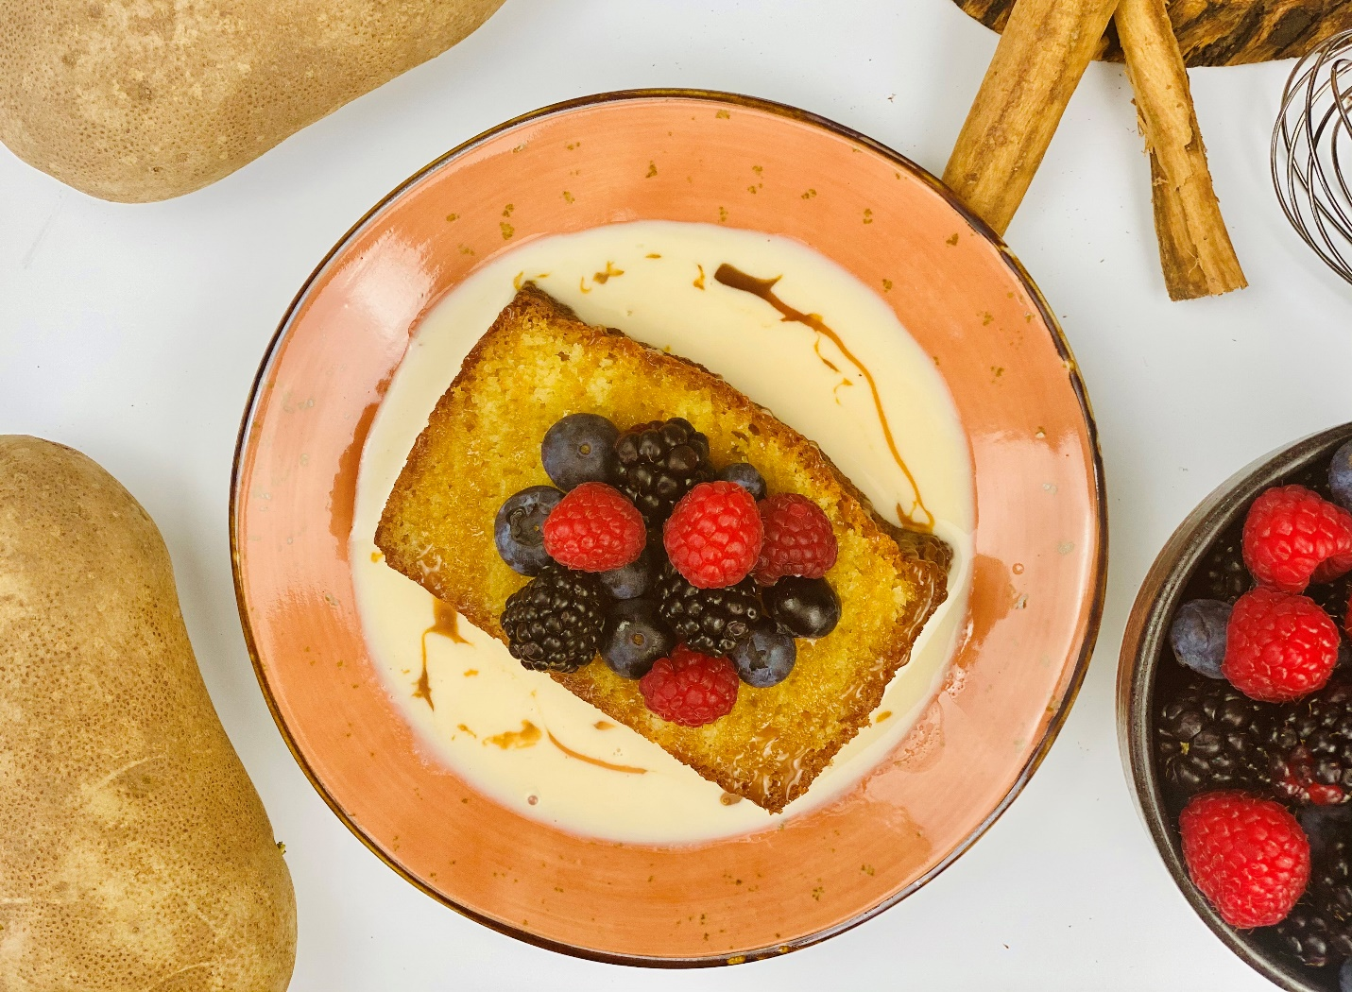
Description: Rich and decadent potato pound cake soaked in sweetened milk then topped with fresh berries and salted caramel.
Servings: 12
Preparation Time: 25 minutes
Cooking Time: 60 minutes
Total Time: 85 minutes
Potato Type: Dehydrated Potato Flakes
Course: Dessert

Ingredients
For the Potato Poundcake:
- ½ cup or 2 sticks (226g) Unsalted Butter, softened (room temperature)
- 1.5 cups (217g) All Purpose Flour
- 1 teaspoon (~1g) Sea Salt (any salt will work, try to avoid iodized salt)
- ½ teaspoon (~1g) Cream of Tartar
- ½ cup (30g) Dehydrated Potato Flakes (Instant Mashed Potatoes)
- 2 cups (240g) Granulated Sugar
- 6 each Large Eggs, room temp
- ½ cup (120ml) Heavy Cream
- 1 teaspoon (5ml) Vanilla Extract
For the Tres Leches (Three Milks)
- 1.5 cups (360ml) Evaporated Milk
- 1 cup (240ml) Sweetened Condensed Milk
- 1/3 cup (80ml) Heavy Whipping Cream
Garnishes:
- ¼ cup (60ml) Salted Caramel Sauce (Store Bought is Fine)
- 2 cups (380g) Fresh Assorted Berries (Blueberries, Blackberries, Strawberries, Raspberries, etc.)
Preparation
- Preheat an oven to 325 F (163 C)
- In a large bowl combine the flour, salt, potato flakes, and cream of tartar, set aside.
- Prepare a loaf pan (8.5x.4.5x2.5 inches) by spraying it lightly with nonstick cooking spray and then dusting it lightly with flour. Cut a piece of parchment paper so it fits in the bottom of the pan (this is optional, but it gives you insurance so you cake does not stick to the pan, that would be a sad day) set the pan aside.
- Meanwhile in a stand mixer or a bowl with a hand mixer (do not do this without an electric mixer, it’s no fun), beat the butter until it is very light and fluffy (about 5 minutes), decrease the speed and gradually add in the sugar. Increase the speed again and beat the butter with the sugar until super light and fluffy (about 8 minutes longer). Add the eggs one at a time. Wait to add the next egg until the previous one is incorporated.
- Add the cream and the vanilla. Reduce the speed of the mixer and add in the dry ingredients from step 1 (a little at a time until it’s all incorporated).
- Transfer the batter into the prepared loaf pan.
- Place the cake in the oven and bake for 75 minutes (rotating the pan halfway through), a toothpick inserted should come out clean.
- Allow the cake to cool for about an hour on a wire rack (pro-tip: you can remove one of the racks from your oven if you don’t have a wire rack). Turn the cake out and enjoy as is. OR! To enjoy as tres leches, follow the next few steps.
- In a medium bowl, combine the evaporated milk, sweetened condensed milk, and the heavy cream.
- Slice the cake into 12 slices and arrange them in a large casserole dish. Pour the milk mixture all over the cake. Allow it to chill in the refrigerator for about 2 hours or even better, overnight.
- To serve, place a slice of the cake on a serving dish and top it with the berries, salted caramel, and some of the reserved soaking milk mixture from the pan.
- Enjoy!
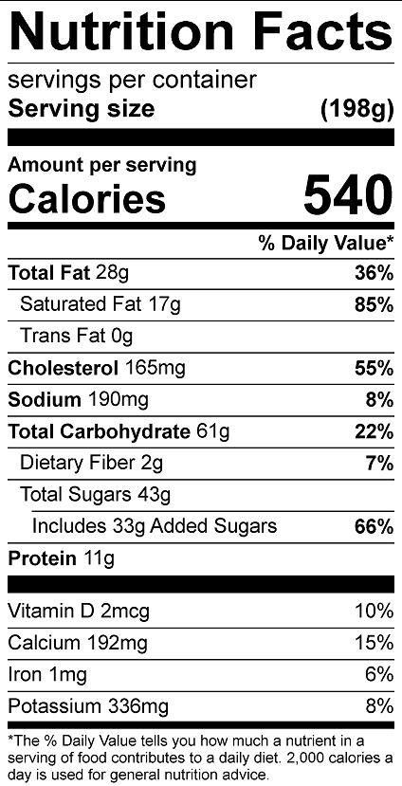
Vitamin C: 10 mg

