Shrimp Ceviche with Purple Potato Chips
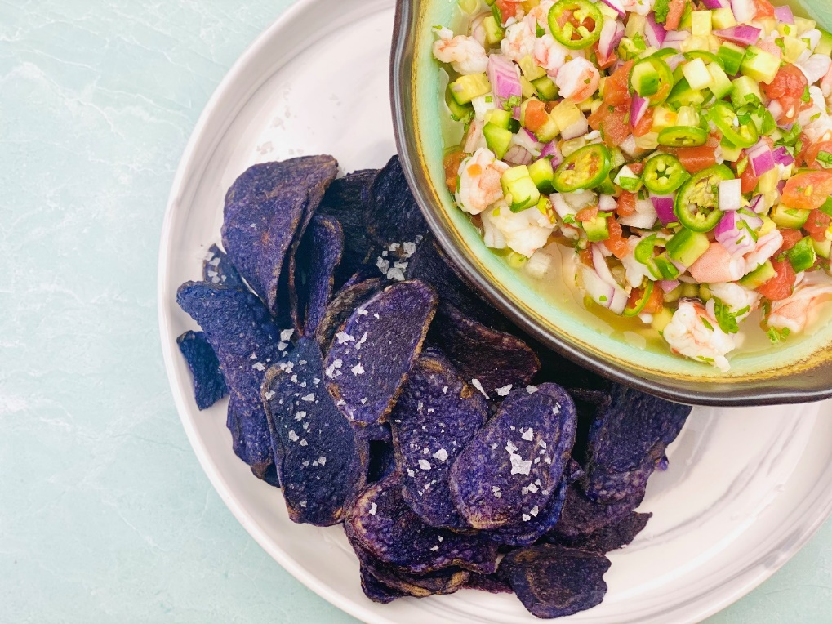
Description: Tender shrimp marinated in citrus juice along with chilies, onions, tomatoes, cucumbers, and garlic. Served alongside crispy purple potato chips.
Servings: 4
Preparation Time: 20 minutes
Cooking Time: 20 minutes (Marinating time, no cooking required)
Total Time: 40 minutes
Potato Type: Potato Chips
Course: Appetizer, Entree

Ingredients
For the Shrimp Ceviche:
- 1 pound (453g) Shrimp, raw, peeled, deveined, chopped into ½ inch pieces
- ½ cup (120ml) Freshly Squeezed Lime Juice
- ¼ cup (60ml) Freshly Squeezed Orange Juice
- ¼ cup (60 ml) Freshly Squeezed Lemon Juice
- 1 each (10g) Serrano Chilies, sliced thin
- 1/3 cup (66g) Tomatoes, diced
- ½ cup (70g) Cucumbers, diced
- 1/3 cup (66g) Red Onions, diced, rinsed in cold water
- 1 each (5g) Garlic Clove, chopped fine
- ¼ cup (2g) Cilantro, chopped
- 2 tablespoons (30ml) Extra Virgin Olive Oil

- 5 ounces (141g) Purple Potato Chips, bagged
Preparation
Ceviche
- Begin by chopping the shrimp into ½ inch pieces, double check to ensure the shrimp is peeled and deveined.
- Pour the lime, orange, and lemon juice over the shrimp and allow it to marinate for 20 minutes.
- Add the chilies, tomatoes, cucumbers, onions, garlic, cilantro, and extra virgin olive oil. Stir to combine and allow to sit for about 10 minutes more.
- Place the ceviche in a serving bowl and pair with crispy blue/purple potato chips. Any potato chips can be subbed, however blue/purple potato chips really make the dish visually stunning. Enjoy!
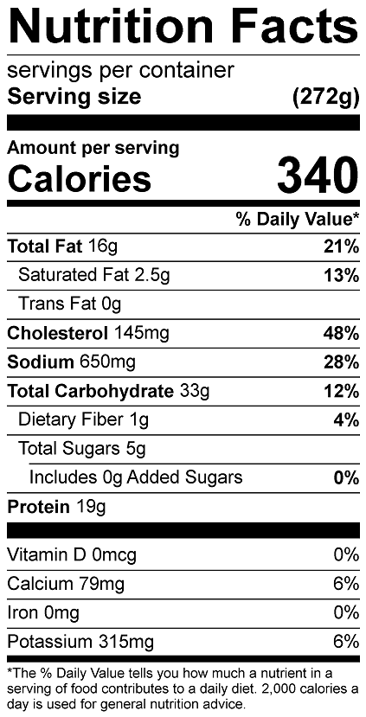
Vitamin C: 28.7 mg

