Potato Tortillas (Flour)
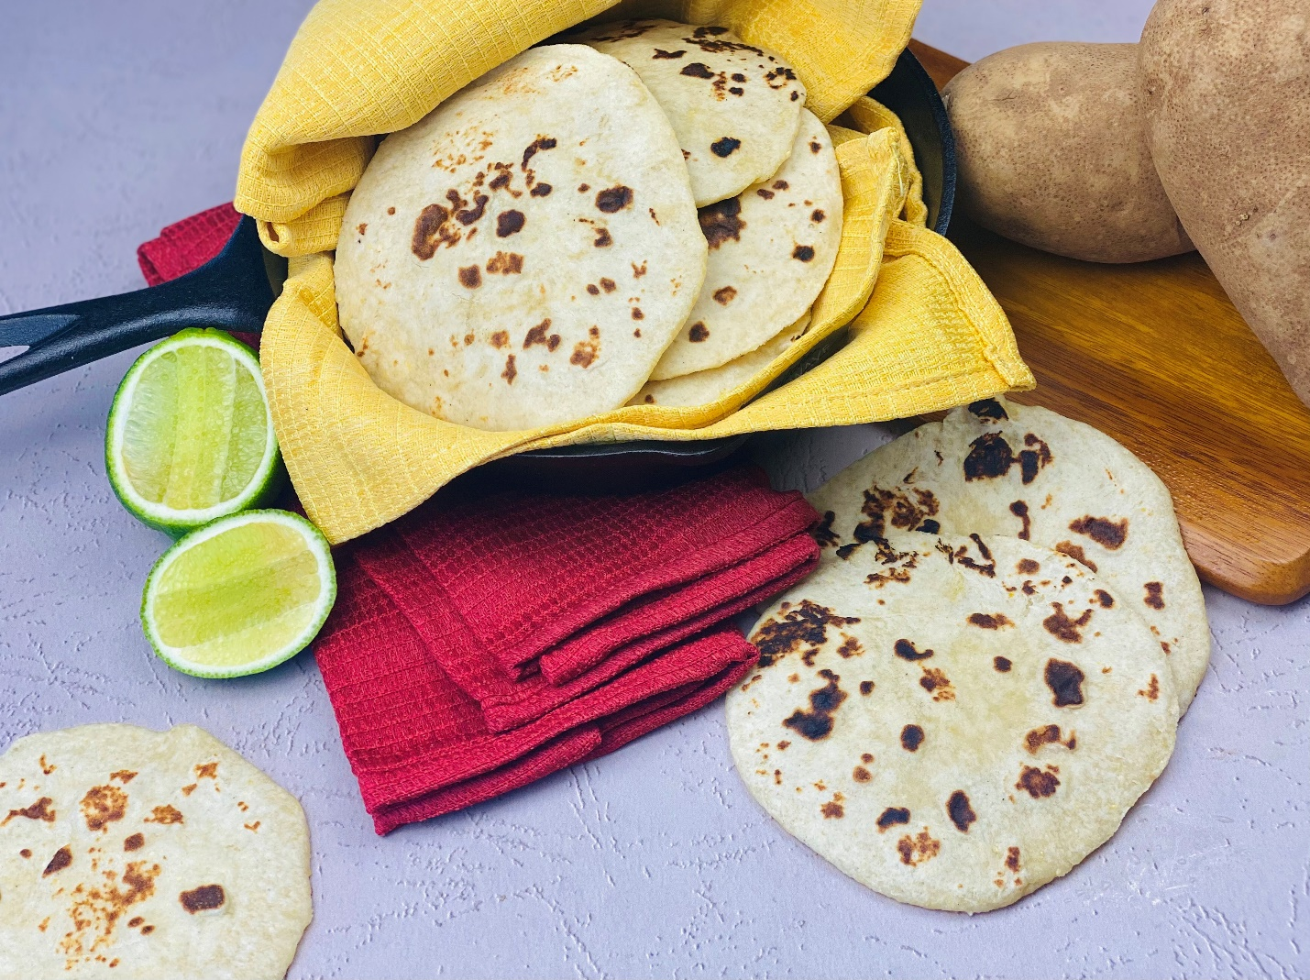
Description: Soft and tender flour tortillas, made using mashed potatoes.
Servings: 12 (2 tortillas per serving)
Preparation Time: 10 minutes
Cooking Time: 5 minutes
Total Time: 15 minutes
Potato Type: Mashed Potatoes (using dehy, fresh, frozen, or refrigerated)
Course: Side, Bread

Ingredients
- 2 cups (500g) Prepared Mashed Potatoes
- 3.5 fluid ounces (100g) Warm Water
- 2 tablespoons (30ml) Vegetable Oil *Any neutral flavored oil can be subbed*
- 3.5 cups (450g) All Purpose Flour
- ¼ cup (50g) Masa Harina (Corn Flour for tamales and tortillas) *optional but gives great flavor*
- 2 teaspoons (7g) Sea Salt
Preparation
- To prepare the tortillas, mix the mashed potatoes with the water and oil. In a separate bowl, combine the flour with the masa (if using) and the salt. Gradually mix the dry ingredients into the wet ingredients until a smooth dough is formed. Knead the dough on a clean work surface for about 5 minutes. The dough with be smooth and should not be sticky. If it is, add a small amount of flour, however its better if the dough is more on the moist side than on the dry side.
- Allow the dough to rest for about 5 minutes before shaping.
- To shape the tortillas, divide the dough into 24 pieces. The best way to do this is to roll the dough into a log, cut the dough in half, then in half again creating 4 equal pieces. Place 3 of the pieces of dough under a lightly damp kitchen towel while you work on the first. Cut the dough into 6 pieces and roll each piece into a little ball (roughly the size of a golf ball). Allow them to rest for 2-3 minutes while you repeat the same with the other pieces of dough. Be sure to keep any pieces of dough you are working with under the towel, so they don’t dry out.
- Using a tortilla press is the best way to flatten them out, it’s also the quickest, however if you do not have one you can use the bottom of a heavy bottom pot or pan, a rolling pin will also work in a pinch.
- Place two pieces of wax paper or parchment paper on each side of the dough ball. Lightly pat the ball into a disk using your hand, and then press the dough ball down until you have created a tortilla. The tortillas can be held between the paper until ready to cook, this can even be done the day before.
- When you are ready to cook your tortillas, heat a cast iron skillet over medium high heat, place the tortilla in the pan and cook for about 45 seconds on each side, the tortillas will puff slightly once flipped. Repeat with your remaining tortillas, storing them in a dry kitchen towel as you cook each one. Before you know it you will have a stack of fluffy and tender potato tortillas to use as you see fit. We recommend any one of our potato taco recipes on PotatoGoodness.com
- Enjoy!
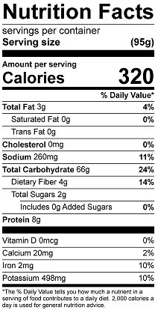
Vitamin C: 33.8 mg

