**Potato Kugel**

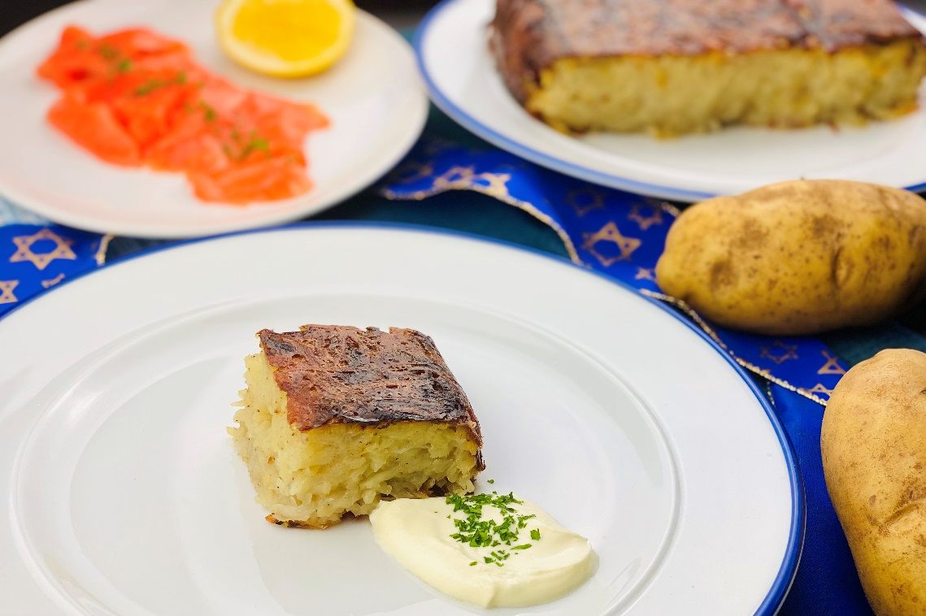

**Description:** Thinly grated russet potatoes and shaved onions are seasoned with salt and pepper before being baked in savory chicken fat until golden brown. A dish often served during Jewish holiday’s but great for any time of the year.

**Servings:** 9

**Preparation Time:** 25 minutes

**Cooking Time:** 45 minutes

**Total Time:** 70 minutes

**Potato Type:** Russet Potatoes

**Course :** Side, Holiday

**Ingredients**

* 1/3 cup (90g) Chicken Fat (Schmaltz) or Duck Fat, melted
* 2-1/4 lbs. (1 kg) Russet Potatoes, peeled and cut in half lengthwise
* 1 cup (200g) Yellow Onions, thinly sliced or grated
* ¼ cup (40g) Potato Starch (Corn Starch can be subbed)
* 2 teaspoons (6g) Sea Salt
* 2 teaspoons (6g) Freshly Ground Black Pepper
* 3 each (165g) Large Eggs, beaten

Garnish

* 9 ounces (250g) Crème Fraiche or Sour Cream
* As Needed Freshly Chopped Parsley

**Preparation**

1. Preheat the oven to 400 °F (205 °C).
2. Pour the chicken or duck fat into a 9x9 inch glass baking dish. Place the baking dish in the oven and allow for the fat and pan to get hot while the ingredients for the kugel are being prepped.
3. In a food processor fitted with a grating attachment or with a box grater, grate the potatoes and onions. Alternately until they are all used. Place the grated potatoes and onions in a large bowl.
4. Mix in the potato starch, salt, pepper, and beaten eggs into the potatoes and onions.
5. Remove the preheated dish from the oven and place the potato mixture into the hot fat, pressing the potatoes down into an even layer. Discard any remining liquid in the bowl and place the dish in the oven.
6. Cook the kugel for 45 minutes or until it is golden and crispy all around. Remove from the oven and allow the kugel to cool for about 10 minutes before slicing into 9 even portions with a sharp knife. The kugel can be served with a variety of ingredients, the most common is sour cream or crème fraiche.

Vitamin C: