Potato Churros with Mexican Hot Chocolate Sauce
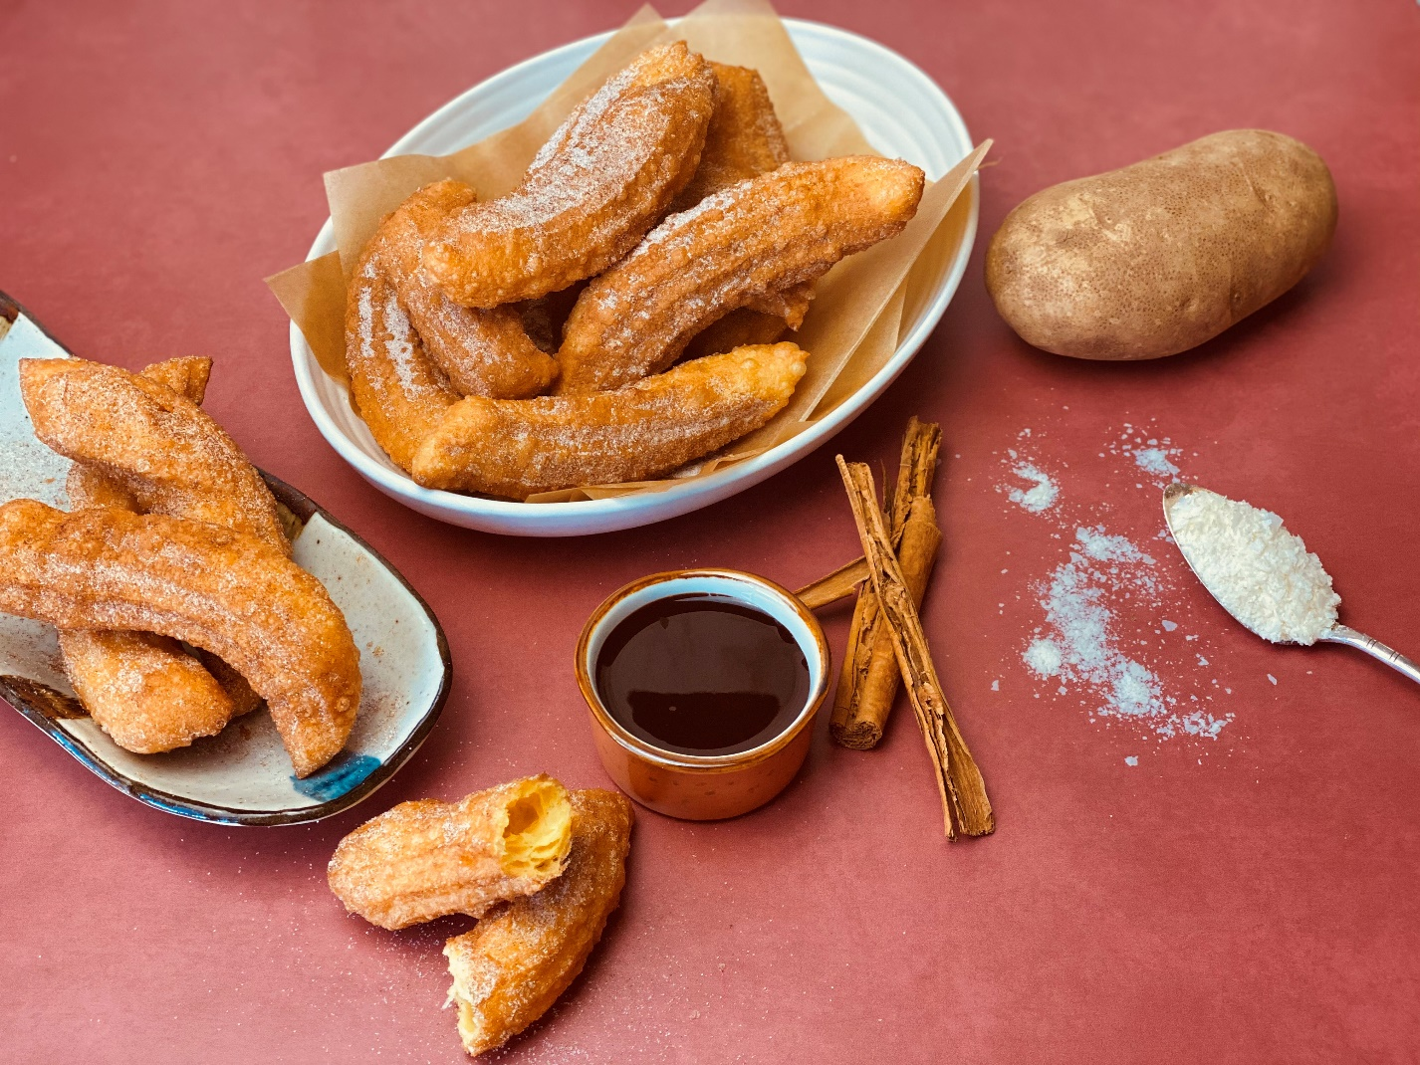
Description: Light and crispy Mexican potato donuts, dusted with cinnamon sugar and served with a chili chocolate dipping sauce
Servings: 8
Preparation Time: 20 minutes
Cooking Time: 10 minutes
Total Time: 30 minutes
Potato Type: Mashed Potatoes (Dehy, Refrigerated, Frozen, or Fresh)
Course: Dessert

Ingredients
For the Potato Churros:
- ¾ cup (185ml) Water
- 4 tablespoons (60g) Unsalted Butter
- 1/2 teaspoon (1g) Sea Salt
- ¾ cup (110g) All Purpose Flour
- 1/3 cup (100g) Prepared Mashed Potatoes (unseasoned)
- 2 each Large Eggs
- 1 teaspoon Vanilla Extract
- As Needed Vegetable Oil for Frying
- ¼ cup (55g) Granulated Sugar
- 1 tablespoon (8g) Ground Cinnamon
For the Mexican Hot Chocolate Sauce
- 8 ounces (240g) Semi-Sweet Baking Chocolate
- ½ cup (120ml) Heavy Whipping Cream
- 1 teaspoon (~1g) Ground Cinnamon
- ½ teaspoon (~1g) Cayenne Pepper
- 2 tablespoons (30g) Granulated Sugar
- 1 teaspoon (2g) Instant Coffee Granules (Optional)
Preparation
- To prepare the potato churros in a medium saucepan combine the water, butter, and salt. Bring the mixture to a boil over medium high heat. When the mixture is boiling, add the flour all at once and stir vigorously to incorporate the flour (a wooden spoon works best, but use what you have). After about 30 seconds the mixture should form a ball. Turn the heat off and allow the mixture to cool for about 3-4 minutes. Stir in the Mashed Potatoes until the mixture is smooth. Stir in the eggs one at a time, wait until the egg is completely incorporated before adding the next. Add the vanilla and stir till combined. Transfer the batter to a pastry bag fitted with a star tip (a resealable bag with the tip cut off can work as well, but you will want a star tip for that classic churro shape).
- Heat the oil to 375 F (190 C), using a pair of scissors in one hand and the pastry bag in the other pipe the batter into the hot oil, cut the churro batter as you squeeze it into the oil. The churros should be about 3-4 inches (7-10 cm).
- Fry the churros for about 4-5 minutes they will float so you will need to flip them and cook the other side for another 2-3 minutes until the churros are golden brown on all sides.
- Remove the churros from the oil and allow them to drain on a wire rack or on paper towels.
- Let the churros cool for about 2-3 minutes before rolling in the cinnamon sugar. Speaking of the cinnamon sugar, to make this mix the cinnamon with the sugar in a dish that will be big enough to fit the churros as you roll them in the mixture.
- You could serve these as is or with store bought chocolate sauce, however if you want to increase the yum factor, you will want to make the Mexican hot chocolate sauce to dip these in.
- To start, chop the chocolate and place it into a medium sized bowl.
- In a medium sauce pot, heat the cream over medium heat (keep your eye on it so it doesn’t boil over, cream tends to boil over when you turn your back on it *it can tell when you’re not paying attention to it).
- When the cream is hot, add it to the chocolate. Stir until the chocolate is completely melted. Stir in the cinnamon, cayenne, sugar, and instant coffee if using.
- Your churros are now ready to party.
- Enjoy!
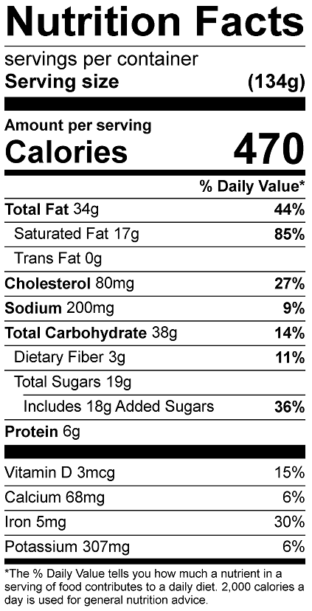
Vitamin C: 1.44 mg

