Mexican Potato Soup with Chorizo and Corn
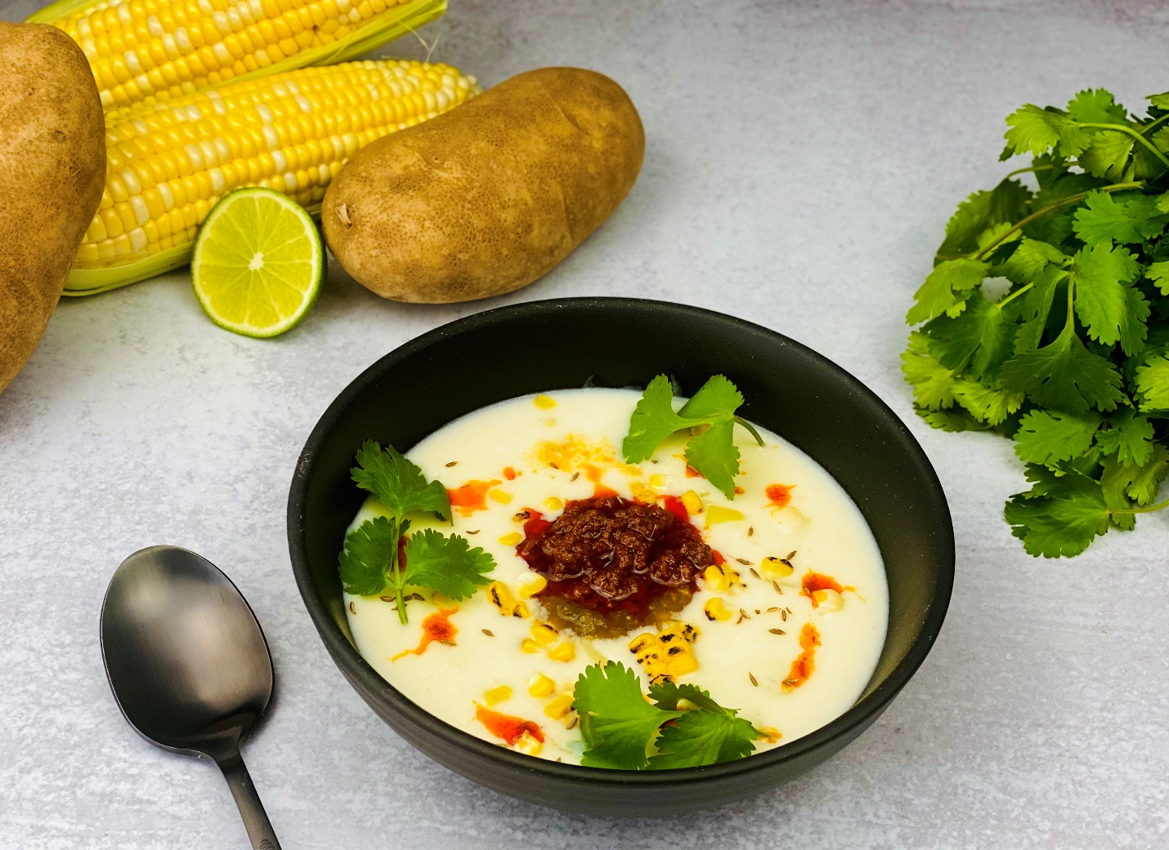
Description: Potatoes slow simmered in cream and Mexican spices then blended until smooth and served with chorizo and charred corn
Servings: 6
Preparation Time: 15 minutes
Cooking Time: 30 minutes
Total Time: 45 minutes
Potato Type: Russet Potatoes
Course: Soup, Appetizer

Ingredients
- 2 tablespoons (30ml) Olive Oil
- ¾ cup (112g) White Onions, roughly chopped
- 3 each (15g) Garlic Cloves
- 2 pounds Russet Potatoes, peeled and diced into 2-inch pieces
- ½ tablespoon (7g) Cumin
- ¼ cup (56g) Masa Harina (Corn Flour for Tortillas and Tamales)
- ½ teaspoon Chili Powder
- 4 cups (960 ml) Chicken Stock (Vegetable Stock can be subbed)
- 1 cup (240 ml) Heavy Cream
- 2 teaspoons (8g) Sea Salt
- 1 teaspoon (3g) White Pepper
To garnish the soup:
- 9 ounces (255g) Pork Chorizo
- ½ cup (120ml) Prepared Salsa Verde
- 2 each (112g) Corn on the cob, husked
- ¼ cup (8g) Cilantro Leaves, picked
Preparation
- To prepare the soup, begin by heating the olive oil in a large, heavy bottomed pot. Add the onions and garlic and cook over medium heat for 2-3 minutes or until the onions are translucent. Stir often so they don’t burn.
- Add the potatoes and cook for 4-5 additional minutes. Add the cumin, masa and chili powder, then cook for an additional 1-2 minutes. Pour in the stock, and simmer for about 30 minutes or until the potatoes are soft. Turn the heat off and add in the cream. Adjust the seasoning with salt and pepper then transfer the soup to a blender and puree until smooth.
- To make the additional garnishes, simply cook the chorizo in a pan over medium high heat, there is going to be a lot of fat in the pan so no need to add oil. Reserve the fat after cooking, as this chorizo oil is going to be delicious in the soup.
- To char the corn simply take an ear of corn and once husked, place it over the flame of an open burner or place it under the broiler in the oven until some nice char appears on the corn. Once cool, cut the kernels off the cob.
- Portion the soup into bowls, and garnish the soup with the cooked chorizo, chorizo oil, prepared salsa verde, corn, and cilantro.
- Enjoy!
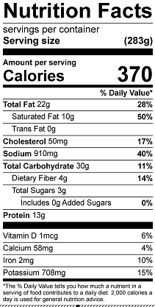
Vitamin C: 11.5 mg

