Grilled Potato Toast with Pork Carnitas, Guacamole and Charred Pineapple
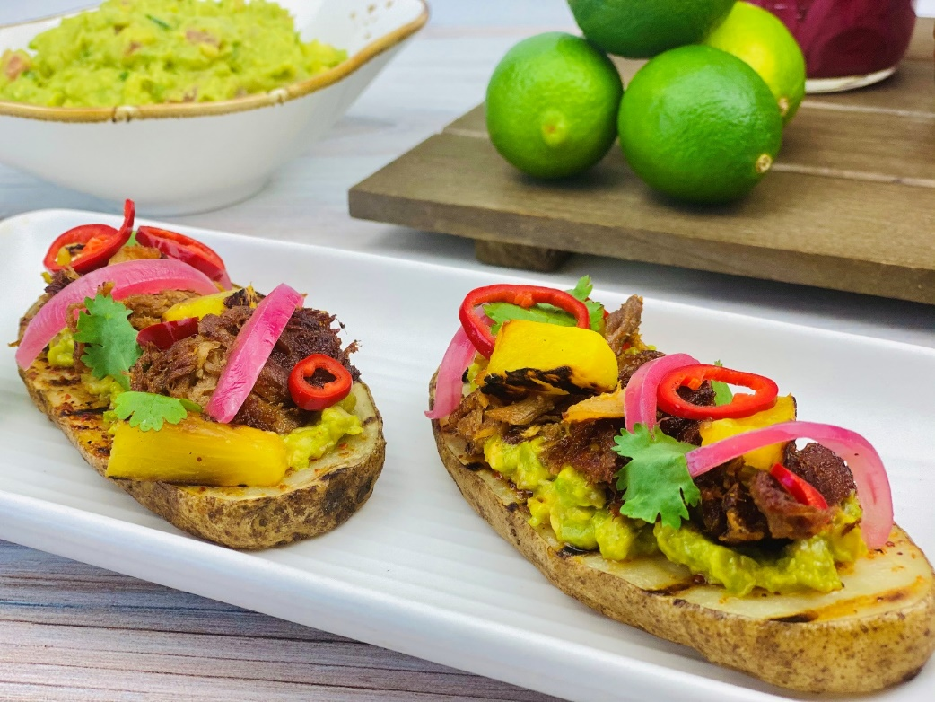
Description: Grilled Potato planks topped with guacamole, crispy pork shoulder, and charred pineapple.
Servings: 4
Preparation Time: 30 minutes
Cooking Time: 20 minutes
Total Time: 50 minutes
Potato Type: Russet Potatoes
Course: Appetizer

Ingredients
For the Potato Toasts:
- 2 each (~10 ounce *280g) Russet Potato, sliced lengthwise ½ inch thick
- 2 tablespoons (30ml) Olive Oil
- ½ tablespoon (6g) Chili Lime Salt (such as Tajin)
- 1 cup (233g) Prepared Guacamole
- ½ pound (226g) Pulled Pork Carnitas (From the refrigerated section of the grocery store, *Pulled Rotisserie Chicken can also be subbed)
- 1 cup (225g) Fresh Pineapple, diced (canned pineapple can be subbed but fresh is preferred)
1/4 cup (3g) Fresh Cilantro Leaves
Garnishes (optional):
- As Needed Pickled Chilies (Jalapenos, Fresnos, Banana Peppers, etc.)
- As Needed Pickled Red Onions
Preparation
- To prepare the potato toasts, slice the potatoes lengthwise about ½ inch thick. Brush the olive oil on both sides of the potatoes and place them on a preheated grill pan, grill, or even under the broiler. Grill the potatoes for 5-7 minutes on each side. Remove the potatoes from the grill and immediately season with the chili lime salt.
- While the potatoes are grilling heat a cast iron pan on the same grill, place the pulled pork on the cast iron skillet and allow it to cook for 3-4 minutes before flipping it over to crisp the other side. *if using rotisserie chicken add a tablespoon of olive oil to the pan before crisping as chicken, especially the breast meat, has less fat).
- When the meat is crispy, remove it from the pan and add the pineapple. Cook the pineapple without stirring it for about 5 minutes, it should develop a nice char. Remove the pineapple and prepare for assembly.
- To assemble the potato toasts, spread ¼ cup of guacamole on one side of the grilled potato plank. Top the guacamole with 2 ounces or ¼ cup of the crispy pork or chicken. Top the meat with some of the charred pineapple and finish the potato toasts with pickled chilies if desired and some cilantro.
- Enjoy!
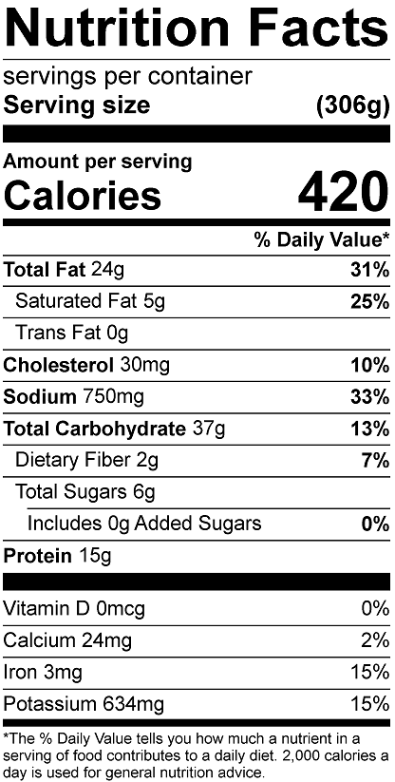
Vitamin C: 48 mg

