Grilled Fingerling Potatoes with Green Chili Vinaigrette, Red Quinoa and Radish
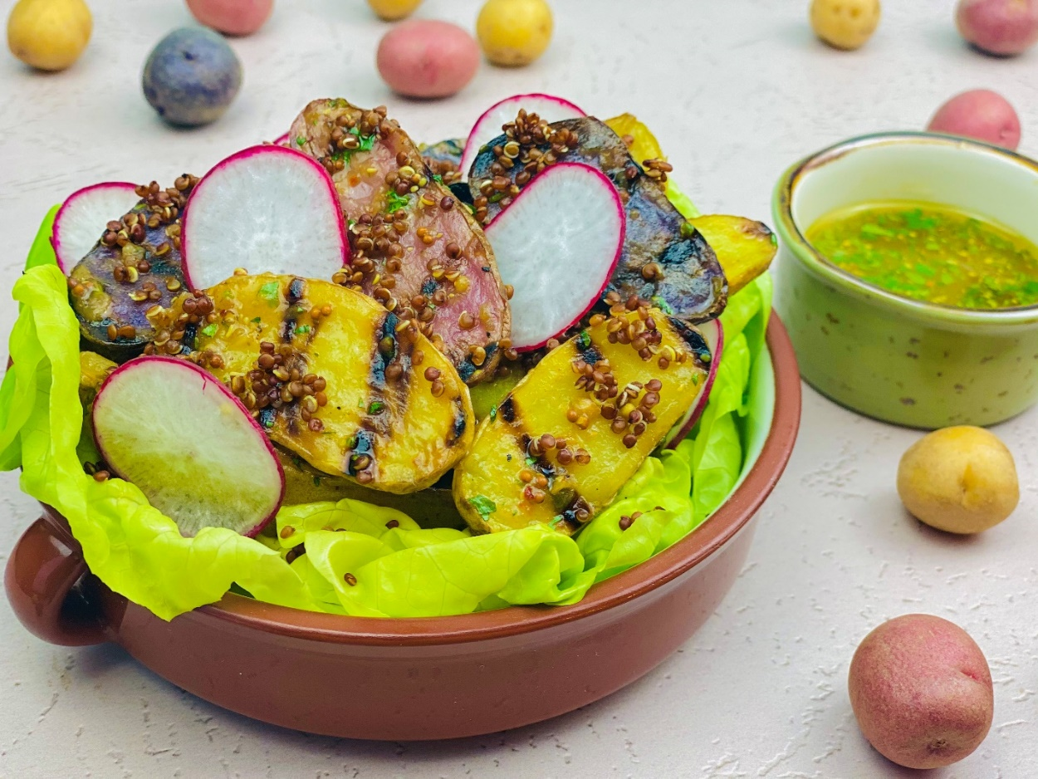
Description: Grilled Fingerling Potatoes tossed in a bright and tangy vinaigrette flavored with green chilies and whole grain mustard. Sprinkled with red quinoa, and sliced radishes.
Servings: 4
Preparation Time: 20 minutes
Cooking Time: 25 minutes
Total Time: 45 minutes
Potato Type: Fingerling Potatoes
Course: Salad, Appetizer, Vegan/Vegetarian, Performance

Ingredients
For the Grilled Fingerlings:
- 1.5 pounds (678g) Fingerling Potatoes, washed, sliced lengthwise
- 1 tablespoon (15ml) Extra Virgin Olive Oil
For the Vinaigrette:
- ½ cup (120ml) Green Chili Salsa (Salsa Verde)
- 3 tablespoons (45 ml) Stone Ground Mustard
- 2 teaspoons (10ml) Agave Nectar (Honey can be subbed but may not be considered vegan)
- 1 teaspoon (2g) Sea Salt
- 1 tablespoon (15ml) Fresh Lime Juice
- 2 tablespoons (30ml) Extra Virgin Olive Oil
For the Red Quinoa:
- 3 cups (720ml) Water
- 2 teaspoons (4g) Sea Salt
- ½ cup (90g) Red Quinoa
Garnishes:
- As Needed Butter Lettuce Leaves (optional)
- ¼ cup (14g) Radishes, sliced
Preparation
- To prepare the potatoes, preheat a grill pan or a grill to medium high heat. Slice the potatoes in half lengthwise, toss the sliced potatoes in the olive oil and place them on the grill cut side down. Allow the potatoes to grill for about 6-8 minutes on each side or until nice grill marks are achieved. Turn off the grill and transfer the potatoes to a bowl and cover them with aluminum foil or plastic wrap (this will allow the potatoes to steam slightly). While the potatoes rest in their little sauna, prepare the vinaigrette.
- In a medium bowl, combine the green chili salsa with the mustard, agave, sea salt, and lime juice. While whisking slowly drizzle in the olive oil.
- Pour the vinaigrette over the potatoes and toss to combine. Cover again and allow the potatoes to marinate for about 20 minutes while you prepare the quinoa.
- Wash the quinoa by placing it into a fine mesh strainer and rinsing it under cold water. This will remove any bitter notes from the quinoa, you could skip this step, but your quinoa will taste better if you don’t.
- Bring the water to boil in a medium saucepan over medium-high heat. Add the salt and the quinoa, cook the quinoa for about 15 minutes or until the grains burst open and they are tender to taste. Drain the quinoa through the same fine mesh strainer used previously and allow it to cool for about 7-10 minutes.
- To assemble the salad, place the potatoes in a serving dish, you can also arrange them on a bed of lettuce leaves if desired. Sprinkle the top of the marinated grilled potatoes with the quinoa and add the sliced radishes. Serve with extra vinaigrette if desired. Enjoy!
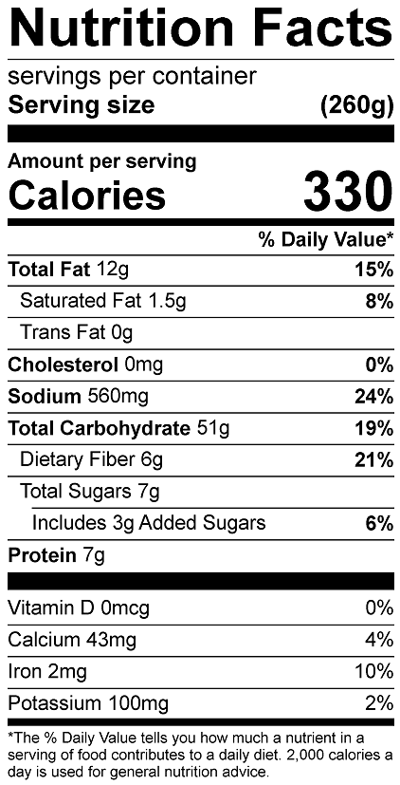
Vitamin C: 39.5 mg

