Green Chili Potato Gratin
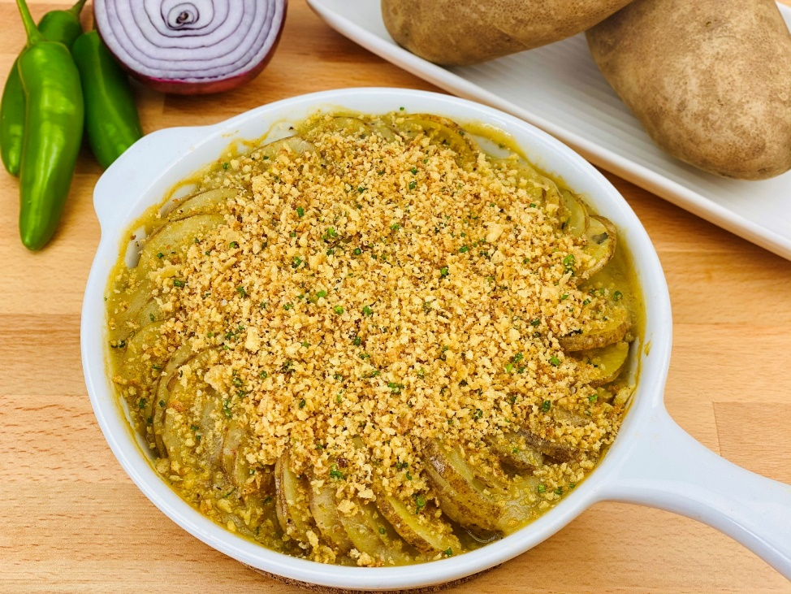
Description: Sliced of Russet Potatoes baked in a rich green chili sauce, topped with crispy breadcrumbs and corn masa
Servings: 6
Preparation Time: 30 minutes
Cooking Time: 30 minutes
Total Time: 60 minutes
Potato Type: Russet Potatoes and Dehydrated Potato Flakes
Course: Side Dish, Vegetarian/Vegan, Performance

Ingredients
For the Potatoes:
- 3 each (500g) Medium Russet Potatoes
- As Needed Cold Water
- 1.5 teaspoon (3g) Salt
For the Green Chili Sauce:
- 1.5 cups (360ml) Vegetable Stock
- 1 cup (240ml) Salsa Verde
- 2 each (10g) Garlic Cloves, chopped
- 1 teaspoon (1g) Ground Cumin
- 1 teaspoon (1g) Oregano (Mexican Oregano is preferred, but Italian oregano will work as it is more common in the U.S.)
- ½ teaspoon (~1g) Smoked Paprika
- 2/3 cup (45g) Dehydrated Potato Flakes
For the Crispy Topping:
- 1 tablespoon (15 ml) Extra Virgin Olive Oil
- ¾ cup (45g) Panko Breadcrumbs
- ¼ cup (31g) Masa Harina (Corn Flour for tamales and tortillas)
- 3 tablespoons (6g) Fresh Chives, chopped (Green Onions that have been thinly sliced can be subbed)
- 1 teaspoon (2g) Chili Lime Seasoning (such as Tajin)
Preparation
- To prepare the potatoes: Begin by preheating the oven to 400 °F (204 °C) slice the potatoes about ¼ inch thick, place them in a medium pot with enough cold water to cover them. Add the salt and bring the potatoes to a boil over medium high heat. Reduce the heat to a simmer and cook the potatoes until they are just tender but not falling apart (about 10-12 minutes). Drain the potatoes and allow them to cool slightly.
- While the potatoes are cooling, prepare the sauce by combining the vegetable stock, salsa verde, chopped garlic, cumin, oregano, and paprika in a medium saucepan. Bring the mixture to a boil, then reduce the heat to a simmer. Whisk in the potato flakes. Continue to stir until the mixture thickens, turn off the heat and retrieve your cooled potatoes.
- Arrange the potatoes in a spiral pattern in an oven safe dish lightly sprayed with nonstick cooking spray (This is optional, but it will make cleaning easier). *If using a rectangle or square dish, simply arrange the potato slices in shingled rows.
- Spoon the sauce over the potatoes, try to ensure that the sauce settles down in-between the slices of potatoes. Gently tap the dish on the counter to help assist the sauce to settle, spoon more sauce on top until it reaches about 2/3rds of the way up the sides of the gratin. Place the dish in the oven and allow it to cook for 15-20 minutes.
- While the potatoes are cooking, prepare the breadcrumb topping. To do this, heat the olive oil in a medium size skillet. Add the breadcrumbs and the masa and turn the heat to medium. While stirring frequently toast the breadcrumbs in pan until they are golden, remove from the heat and immediately place the toasted mixture into a bowl (This prevents them from overcooking in the pan that is still hot).
- Stir in the chopped chives, and chili lime seasoning.
- Remove the gratin from the oven and sprinkle the toasted breadcrumb mixture on top. Allow to cool for about 5 minutes before serving. Enjoy!
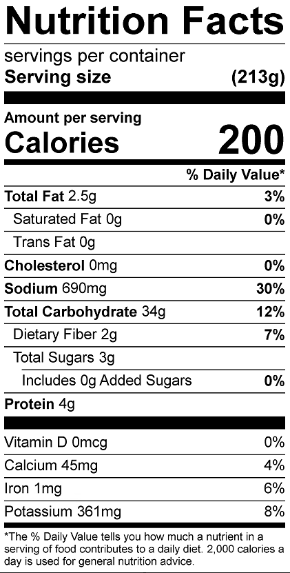
Vitamin C: 10.5 mg

