**Schupfnudeln: German Style Potato Noodles with Asparagus and Mushrooms**

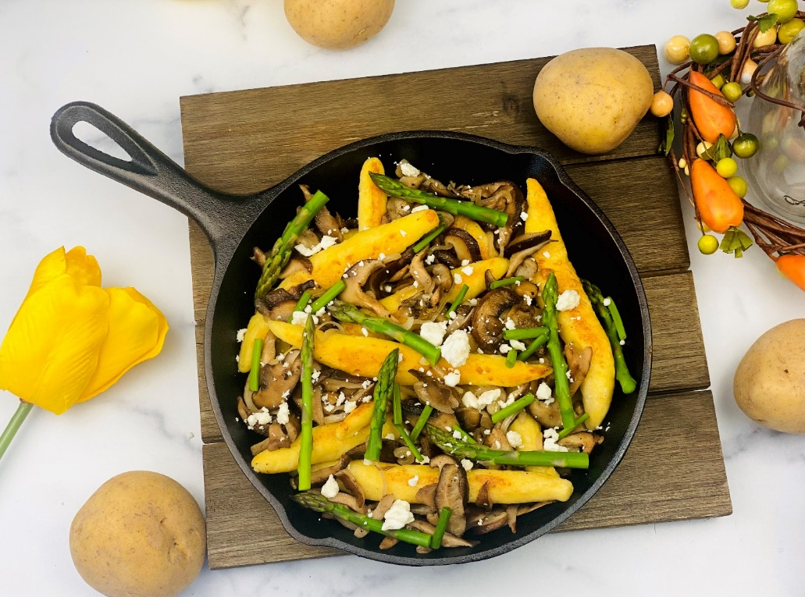

**Description:** Tender German style potato noodles, browned in butter and served with roasted mushrooms, asparagus, and creamy goat cheese.

**Servings:** 4

**Preparation Time:** 20 minutes

**Cooking Time:** 20 minutes

**Total Time:** 40 minutes

**Potato Type:** Russet Potatoes or Dehydrated Potatoes

**Course:** Appetizer, Side Dish, Main Course (Lunch or Dinner)

**Ingredients**

*For the Potato Noodles:*

* 1 lb. (454g) Cooked Russet Potatoes, peeled and mashed.
* 1 each (55g) Large Egg, beaten
* 2/3 cup (85g) All Purpose Flour
* ½ teaspoon (1g) Kosher Salt
* 1/8th teaspoon (~1g) Nutmeg (freshly grated or ground)
* As Needed Boiling Water
* 2 tablespoons (30g) Unsalted Butter

For the Roasted Mushrooms and Asparagus:

* 3 cups (240g) Assorted Mushrooms (Cremini, Shiitake, Button, Portabella, etc.), sliced
* 2 tablespoons (30ml) Extra Virgin Olive Oil
* 2 teaspoons (2g) Kosher Salt
* 1 cup (125g) Fresh Asparagus Tips, Cut 1 inch, cooked and cooled.
* 1 teaspoon (approx. 1 each) Lemon, zested and juiced
* ½ teaspoon (~1g) Freshly Ground Black Pepper

Garnish:

* ½ cup (75g) Goat Cheese, crumbles

**Preparation**

1. To prepare the potato noodles, begin by washing the potatoes and cooking them in a pot filled with cold water. Bring the pot to a boil and then reduce the heat to a simmer. Cook the potatoes until they are fork tender and soft. Peel the potatoes while they are still warm and pass them through a potato ricer. If you do not have a potato ricer, just mash the potatoes with a fork or with a potato masher. Spread the cooked potato pulp out on a baking sheet or large plate so the steam can evaporate quickly.
2. Once the potatoes are slightly cooled quickly mix them with the beaten egg, flour, salt and nutmeg. The dough should come together relatively quickly. The dough should be soft and just slightly sticky, if the dough is too sticky you can add a little more flour gradually. What you are looking for is a soft, supple dough, which leaves an indent when poked gently with a finger.
3. Allow the dough to rest for about 5 minutes while you bring a pot of water to boil on the stove. Once the water is boiling, reduce the heat to a simmer. And season the water with just a pinch of salt.
4. Prepare a baking sheet with a little nonstick spray or vegetable oil.
5. With lightly floured hands, roll the dough into a relatively thick log about 4 inches in diameter, slice the log into 4 equal pieces, then roll each piece into a rope about ½ an inch in diameter.
6. Using a sharp knife dipped in flour, cut the dough into 2-inch lengths, using your hand take each “noodle” and roll them so the ends are slightly tapered. After each noodle is made set to the side while more noodles are being made, cover the uncooked noodles with a loose fitting, damp, terry towel, or a piece of loosely fitting plastic wrap.
7. Once the noodles are all formed, gently place them a few at a time in the simmering water. After about a minute, the noodles should float, allow them to cook for an additional 30 seconds to a minute. Carefully remove them from the water and place them onto the prepared baking sheet which has been lightly oiled. Continue this process until all the noodles have been cooked. Once cooked and cooled, these can be frozen on a baking sheet lined with parchment paper, then transferred to plastic resealable bags, for a quick dinner any day of the week.
8. To cook the mushrooms and asparagus: preheat the oven to 450 F (232 C), Toss the mushrooms in the oil and season with salt. Spread the mushrooms onto an aluminum foil-lined baking sheet and roast in the oven for 8-10 minutes (this is great to do while you are working on the noodles).
9. Give the mushrooms a stir and when they are looking golden brown, add the asparagus to the pan and toss to coat them with some of the oil and roasted mushrooms. Return the pan to the oven and cook for 2-3 minutes, season the asparagus with the lemon zest, and black pepper.
10. To brown the potato noodles, heat a seasoned cast iron pan or nonstick pan over medium high heat. Add the butter and allow the butter to get slightly brown by swirling it around in the pan. Add the potato noodles in batches cooking each batch in the brown butter until, golden, brown, and delicious. When the noodles get brown, add the roasted asparagus and mushrooms, and gently toss to combine. Adjust the seasoning with salt and pepper and arrange on a serving dish.
11. Right before serving, garnish the dishes with a good sprinkle of crumbled goat cheese. Serve right away. And Enjoy!

***Dehydrated Potato Flakes can be used instead of fresh. Simply rehydrate 2 cups of dehydrated potato flakes with 2-1/2 cups of hot water, allow the potato flakes to sit for about a minute before fluffing with a fork.

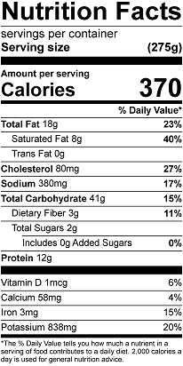

Vitamin C: 23.6 mg