Easy Air Fryer Mashed Potato and Veggie Quesadillas
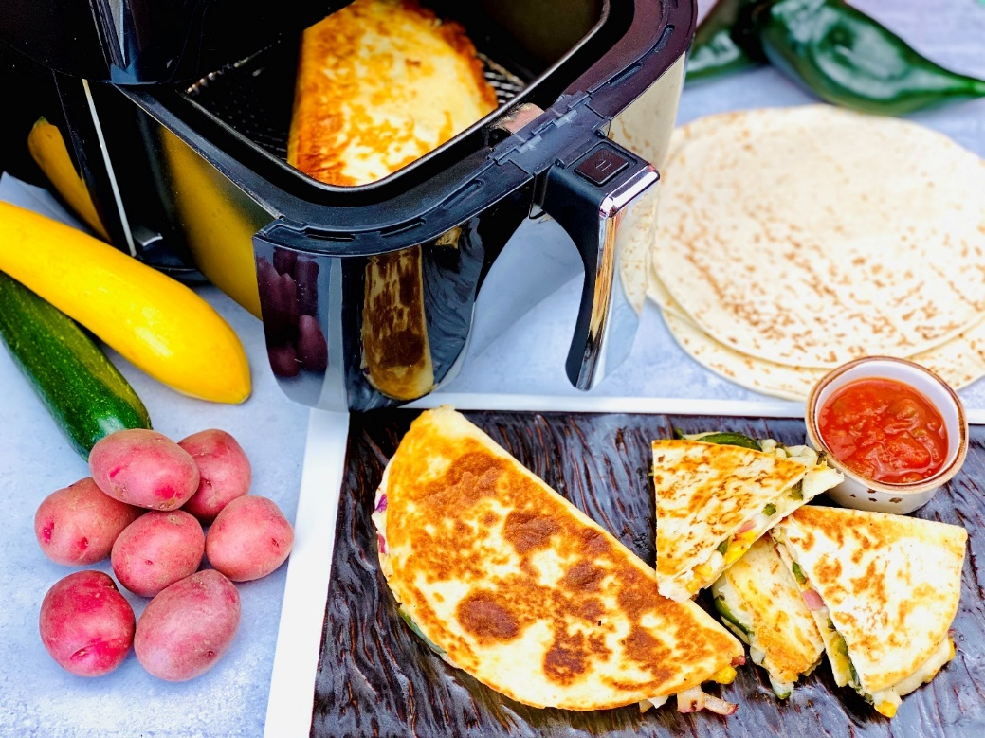
Description: Cheesy Pepper Jack Mashed Potatoes Spread on a flour tortilla and filled with peppers, onions, and zucchini, brushed with olive oil and cooked in an air fryer until crispy.
Servings: 4
Preparation Time: 15 minutes
Cooking Time: 20 minutes
Total Time: 35 minutes
Potato Type: Dehydrated Potato Flakes
Course: Entree, Vegetarian, Air Fryer

Ingredients
For the Potatoes:
- 1-1/4 cup (300ml) Water
- 2 tablespoons (28g) Unsalted Butter
- ½ teaspoon (~1g) Salt
- 2/3 cup (80ml) Whole Milk
- 1-1/3 cup (80g) Dehydrated Potato Flakes
- 1 cup (83g) Shredded Pepper Jack Cheese
For the Veggies:
- 1-1/2 cups (300g) Frozen Peppers and Onions, thawed (Fresh can be subbed but they will need to be cooked first, using frozen is a time saver and allows the entire meal to be done in the Air Fryer)
- ½ cup (100g) Frozen Yellow and Green Zucchini Squash, thawed
- 2 teaspoons Chili Lime Seasoning (such as Tajin)
4 each 8-inch Flour Tortillas
As Needed Olive Oil Spray
Additional Pairings:
- As Needed Prepared Salsa
- As Needed Sour Cream
Preparation
- To prepare the potatoes: Heat the water and butter in a microwave safe container for 2-3 minutes. Add the salt and the milk. Then add the potato flakes. Stir to combined and allow the mixture to sit for 30 seconds to a minute. Stir in the pepper jack cheese and set the potatoes to the side.
- Take the frozen veggies that have been thawed and drain them of any excess liquid they may have by placing them on some paper towels. Cut any large vegetables into strips or dices, whichever you prefer. Season them with the chili lime seasoning. Set aside for assembly.
- Preheat the air fryer to 400 °F (204 °C).
- To assemble the quesadillas, Spread 2/3rds cups of the cheesy mash onto each tortilla. Scatter some of the veggies on half of each tortilla and fold the top over and gently press down with your hands. Lightly spray each side of the quesadillas with the olive oil spray and place them one at a time into the air fryer. Cook the quesadilla for 8-10 minutes.
- Remove the quesadilla from the air fryer and repeat. These can also be made in the oven if you have a large family to feed. To do this simply preheat the oven to 400 °F (204 °C) and place the rack on the highest level Arrange the quesadillas on a baking sheet and spray with the olive oil. Flip the quesadillas after about 4 minutes to cook the other side after spraying it with olive oil spray.
- When the quesadillas are done, no matter your cooking method, cut them into wedges and serve with salsa and sour cream. Enjoy!
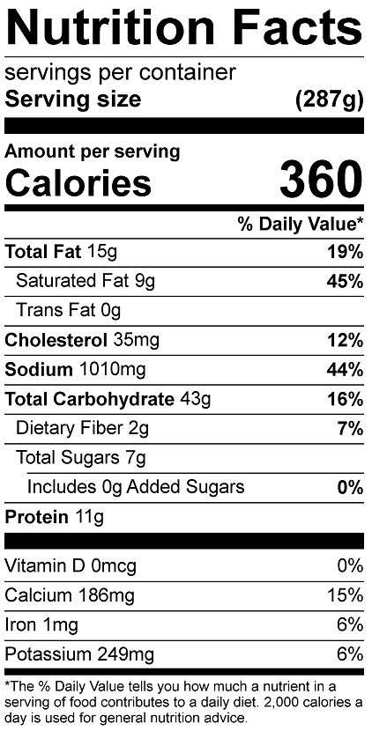

Vitamin C: 31.5 mg

