Crispy Schmaltz Roasted Potatoes
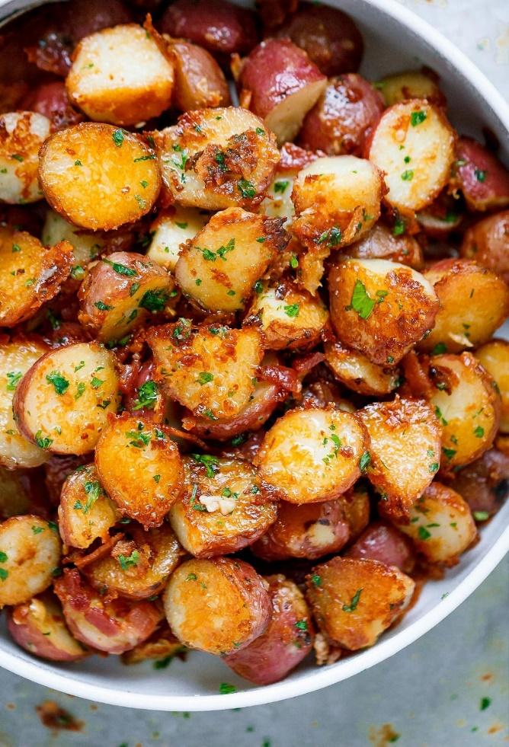
Description: Petite red potatoes crisped in melted chicken fat. A simple yet luxurious potato side.
Servings: 6
Preparation Time: 10 minutes
Cooking Time: 45 minutes
Total Time: 55 minutes
Potato Type: Red potatoes
Course: Side

Ingredients
For the Schmaltz:
- 1 lb. (454g) Chicken Skin and Chicken Fat Trimmings
- 1/8th teaspoon (~1g) Kosher Salt
- ¼ cup (60ml) Water
- 1/3 cup (20g) Yellow Onion, sliced
For the Potatoes:
- 2 lbs. (904g) Red Potatoes, cut in half or in quarters
- 4 each (20g) Garlic Cloves
- 1-2 sprigs (2g) Rosemary
- 3 tablespoons (45ml) Chicken Schmaltz (Recipe Above)
- 1 tablespoon (3g) Parsley, chopped
Preparation
- Cut the chicken skin into pieces and in a nonstick medium sized pan, add the chicken skin/fat, salt, and water.
- Spread the chicken skin/fat evenly across the bottom of the pan. Add the sliced onions on top and cook over medium heat for 10 minutes or until the schmaltz starts to render. Then stir every 5-10 minutes, until the skins get crispy, and the fat is rendered.
- Remove the chicken skins, and strainer the fat through a fine mesh strainer, discard the onion. Chop the crispy chicken skins and set aside until ready to use.
- Place the potatoes in a large bowl together with the schmaltz, garlic, herbs, salt, and pepper.
- Transfer the potatoes to a baking sheet and bake at 400 °F (204 °C).
- The potatoes should roast in the oven for about an hour until they are golden brown and crisp.
- Remove the potatoes from the oven, place in a serving dish and garnish with the freshly chopped parsley, and the crispy chicken skins from before.
- Serve immediately. Enjoy!

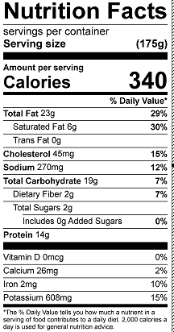
Vitamin C: 11.2 mg

