**Cookies and Cream Potato Sweet Rolls**

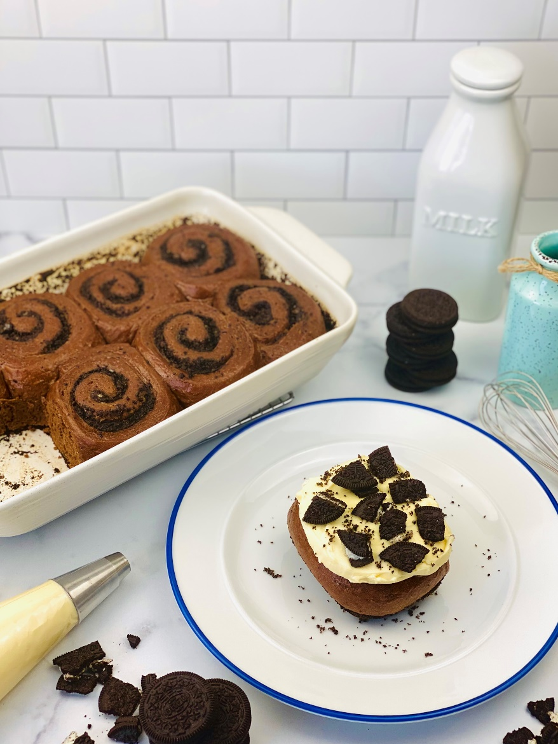

**Description:** Tender and moist chocolate potato dough around a chocolate sandwich cookie crumble, topped with Vanilla Cream Cheese Icing. Perfect when paired with a frosty glass of milk.

**Servings:** 16 (1/2 roll)

**Preparation Time:** 30 minutes

**Cooking Time:** 35 minutes

**Total Time:** 65 minutes

**Course:** Pastry/Dessert

**Ingredients**

For the Chocolate Dough:

* 4.5 cups All Purpose Flour
* ½ cup Unsweetened Cocoa Powder
* 5 teaspoons Dry Active Yeast
* ½ cup Granulated Sugar
* 1 teaspoon Sea Salt
* 1.5 cups Water
* 6 tablespoons Unsalted Butter, melted
* 1 each Large Egg
* ½ cup Dehydrated Potato Flakes

For the Cookie Crumble Filling:

* 3 tablespoons Unsalted Butter, softened
* 18 each Chocolate Sandwich Cookies
* 2 tablespoons Unsalted Butter, Melted
* 3 tablespoons Brown Sugar
* 2 tablespoons All Purpose Flour
* 1 teaspoon Sea Salt

For the Vanilla Cream Cheese Icing:

* 16 ounces Cream Cheese, softened
* 6 ounces Unsalted Butter, softened
* 2/3 cup Powdered Sugar
* 2 teaspoons Pure Vanilla Extract

As Needed Broken Chocolate Sandwich Cookie Pieces

**Preparation**

1. Preheat the oven to 350 F (176.7 C).
2. Butter a 9x13 inch baking dish and set aside.
3. In a stand mixer, combine 2 cups of the flour with the cocoa powder, sugar, yeast, and salt.
4. Melt the butter in the microwave and add the water, make sure the water is warm, but not hot (85 F or 29.4 C). Whisk the egg into the water and butter mixture.
5. With the mixer running on low speed slowly add in the butter, water and egg mixture.
6. Mix together the remaining flour and the potato flakes. Add this mixture to the wet dough ½ a cup at a time until a smooth dough comes together.
7. Continue to knead in the mixer at low speed for 4-6 minutes or until the dough is smooth. Cover the bowl with plastic wrap and allow the dough to rest for about 20 minutes.
8. While the dough is resting prepare the cookie filling by pulsing the ingredients for the filling in a food processor until a fine crumb appears. Set aside until ready to fill.
9. Transfer the dough to a lightly floured surface and roll the dough into a 15x10 inch rectangle.
10. Spread the 3 tablespoons of softened butter over the dough, leaving about a 1-inch gap at the top of the rectangle so the rolls can be sealed after rolling.
11. Sprinkle a ½ inch layer of the cookie crumble on the buttered surface of the dough. Roll the dough evenly from the bottom of the rectangle and gently crimp the edge of the dough that doesn’t have the cookie crumble.
12. Cut the roll into eight even pieces. With the remaining cookie crumble sprinkle a light coating of the cookie crumble into the prepared pan, ensuring that the edges get coated.
13. Arrange the rolls in the pan, 2x4.
14. Cover with plastic wrap and allow the rolls to proof in a warm spot for about an hour.
15. When the rolls are proofed, place them into a preheated oven for 25-30 minutes or until a toothpick inserted between the rolls comes out clean.
16. Allow the rolls to cool for about 20 minutes while you make the icing.
17. To make the icing, whip the cream cheese and butter in a stand mixer fitted with a paddle attachment until smooth, scraping down the sides of the mixer occasionally. Add the vanilla and powdered sugar then mix till smooth.
18. Transfer the frosting to a pastry bag fitted with a round tip, and pipe the frosting on the rolls. You don’t need to use a pastry bag, you can just spread it on with an offset spatula, but the pastry bag makes it look really nice.
19. To finish, simple top the rolls with the broken cookie pieces and dig in!
20. Enjoy!

