Brie Whipped Mashed Potatoes
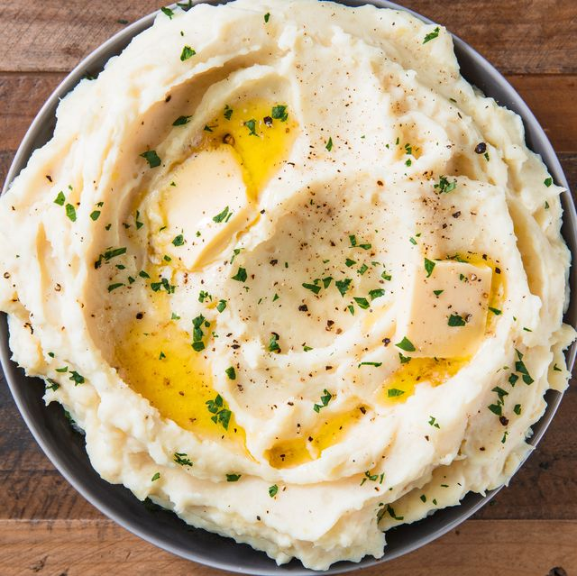
Description: Light and fluffy mashed potatoes with brie cheese, a great side with any holiday entree.
Servings: 8
Preparation Time: 10 minutes
Cooking Time: 45 minutes
Total Time: 55 minutes
Potato Type: Russet Potatoes
Course: Side

Ingredients
For the Potatoes:
- 3 lbs. (904g) Russet Potatoes, peeled and cut into 2-inch pieces
- 1 tablespoon (3g) Kosher Salt
- 6 ounces (180g) Unsalted Butter, softened
- ½ cup (120ml) Half & Half
- 8 ounces (240g) Brie Cheese, rind removed, cut into ½ inch cubes
- As Needed Kosher Salt
- As Needed Freshly Ground White Pepper
Garnish:
- As Needed Fresh Parsley, chopped
Preparation
- In a heavy bottomed pot, add the potatoes with enough cold water to cover them.
- Add the salt, and place over high heat. When the water reaches a boil, reduce the heat to a simmer.
- Continue to cook the potatoes until they are fork tender (about 35-45 minutes). Drain the potatoes well and return them back to the heat to dry out slightly for about 30 seconds to a minute. For best results pass the potatoes through a potato ricer or food mill. If you do not have either of those pieces of equipment the potatoes can be mashed with a sturdy whisk, potato masher, fork, stand mixer, hand mixer, etc.
- Heat the half and half until it is hot, add the butter and stir the mixture into the potatoes a little at a time until you reach your desired consistency. Fold in the brie until well incorporated.
- Adjust the seasoning with salt and pepper, then transfer to a serving dish.
- Garnish the potatoes with freshly chopped parsley and serve immediately. Enjoy!

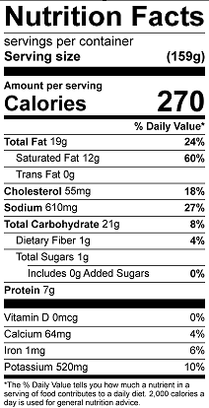
Vitamin C: 7 mg

