Baja Style Fish Tacos with Potato-Corn Tortillas
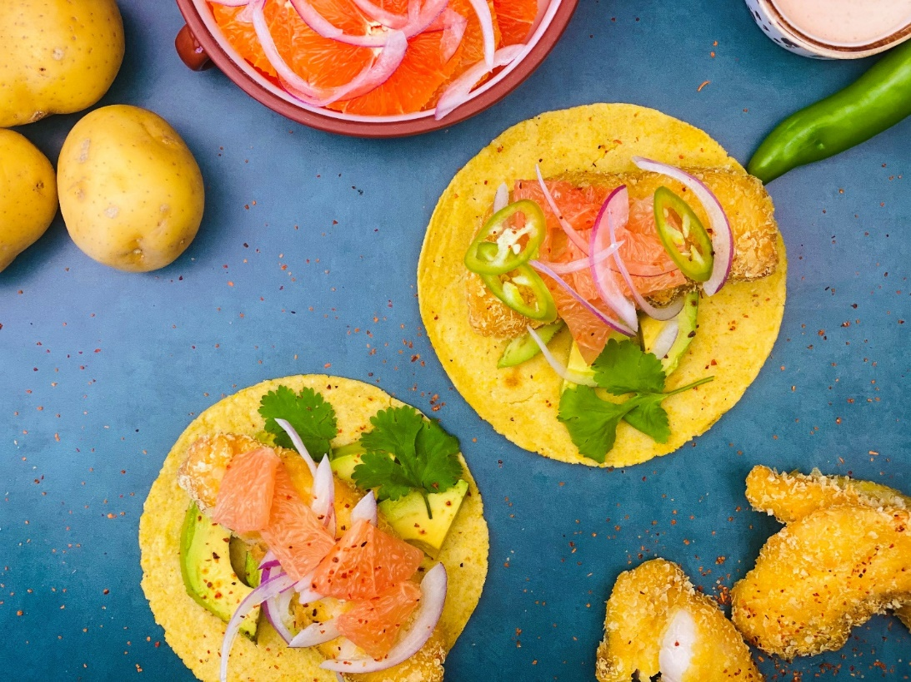
Description: Potato crusted white fish, served in a warm potato-corn tortilla topped with grapefruit, avocado, and chilies.
Servings: 6 (2 tacos per serving)
Preparation Time: 30 minutes
Cooking Time: 30 minutes
Total Time: 60 minutes
Potato Type: Dehydrate Potato Flakes
Course: Entree

Ingredients
For the Potato-Corn Tortillas:
- ½ cup (50g) Dehydrated Potato Flakes
- ¾ cup (200g) Warm Water
- ¾ cup (200g) Masa Harina (Corn Flour for tortillas and tamales)
- 2 tablespoons (30g) Vegetable Oil
- 2 teaspoons (5g) Sea Salt
For the Potato Crusted Fish:
- 1.5 pounds (675g) Grouper, Cod, Haddock, Snapper, Bass (Any Mild, Firm Flesh, White Fish), de-boned and scaled, cut into 2-ounce pieces.
- 2 teaspoons (5g) Sea Salt
- 1 cup (150g) Masa Harina (Corn Flour for tortillas and tamales)
- 2 each Large Eggs
- 2 tablespoons (30ml) Water
- 1 cup (100g) Potato Flakes
- As Needed Vegetable Oil for Frying
- As Needed Chili Lime Salt (such as Tajin) *Optional
For the Sauce:
- ½ cup (123g) Sour Cream
- 1 tablespoon (15ml) Water
- 2 tablespoons (30ml) Hot Sauce
Garnishes:
- 1.5 cups (128g) Grapefruit, peeled and cut into small wedges
- 3 each Medium Haas Avocados, sliced
- 1 cup (120g) Red Onion, thinly sliced and rinsed under cold water
- ½ cup Cilantro Leaves

Preparation
- To prepare the tortillas, in a large bowl combine the dehydrated potato flakes with the water, mix in the masa, vegetable oil, and salt. Knead the mixture until a smooth dough forms (about 2 minutes). Set the dough aside covered with a lightly damp towel for about 3-5 minutes.
- Divide the tortillas into 12 equal pieces. Using a tortilla press or the bottom of a pan with wax paper, press out the tortillas. Cook the tortillas in a dry, cast iron pan, heated over medium-high heat. The tortillas should only take about 30 seconds on each side, over cooking them will cause them to be dry and brittle. As the tortillas cook, place them in a dry, clean dish cloth, this will allow them to steam slightly, making them more pliable, as well as keeping them warm.
- To make the fish, season the fish with the salt, allow the fish to sit for about 5 minutes (this will pull some moisture out and slightly “cure” the fish. Place the fish into a resealable plastic bag and add the masa. Seal the bag and shake to coat the fish.
- Crack the eggs into a shallow dish and whisk in the water. In another shallow dish, place the potato flakes.
- Dip the masa coated fish into the egg mixture, allow the excess to drip off and then dredge the fish in the potato flakes. Arrange the fish onto a baking sheet. Once the fish is prepared heat a pan of oil over medium-high heat. When the oil is hot, cook the fish for about 3-4 minutes on each side until golden brown, allow the fish to drain on a wire rack on a baking sheet (you can also use paper towels). Season the fish with the chili lime salt if desired, alternatively you can also use regular salt to season the crust of the fish. Once all the fish is cooked, it’s a good idea to hold it in a 200 °F oven while you assemble the garnishes.
- To make the sauce simply combine the sour cream, water, and hot sauce together in a small bowl.
- To serve the tacos, place some avocado down on a tortilla, followed by fish, the grapefruit, the onions, and cilantro. Drizzle with the sauce and enjoy!
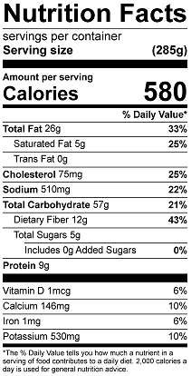
Vitamin C: 27.8 mg

