Arugula Salad with Crispy Potato Croutons and Chili Lime Dressing
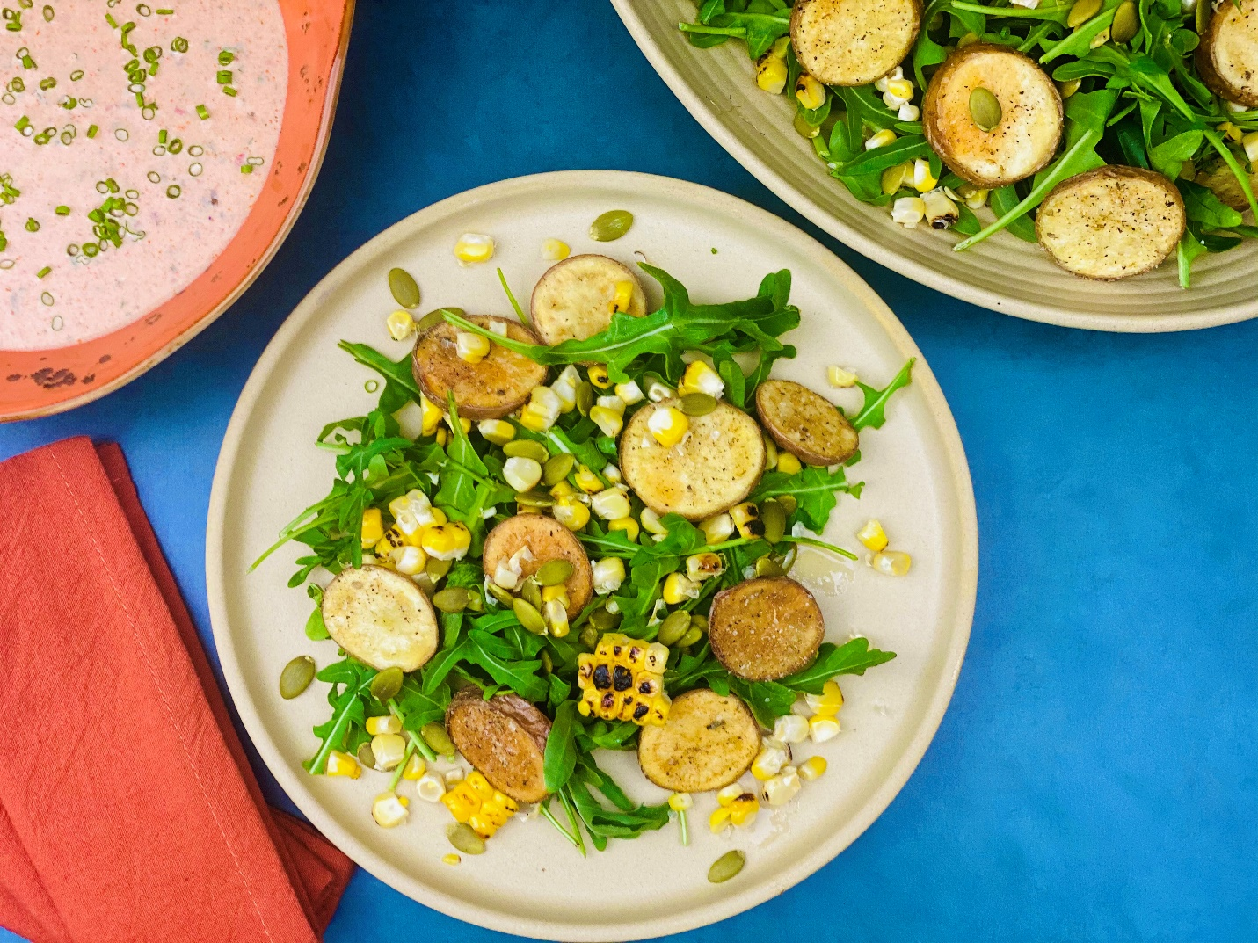
Description: Crispy baby potatoes are seasoned with cumin and oregano before being nestled on a bed of arugula, pumpkin seeds, and grilled corn. This salad is served with a tangy buttermilk-chipotle-lime dressing.
Servings: 6
Preparation Time: 10 minutes
Cooking Time: 30 minutes
Total Time: 40 minutes
Potato Type: Fingerling or Petite Potatoes
Course: Salad, Appetizer, Performance

Ingredients
For the potato croutons:
- 1.5 pounds (680g) Fingerling Potatoes, sliced ½ inch thick
- As Needed Olive Oil Spray
- 1 tablespoon (6g) Cumin
- 2 teaspoons (5g) Sea Salt
- 1 teaspoon (2g) Black Pepper
- 2 teaspoons (3g) Oregano
For the Salad:
- 5 cups (125g) Arugula
- ¾ cup (89g) Toasted Pumpkin Seeds
- 1 cup (164g) Sweet Corn
For the Dressing:
- ½ cup (60ml) Non-Fat Greek Yogurt
- 1/3 cup (80g) Light Mayo
- ¼ cup (60ml) Cultured Buttermilk
- ½ cup (20g) Cilantro, chopped
- 1 each (10g) Chipotle Peppers in Adobo Sauce, chopped fine
- 2 tablespoons (30ml) Freshly Squeezed Lime Juice
- 1 teaspoon (2g) Garlic Powder
- 1 tablespoon (3g) Fresh Chives, chopped fine (Dried Chives can be subbed, just reduce to 2 teaspoons)
Preparation
- To prepare the croutons, slice the fingerling potatoes into coins about ½ inch thick. Spray them with the olive oil spray and arrange them on a baking sheet. Place into a preheated 400 °F (204 °C) oven. Roast the potatoes for 20-25 minutes or until they are crispy and golden. While the potatoes are cooking, mix the cumin, salt, black pepper and oregano together in a small bowl. When the potatoes are done season them with the spice mix.
- To char the corn, remove the husk and place the corn over an open flame, or a grill, or under a broiler for 3-5 minutes turning often until the corn is blistered and black. Allow the corn to cool slightly before cutting the corn kernels off the cob.
- For the salad, simply arrange a bed of arugula into a serving dish, and top with toasted pumpkin seeds, charred corn kernels, and the potato croutons.
- To make the dressing, place all the ingredients together in a bowl and whisk until smooth and creamy.
- To serve drizzle the dressing over the top of the salad and enjoy.

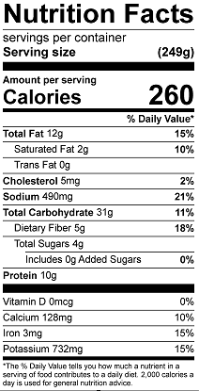
Vitamin C: 32.3 mg

