Turkish Falafel Potato Bowl with Lemon Sesame Dressing
Description: Crispy chickpea and herb patties on whipped potatoes with a cool sesame dressing.
Servings: 24
Preparation Time: 20 minutes
Cooking Time: 30 minutes
Total Time: 50 minutes
Potato Type: Dehydrated Potato Flakes, Dehydrated Potato Pearls, Refrigerated Mashed Potatoes, Frozen Mashed Potatoes
Course: Entree

Ingredients
For the Mashed Potatoes
- 4.5 pounds (2kg) Prepared Mashed Potatoes
For the Falafel
- 4.5 pounds (2 kg) Prepared Falafel Mix
For the Cucumber Yogurt Sauce
- 2 cups (480ml) Greek Yogurt
- ½ cup (75g) English Cucumber, diced
- ½ cup (6g) Mint, chopped
- 2 teaspoons (2g) Dill, dried
For the Lemon-Sesame Dressing
- ½ cup (120ml) Tahini (Sesame Seed Butter)
- 3 fluid ounces (89ml) Water (more if needed)
- ¼ cup (60ml) Fresh Lemon Juice
- 2 tablespoons (30 ml) Honey
- 2 teaspoons (10ml) Sesame Oil
- 2 each (10g) Garlic Cloves, finely chopped
- ½ teaspoon (~1g) Kosher Salt
As Needed Chopped Parsley (Garnish), optional
Preparation
- Preheat the oven to 450 °F (232 °C).
- Prepare the falafel mix and shape into 48 1-1/2 ounce patties, this can be done using a red #24 (1.5 ounce) disher.
- Once the patties are formed into balls, place them on a sheet pan lined with parchment paper, using wet hand, gently press the falafel balls down slightly. Bake the falafels for 15-20 minutes or until they are crispy.
- To prepare the mashed potatoes, simply follow the instructions on the manufacturers packaging and hold warm at >145 F for no longer than 4 hours.
- To make the yogurt sauce: combine the yogurt, cucumber, mint, and dill together in a large bowl. Keep the sauce cold (<40 °F or <4.4 °C)
- To make the lemon-sesame dressing: In a small bowl, whisk together the tahini, water, lemon juice, olive oil, maple syrup, sesame oil, garlic, and salt until smooth. If the dressing is too thick, add more water, ½ tablespoon at a time, until it’s a drizzleable consistency.
- To plate up, place a ½ cup or white disher of the mashed potatoes at the base. Spoon 1 ounce of the yogurt dressing followed by two falafel. Drizzle a tablespoon of the dressing over the potato bowl and garnish with chopped parsley if desired. This dish can be made with a baked potato instead of mashed potatoes if desired.
- If falafel is not an option, turkey meatballs can also be used (See below photo).

Turkish Falafel Potato Bowl with Lemon Sesame Dressing
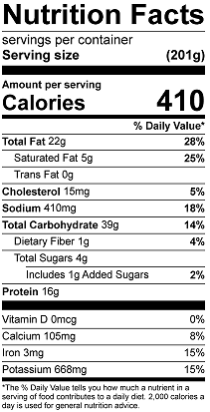
Vitamin C: 11mg

Turkish Falafel Baked Potato with Lemon Sesame Dressing
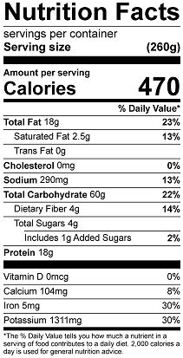
Vitamin C: 14.6mg
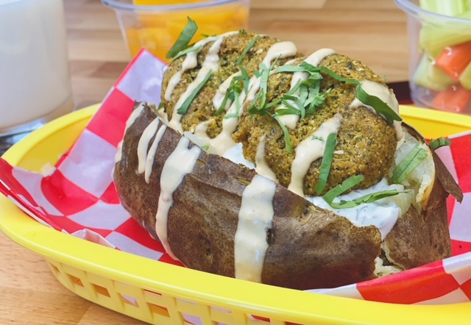

Turkey Meatball Baked Potato with Lemon Sesame Dressing
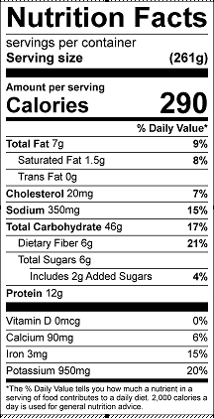
Vitamin C: 13.3mg
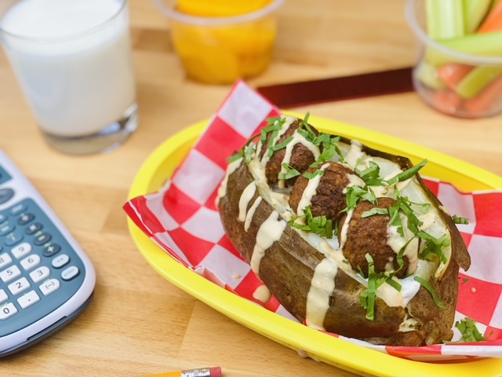
Turkey Meatball Potato Bowl with Lemon Sesame Dressing

