Southwest Potato Tostada
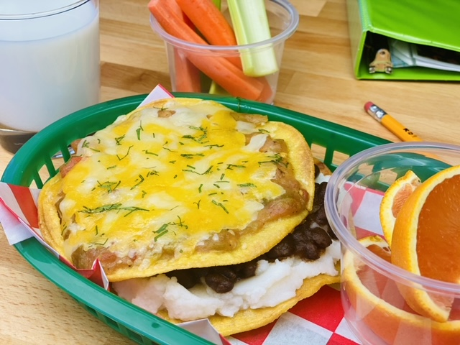
Description: Crispy tortilla shells, creamy mashed potatoes, seasoned black beans, green chili and melted cheese are layered to make a delicious vegetarian option featuring potatoes.
Servings: 24
Preparation Time: 30 minutes
Cooking Time: 30 minutes
Total Time: 60 minutes
Potato Type: Dehydrated Potato Flakes, Dehydrated Potato Pearls, Refrigerated Mashed Potatoes, Frozen Mashed Potatoes
Course: Entree

Ingredients
For the Mashed Potatoes
- 4.5 pounds (2kg) Prepared Mashed Potatoes
For the Black Beans
- 4.5 pounds (2 kg) Prepared Canned Black Beans, drained and rinsed
- 3 tablespoons (20g) Cumin, ground
- ¼ cup (60ml) Lime Juice
- 3 tablespoons (20g) Smoked Paprika
- 2 cups (480ml) Prepared Salsa, canned
For the Green Chili
- 2 quarts (1.9L) Prepared Green Chili, frozen
- 48 each 6-inch Corn Tortilla Shells or Corn Tostadas
- 2.25 pounds (1kg) Shredded Cheddar Cheese
As Needed Chopped Cilantro (Garnish), optional
Preparation
- Preheat the oven to 450 °F (232 °C).
- Arrange the corn tortillas on baking sheets lined with parchment paper, and lightly spray the tortillas with oil. Place into the oven and bake for 6-8 minutes or until they are golden and crisp, flip them halfway through cooking to ensure even cooking.
- Prepare the mashed potatoes according to the manufacturer’s instructions.
- To prepare the black beans, combine the black beans, cumin, lime, salsa, and paprika together and heat over medium heat until the beans reach 145 °F (63 °C). Hold at >145 °F until ready to use for up to 4 hours.
- When ready to prepare, spoon 1-1/2 ounces of green chili onto half of the tostadas, top with 1-1/2 ounces of cheese and place in the oven for 3-5 minutes or until the cheese is bubbling and melted.
- Spoon ½ cup of the mashed potato mixture onto the non-sauced tortilla. Then spoon 3 ounces of the black beans onto the mashed potatoes. Next place the sauced and cheese corn tortilla on top. Alternatively, this can be served on tortilla chips instead of the tostada.
- This dish can also be made featuring a baked potato instead of mashed potatoes. Simply prepare baked potatoes then top them with the green chile, black beans and cheese. Return the potatoes to the oven just until the cheese is melted (this is an optional step, which can be omitted).

Southwest Potato Tostada
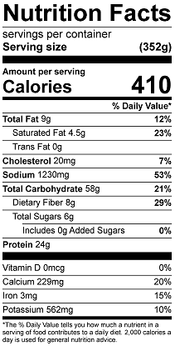
Vitamin C: 41mg

Southwest Loaded Baked Potato
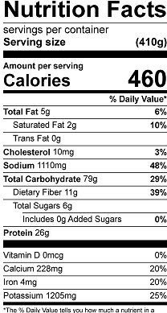
Vitamin C: 44.7mg
