Korean BBQ Chicken Fries
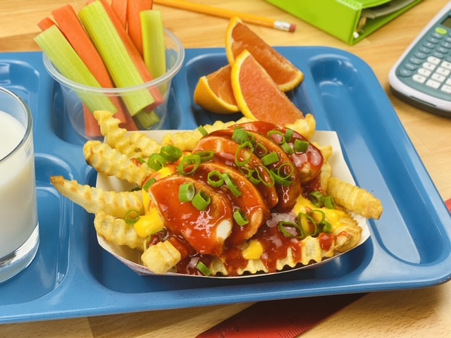
Description: Crispy oven baked fries topped with grilled chicken, cheddar cheese sauce, and a Korean inspired BBQ Sauce.
Servings: 24
Preparation Time: 10 minutes
Cooking Time: 45 minutes
Total Time: 55 minutes
Potato Type: Frozen Crinkle Cut Fries
Course: Entree

Ingredients
For the Fries:
- 4.5 pounds (2kg) Frozen Crinkle Cut Fries
For the Cheese Sauce:
- 4.5 cups (1.1 L) Prepared Cheese Sauce (Frozen or Canned)
For the BBQ Sauce:
- 3 cups (720ml) Prepared BBQ Sauce
- ½ cup (120ml) Hot Water
- ½ cup (120ml) Gochujang (Korean Pepper Paste)
- ½ cup (120ml) Rice Wine Vinegar
For the Chicken:
- 4.5 pounds (2.7kg) Chicken Breast, frozen (24 each x 3 ounce or 85g)
As Needed Chopped Green Onions (Garnish)
Preparation
- Preheat the oven to 450 °F (232 °C).
- Arrange the fries on sheet pans lined with parchment paper. Place the fries in the oven and bake for 20-25 minutes or until the fries are crisp and golden brown. Hold hot for service. *It’s best to batch cook the fries for each class as they come in for service.
- Heat the cheese sauce to 145 °F (62.8 °C) and hold warm for service.
- To make the BBQ Sauce, pour the prepared sauce into a large bowl. Separately combine the hot water with the gochujang and the vinegar. Stir well to combine and then whisk the gochujang mixture with the BBQ sauce. (Can be made up to 3 days prior to service)
- For the Chicken, arrange the frozen portioned chicken breasts on a sheet pan lined with parchment paper. Place the chicken in a 350 °F (176.7 °C), cook the chicken until an internal thermometer reaches 165 °F (74 °C). Remove the chicken and brush them with a little BBQ sauce, until lightly coated, reserve the remaining BBQ sauce for the hot line.
- Cut each chicken breast into 4 slices and shingle them in a full 200 hotel pan to hold warm (141 °F or 60 °C).
- To assemble the dish, place ¾ cup (3 ounces weight or 85g) of the baked fries into a serving boat. Top the fries with ¼ cup (2 ounces or 60ml) of warm cheese sauce. Then top with 4 pieces or one 4 ounce breast of chicken and 1 ounce of BBQ Sauce. Lastly garnish with an optional tablespoon sized sprinkling of green onion.
- To make this meal creditable combine the fries with ½ cup of fruit, 1 cup of 1% or fat free milk, and a serving of whole grains such as a dinner roll. *Alternatively, this can be served on a baked potato as well, simply sub out small baked potatoes for the fries. Enjoy!

Korean BBQ Chicken Cheese Fries
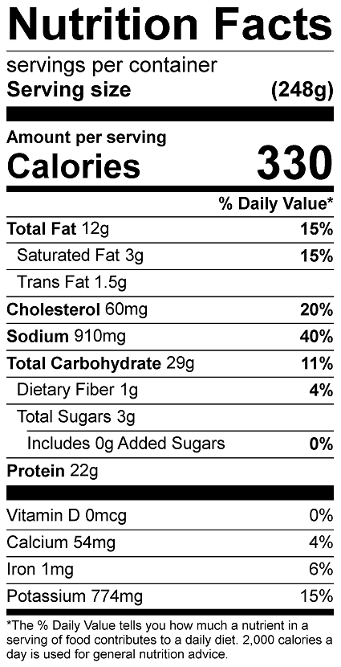
Vitamin C: 10.4 mg

Korean BBQ Chicken Cheese Baked Potato
