Indian Butter Chicken Tater Drums
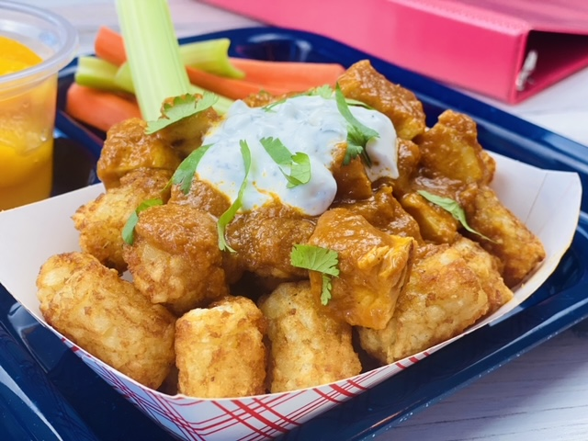
Description: Crispy oven baked tater drums topped with slow simmered chicken breast in a fragrant Indian tomato sauce.
Servings: 24
Preparation Time: 10 minutes
Cooking Time: 45 minutes
Total Time: 55 minutes
Potato Type: Frozen Crinkle Cut Fries
Course: Entree

Ingredients
For the Tater Drums:
- 4.5 pounds (2kg) Frozen Tater Drums
For the Butter Chicken Sauce:
- ¼ cup (60ml) Olive Oil
- 4 cups (500g) Yellow Onion, diced
- 3 tablespoons (45g) Ginger, finely chopped
- 3 tablespoon (45g) Garlic, finely chopped
- 8 cups (1.9L) Canned Tomato Sauce
- 2 tablespoon (12g) Curry Powder
- 2 teaspoons (3g) Garam Masala
- 2 tablespoons (8g) Paprika
- 2 teaspoons (3g) Cumin
- 1 cup (240ml) Low Fat Greek Yogurt
- 2 teaspoons (4g) Black Pepper
- 4.5 pounds (2 kg) Diced Chicken Breast, fully cooked, frozen
For the Yogurt Sauce:
- 2 cups (480ml) Greek Yogurt
- ½ cup (75g) English Cucumber, diced
- ½ cup (6g) Mint, chopped
- 2 teaspoons (2g) Dill, dried
As Needed Chopped Cilantro (Garnish), optional
Preparation
- Preheat the oven to 450 °F (232 °C).
- Arrange the tater drums on sheet pans lined with parchment paper. Place the tater drums in the oven and bake for 20-25 minutes or until they are crisp and golden brown. Hold hot for service. *It’s best to batch cook the tater drums for each class as they come in for service.
- To make the butter chicken, begin by heating the oil in a tilt skillet or large pot and add the olive oil. When the oil is hot add the onions and cook for 2-3 minutes. When the onions are translucent add the ginger and the garlic and cook for an additional 2 minutes. Add the tomato sauce, curry powder, garam masala, paprika, and cumin. Simmer the mixture for about 15 minutes, stirring occasionally so the sauce doesn’t burn. Add the yogurt and the diced fully cooked chicken (raw chicken can be subbed just add it before the yogurt and cook till the temp is 165 °F (74 °C) then add the yogurt and proceed with the recipe).
- To make the yogurt sauce combine the yogurt, cucumber, mint, and dill together in a large bowl. Keep the sauce cold (<40 °F or <4.4 °C)
- To assemble the dish, place ¾ cup (3 ounces weight or 85g) of the baked tater drums into a serving boat. Top with ½ cup (4 ounces or 120ml) of the stewed butter chicken. Then top with ½ ounce of the yogurt sauce and a sprinkling of chopped cilantro if desired.
- To make this meal creditable combine the fries with ½ cup of fruit, 1 cup of 1% or fat free milk, and a serving of whole grains such as a dinner roll. *Alternatively this can be served on a baked potato as well, simply sub out small baked potatoes for the tater drums. Enjoy!

Indian Butter Chicken Tater Drums
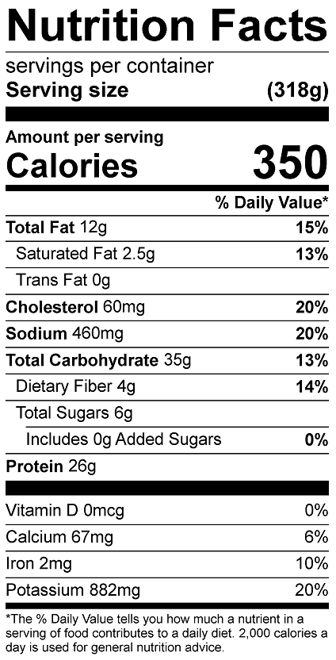
Vitamin C: 6.4 mg

Indian Butter Chicken Baked Potato
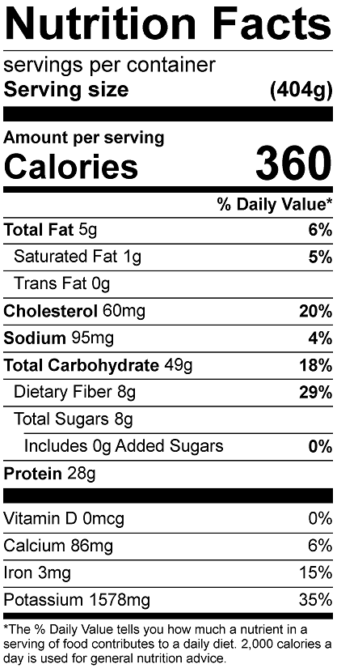
Vitamin C: 17.1mg
