BBQ Roasted Potatoes with Smoky Pulled Chicken
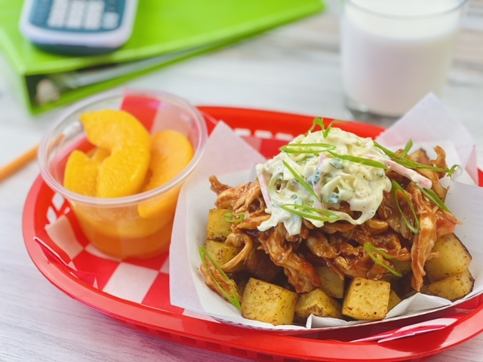
Description: Crispy oven baked BBQ spice rubbed potatoes topped with pulled BBQ chicken breast and creamy coleslaw.
Servings: 24
Preparation Time: 20 minutes
Cooking Time: 60 minutes
Total Time: 80 minutes
Potato Type: Diced Frozen Potatoes or Diced Fresh Potatoes (any variety)
Course: Entree

Ingredients
For the BBQ Roasted Potatoes:
- 4.5 pounds (2kg) Frozen Diced Potatoes
- ¼ cup (50g) Prepared BBQ Spice Blend
For the BBQ Chicken:
- 4.5 pounds (2 kg) Chicken Breast, fully cooked, shredded
- 3 cups (720 ml) BBQ Sauce
For the Coleslaw:
- 1 pound (453g) Green Cabbage, thinly shredded
- 8 ounces (226g) Carrots, shredded
- 1 cup (11g) Cilantro, chopped
- 2 cups (480ml) Non-Fat Greek Yogurt
- ½ cup (120ml) Low Fat Mayonnaise
- ¼ cup (60ml) Rice Vinegar
- 1-1/2 tablespoons Celery Seed
As Needed Chopped Parsley (Garnish), optional
Preparation
BBQ Roasted Potatoes
- Preheat the oven to 450 °F (232 °C).
- Arrange the diced potatoes on sheet pans lined with parchment paper. Season them evenly with the BBQ spice blend. Place the potatoes in the oven and bake for 20-25 minutes or until they are crisp and golden brown. Hold hot for service. *It’s best to batch cook the potatoes for each class as they come in for service.
BBQ Chicken
- Combine the BBQ sauce with the shredded chicken and heat to 165 °F (74 °C). Hold the chicken at 145 °F (62.8 °C) for no more than 4 hours.
Coleslaw
- Combine the cabbage, carrots, cilantro in a bowl and toss to combine. To keep the coleslaw, crisp its best to toss it with the sauce in batches throughout service time. To make the sauce, combine the yogurt, mayonnaise, vinegar, and celery seed until well incorporated. Toss some of the slaw with some of the sauce and toss until lightly dressed. Keep the slaw cold (<40 °F or <4.4 °C)
To Assemble the Dish
- Place ¾ cup (3 ounces weight or 85g) of the BBQ spiced potatoes into a serving boat. Top with ½ cup (3 ounces or 120ml) of the BBQ chicken. Then top with ½ ounce (2 tablespoons) of the creamy coleslaw and a sprinkling of chopped parsley if desired.
- To make this meal creditable combine the fries with ½ cup of fruit, 1 cup of 1% or fat free milk, and a serving of whole grains such as a dinner roll. *Alternatively, this can be served on a baked potato as well, simply sub out small baked potatoes for the diced potatoes.

BBQ Roasted Potatoes with Smoky Chicken
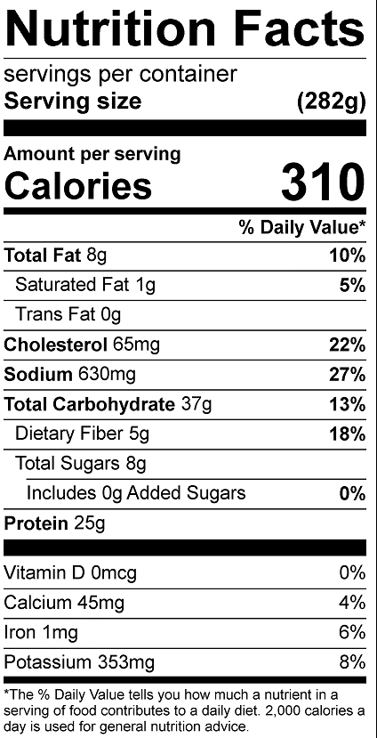
Vitamin C: 15.2 mg

BBQ Pulled Chicken Baked Potato
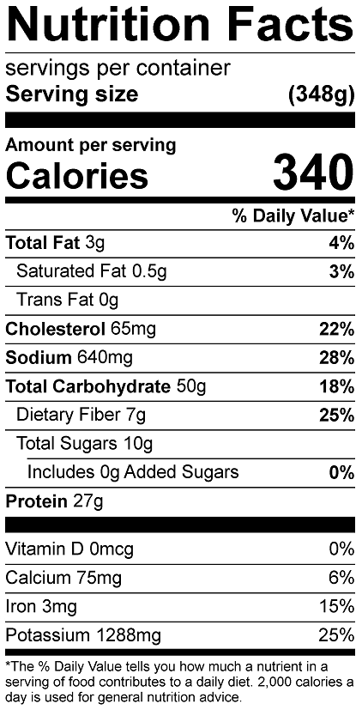
Vitamin C: 22mg
