Thick Cut Potato Chips with Kimchi Queso
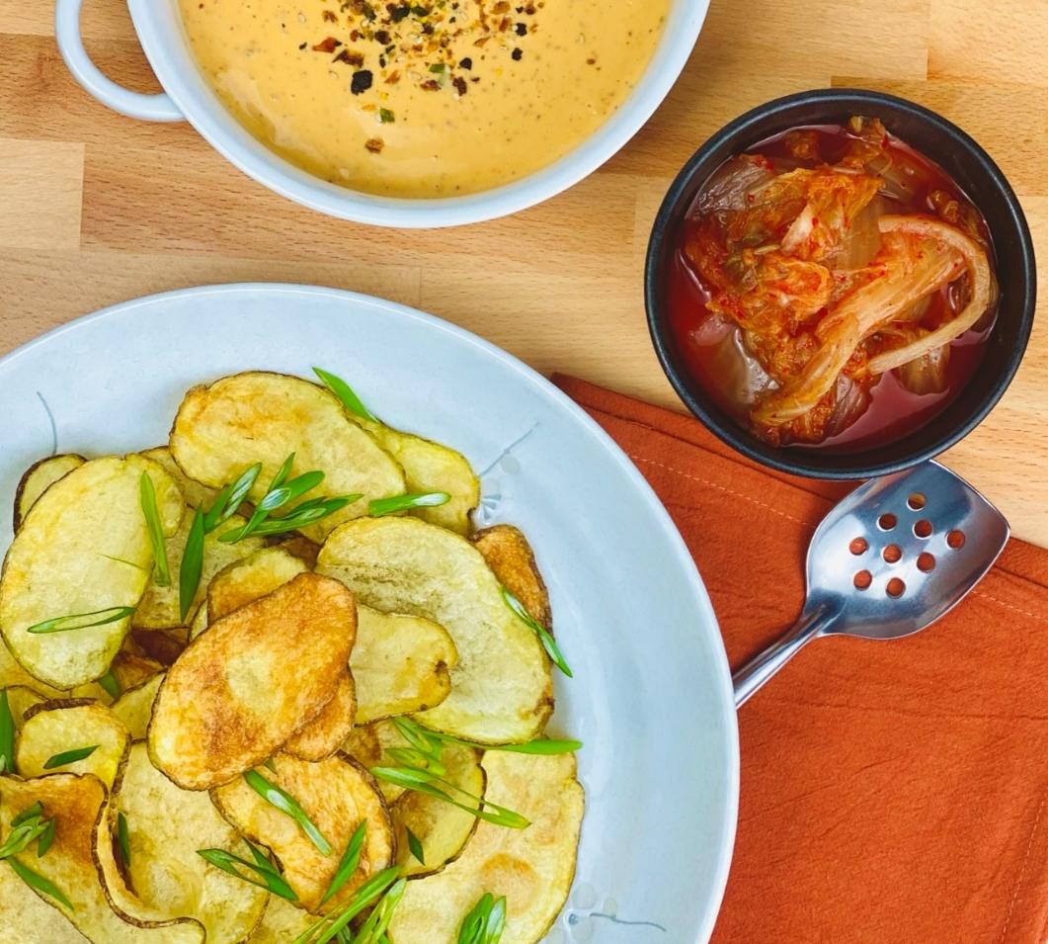
Description: Crispy thick cut russet potato chips with a creamy queso dip flavored with spicy kimchi.
Servings: 12
Preparation Time: 15 minutes
Cooking Time: 20 minutes
Total Time: 35 minutes
Potato Type: Russets
Course: Appetizer, Snack

Ingredients
- 2.2lbs (1 kg) Russet Potatoes, sliced lengthwise 1/8th inch thick
- As Needed Vegetable Oil for frying
- 2 teaspoons Sea Salt
- 2/3 cup (180g) Prepared Cabbage Kimchi, chopped
- 32 ounces (907g) Velveeta Cheese, cut into 1 inch cubes
- 1 cup (240ml) Whole Milk
- 1 tablespoon (2g) Furikake Seasoning (Optional)
- ½ cup (40g) Green Onions, sliced
Preparation
- Preheat a fryer or a pot of oil to 350 °F (177 °C)
- Slice the russets and immediately place them into a container of water to prevent them from oxidizing. Drain the sliced potatoes in a salad spinner or on paper towels. Fry the chips in the oil for 7-8 minutes or until the bubbles subside and the potatoes are golden and crisp. Drain the chips on some paper towels or a cookie sheet fitted with a wire rack.
- To make the queso; start by chopping the kimchi, this can be done by hand or in a food processor or blender. Simply roughly chop the kimchi and set it aside. The Velveeta and the milk can be placed into a large saucepan or even a crockpot. Heat the cheese over medium heat, until it’s melted and incorporated with the milk.
- Add the chopped kimchi and stir to combine.
- When ready to serve, garnish the queso with the furikake seasoning if desired. And sprinkle the chips with the sliced green onion.
- Serve immediately and enjoy.
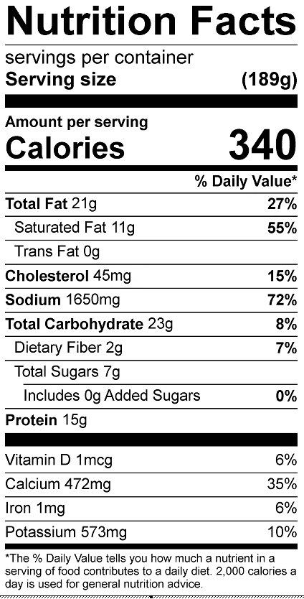

Vitamin C: 5.52mg

