Shepherd’s Pie with Irish Cheddar Mashed Potatoes
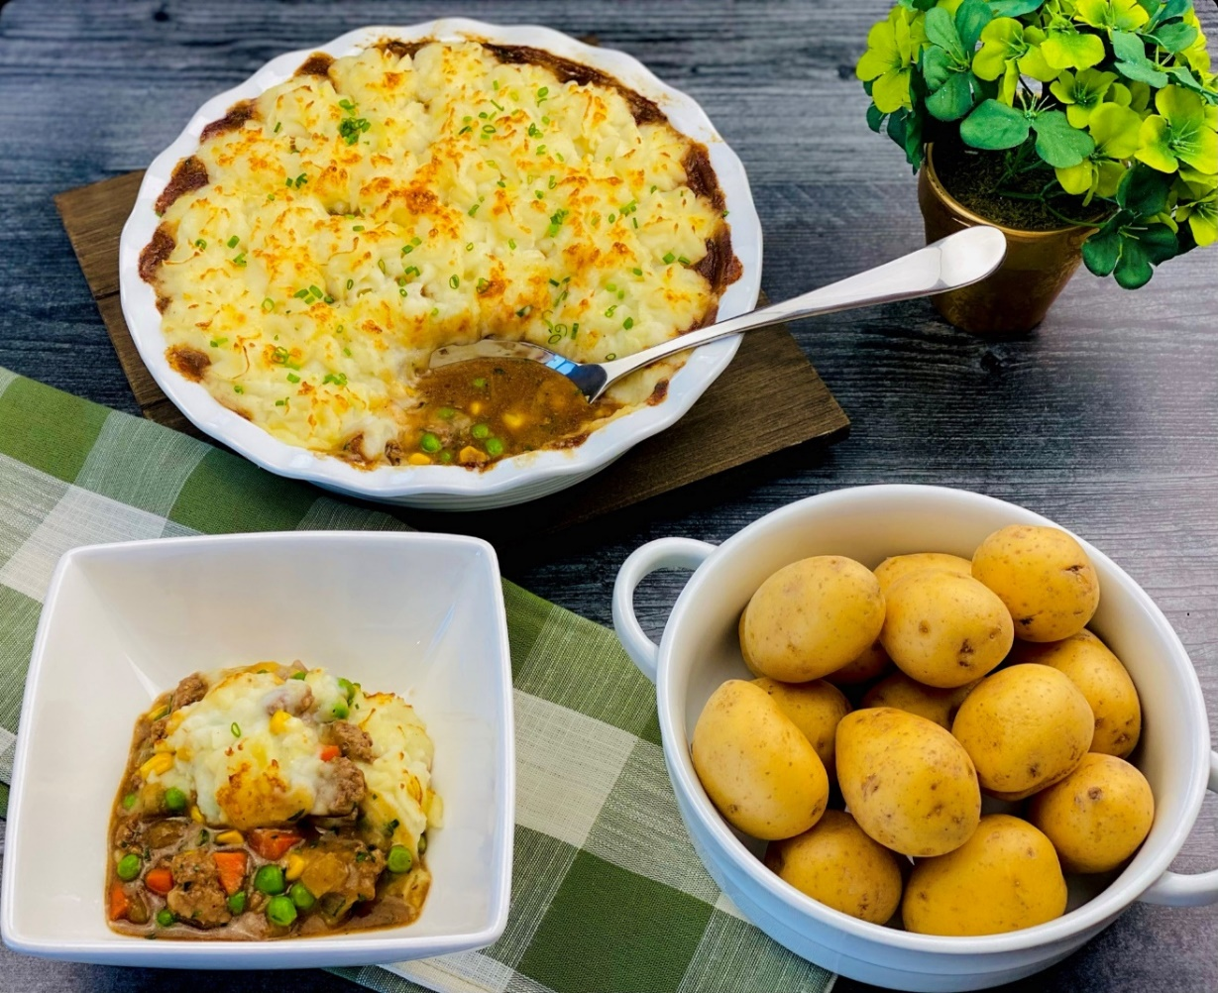
Description: Ground lamb and aromatic vegetables, slow simmered in a rich brown gravy, topped with silky smooth mashed potatoes flavored with aged Irish cheddar and chives.
Servings: 8
Preparation Time: 15 minutes
Cooking Time: 45 minutes
Total Time: 60 minutes
Potato Type: Yellow Potatoes, Dehydrated Potato Flakes, or Frozen/Refrigerated Mashed Potatoes
Course: Entrée, Lunch, Dinner

Ingredients
For the Lamb Filling:
- 1 lb. (454g) Ground Lamb
- ½ cup (75g) Yellow Onion, chopped ¼ inch
- ¼ cup (40g) Carrots, chopped ¼ inch
- ¼ cup (40g) Celery, chopped ¼ inch
- ½ cup (75g) Yellow Corn Kernels, Frozen
- ½ cup (75g) Green Peas
- ½ tablespoon (3g) Kosher Salt
- 1 teaspoon (1g) Freshly Ground Black Pepper
For the Brown Gravy:
- 2 tablespoons (30g) Unsalted Butter
- 3 tablespoons (40g) All Purpose Flour
- 2 tablespoons (30g) Tomato Paste
- ½ cup (120ml) Dry Red Wine
- 2 cups (480ml) Beef Stock or Beef Broth
- ¼ teaspoon (~1g) Dried Thyme
- ½ teaspoon (1g) Dried Marjoram (optional)
- 1 each Bay Leaf
* Pre-purchased brown gravy can also be substituted
For the Irish Cheddar Mashed Potatoes:
- 3 cups (185g) Potato Flakes
- 2-1/2 cups (600ml) Water
- ¼ cup (56.5g) Unsalted Butter
- 1-1/2 cups (360g) Whole Milk
- 1 teaspoon (1g) Kosher Salt
- ¾ cup (62.5g) Shredded Irish Cheddar (Aged White Cheddar can be subbed)
Garnish:
- ¼ cup (2g) Fresh Chives, finely chopped

Preparation
- In a large nonstick skillet over high heat, brown the ground lamb. Once the lamb is nicely browned, remove the lamb and drain off all but 1 tablespoon of the rendered fat in the pan. Set the lamb aside while the vegetables are sauteing.
- Sauté the onions, carrots, and celery in the tablespoon of reserved lamb fat. The onions should be translucent after about 2-3 minutes of cooking. Turn off the heat and add the corn and peas along with the cooked ground lamb. Season with salt and pepper. Set this mixture to the side while the gravy is being made.
- In a medium saucepan, heat the butter over medium-high heat. Once the butter is melted add the flour and cook for about 3-4 minutes, stirring constantly until the butter and the flour mixture have turned a nutty brown color. Add the tomato paste and sit until combined. Whisk in the red wine and then the beef stock. Reduce the heat to low and add the thyme, bay leaf, and marjoram if using. Simmer the sauce for about 20 minutes. Discard the bay leaf and strain the sauce through a fine-mesh strainer to eliminate any lumps. Set aside until ready to assemble the pie.
- To make the mashed potatoes, place the potato flakes into a large bowl. Heat the water to a boil, remove from the heat and stir in the butter, milk, and salt. Pour the hot liquid over the potato flakes and stir to combine. Allow to rest for 1 minute before stirring again gently. Gently stir in the cheese. The dish is now ready to be assembled.
- Place the ground lamb/vegetable mixture into an oven-safe dish. Stir in the gravy and top with the mashed potatoes. The potatoes can just be simply spooned on top, but for a beautiful presentation consider a pastry bag with a star pastry tip to pipe a decorative pattern around the dish.
- Place the pie under the broiler for 2-3 minutes or until the top of the potatoes are golden brown.
- Remove from the oven and allow the pie to rest for 3-5 minutes. Sprinkle the top of the mashed potatoes with the chopped chives and serve immediately.

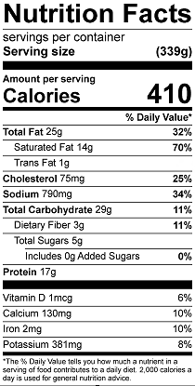
Vitamin C: 22.14

