Potato “Wings”
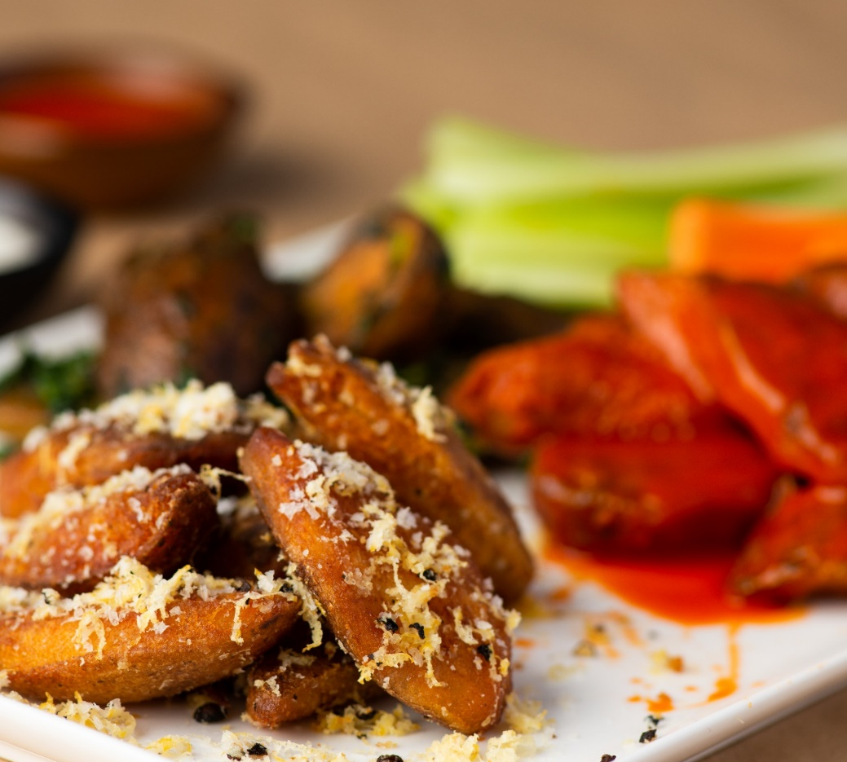
Description: Crispy pieces of russet potato tossed with your choice of seasonings and/or sauces. Try Lemon Pepper-Parmesan, Pesto, or classic Buffalo.
Servings: 12
Preparation Time: 25 minutes
Cooking Time: 45 minutes
Total Time: 70 minutes
Potato Type: Russets
Course : Appetizer, Snack

Ingredients
For the Potato Wings:
- 2.2lbs (1 kg) Russet Potatoes, cut in half lengthwise
- As Needed Cold Water
- 2 tablespoons (10g) Kosher Salt
- 2 tablespoon (10g) Baking Soda
- As Needed Vegetable Oil for frying
For the Buffalo Sauce
- ½ cup (120ml) Hot Sauce
- ½ cup (113g) Unsalted Butter, melted
Garnish
- 8 ounces (150g) Carrots, cut into ½ inch sticks
- 8 ounces (150g) Celery, cut into ½ inch sticks
- ½ cup (120ml) Ranch Dressing
Preparation
- Cut the potatoes into thick-cut rounds (lengthwise) about a 1/2 an inch thick. The rounds can be cut on the diagonal if too large, this will give you your “drums” and the small rounds will be your “flats”. Hold the potatoes in cold water to prevent from oxidizing.
- Once all the potatoes are cut remove them from the water and place them in a large pot and cover with cold water. Add the salt to the water and place on the stove over high heat, bring them to a boil and then reduce the heat to a simmer. Cook the potatoes until they are just about fork tender (about 12 minutes). During the last 5 minutes of cooking add the baking soda. Immediately remove them from the heat, drain and arrange on baking sheets. Place the potatoes in the freezer overnight. Once the potatoes are completely frozen. They are ready to be fried. The potatoes can be transferred to freezer bags at this stage up to 3 months in advance.
  - Pro tip: the ratio of baking soda to water is crucial. Aim for 1 Tablespoon for every gallon of water. This method works best with russet potatoes. For optimal results, potatoes must be frozen overnight before frying.
- Preheat the oil in a deep fryer to 375 °F. Fry the potatoes in batches for 7-8 minutes or until they are golden brown and super crispy. Keep the potatoes warm in a low (200 °F) oven until ready to use.
- To make the sauce mix the hot sauce and butter together in a small bowl. Pour some of the sauce over the crispy potato wings and toss quickly to coat or serve the sauce on the side. Conversely any sauce or seasoning can work on these potato wings.

Variations
How to make this recipe with frozen potatoes: Substitute frozen potato wedges that have been cooked in a 450 °F oven for 18-20 minutes for the from-scratch potatoes in this recipe. Toss the cooked potato wedges in prepared buffalo sauce and serve with celery, carrots and ranch dressing.
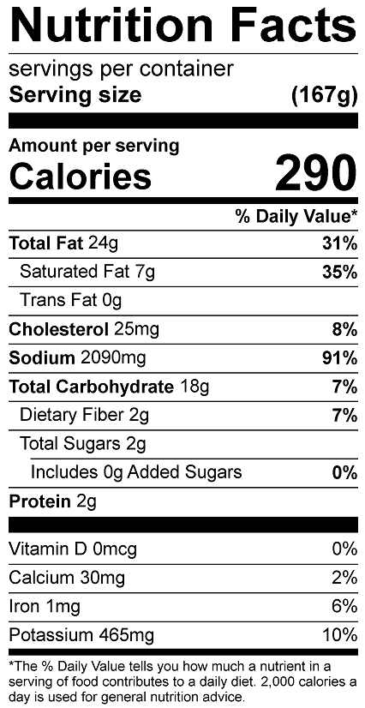

Vitamin C: 6.44mg

