Loaded Baked Potato Dip with Crispy Fingerling Chips
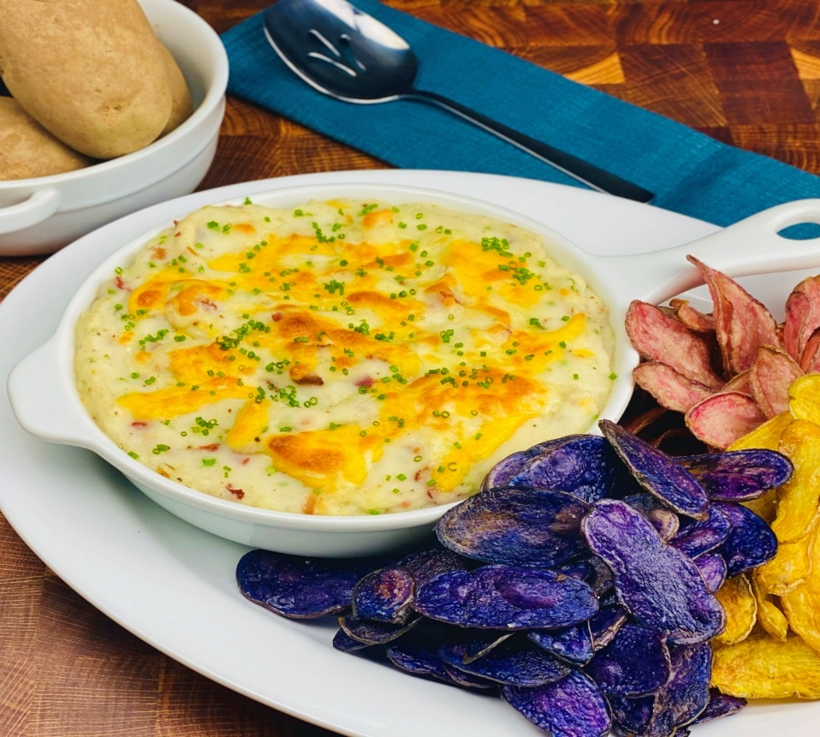
Description: Whipped light and creamy potatoes with smoky bacon, cheddar, sour cream, and chives, baked in the oven and served with crispy sea salt chips.
Servings: 12
Preparation Time: 10 minutes
Cooking Time: 30 minutes
Total Time: 40 minutes
Potato Type: Dehydrated Potato Flakes, Frozen Mashed Potatoes, Fresh Mashed Potatoes, or Refrigerated Mashed Potatoes
Course: Appetizer

Ingredients
Loaded Baked Potato Dip:
- 2.2lbs (1 kg) Prepared Mashed Potatoes (Dehy), *Fresh or Frozen Prepared Mashed Potatoes can be subbed
  - 2-3/4 cups (660ml) Water
  - 4.5 tablespoons (75g) Butter, Unsalted
  - ½ teaspoon (1g) Kosher Salt
  - 1-1/2 cups (360ml) Milk
  - 3 cups (150g) Potato Flakes
- 1/3 cup (90g) Bacon Bits
- 1/3 cup (8g) Chopped Chives (Green Onions can be subbed)
- ¾ cup (120g) Shredded Cheddar Cheese
- ½ cup (120ml) Sour Cream
- 1 teaspoon (2g) Kosher Salt
- 1 teaspoon (1g) Freshly Ground White Pepper
Fingerling Potato Chips:
- 1-1/2 lbs (680g) Fingerling Potatoes, thinly sliced, lengthwise
- As Needed Vegetable Oil for frying
- 1 teaspoon Fine Sea Salt
Preparation
- Preheat the oven to 350 °F (177 °C)
- To make the fingerling potato chips, heat the oil to 350 °F. Thinly slice the potatoes using a knife or a mandolin. Hold the potatoes in water until ready to fry. To fry drain the potatoes and dry them slightly in a salad spinner or just on some paper towels. Fry the potatoes in batches, until they are crisp. About 6-8 minutes. Drain the chips on a tray lined with paper towels and season them with sea salt.
- To make the potato dip, heat the water, butter and salt to boiling in a medium saucepan. Remove from the heat. Stir the milk and the potato flakes into the potatoes with a small whisk or fork until the potatoes are the desired consistency. Mix in the bacon, chives, ½ cup cheese, sour cream, salt and pepper. Transfer the loaded mash into an oven safe dish. Top the potatoes with the remaining ¼ cup of cheese and place in the oven for 8-10 minutes or until the cheese is melted and the potato dip is hot.
- Arrange the chips next to the potato dip and enjoy!
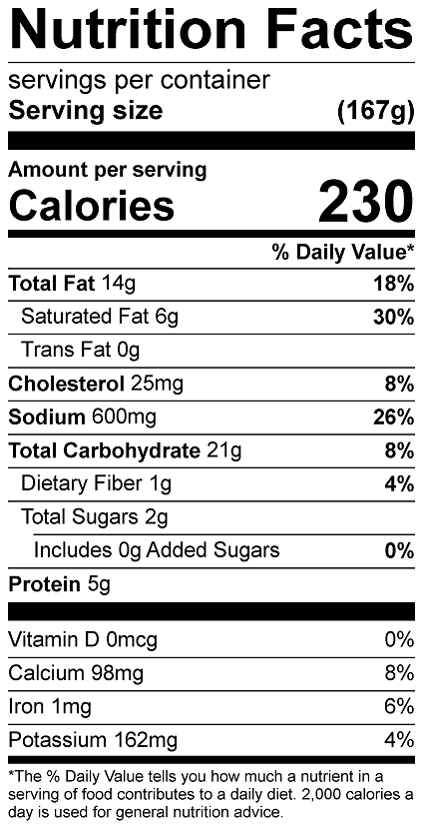

Vitamin C: 20.19mg

