**Green Goddess Potato Salad**

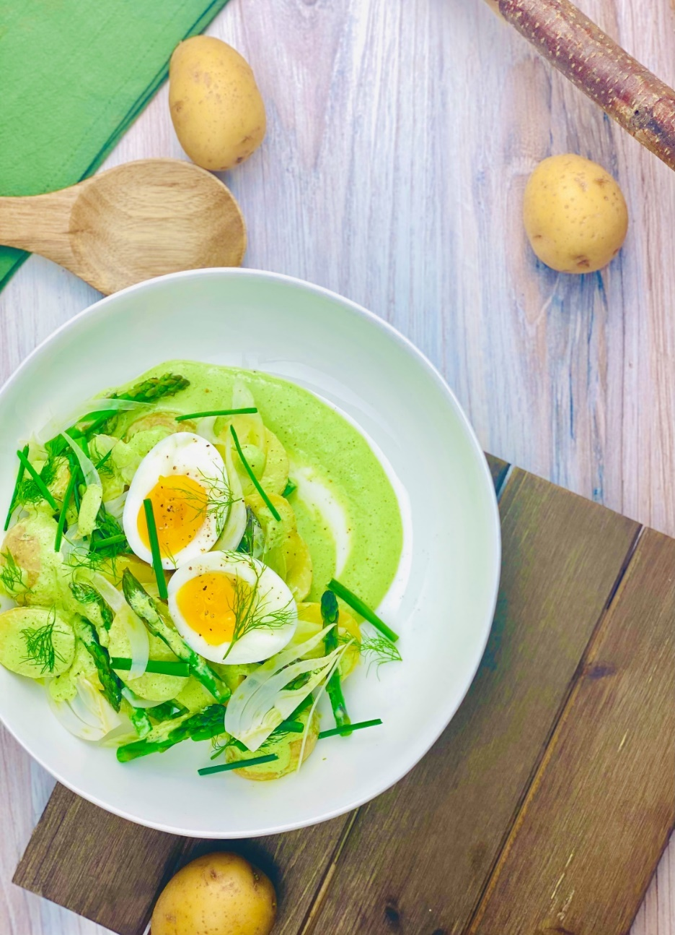

**Description:** Tender potatoes in an herb yogurt dressing with fennel, asparagus, and eggs.

**Servings:** 8

**Preparation Time:** 20 minutes

**Cooking Time:** 25 minutes

**Total Time:** 45 minutes

**Potato Type:** Yellow Potatoes

**Course:** Side Dish, Lunch, Dinner

**Ingredients**

*For the Potato Salad:*

* 2 lbs. (907g) Yellow Potatoes, sliced
* 1-1/2 teaspoons (2g) Kosher Salt
* 1-1/2 cups (75g) Asparagus, cut into 1-inch pieces
* 6 each Large Eggs
* ¾ cup (60g) Fennel, thinly sliced
* ¼ cup (4g) Chives, cut into ½ inch pieces

For the Herb Yogurt Dressing

* 2/3 cup (6g) Fresh Basil, chopped rough
* ½ cup (4g) Fresh Tarragon
* 1/3 cup (4g) Fresh Dill
* 2 each (10g) Garlic Cloves
* 1 tablespoon (15g) Capers
* ½ teaspoon (1g) Kosher Salt
* ¾ cup (180ml) Greek Yogurt
* ¼ cup (60ml) Mayonnaise
* 2 tablespoons (30ml) Cultured Buttermilk
* 2 tablespoons (30ml) Freshly Squeezed Lemon Juice
* 1-1/2 teaspoons (2g) Freshly Ground Black Pepper

**Preparation**

1. To prepare the potato salad, place the potatoes in a large pot and cover them with cold water so the potatoes are submerged. Add the salt and place over high heat. Bring the potatoes to a boil then reduce the heat to a simmer. Cook the potatoes for roughly 15-20 minutes or until they are just fork tender. Add the asparagus and cook for another 2-3 minutes. Drain the potatoes and asparagus and allow to cool completely. While you wait for the potatoes to cool cook the eggs.
2. To cook the eggs, bring a pot of water to a boil and gently add the eggs, set a timer for 11 minutes, when the time goes off remove the eggs from the water and immediately place them into a bowl of ice water. Peel the eggs and slice, set aside until ready to serve.
3. To make the dressing, in a blender combine the basil, tarragon, dill, garlic, capers, salt, yogurt, mayonnaise, buttermilk, lemon juice and pepper. Blend on high until all ingredients are smooth. Keep the dressing chilled until ready to use. This dressing can be made up to 48 hours in advance.
4. To plate up toss the potatoes and asparagus in half of the dressing. Arrange the dressed vegetables on a serving plate and arrange some of the sliced fennel on top of the dressed veggies, lightly drizzle some of the remaining dressing on top, and garnish with the egg slices and fresh chives.

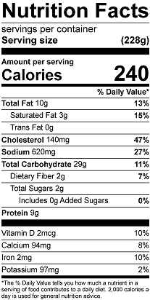

Vitamin C: 26mg