Colcannon
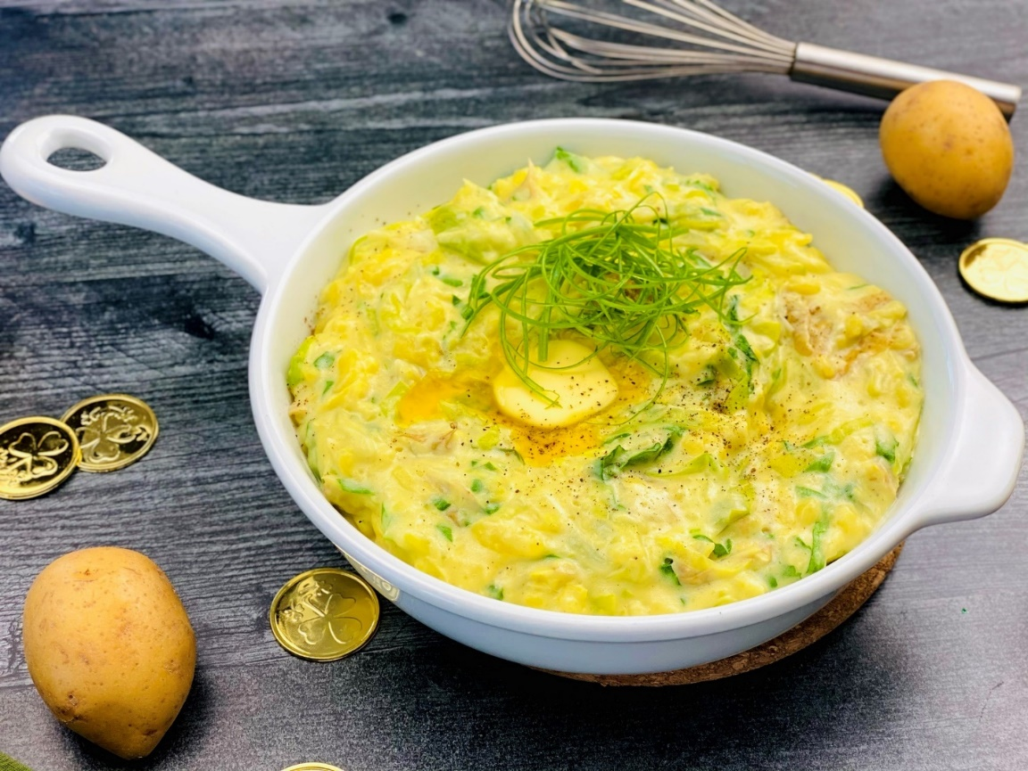
Description: Creamy yellow potatoes are whipped together with butter, cream, garlic, kale, cabbage, and green onions for a delicious and comforting side dish.
Servings: 8
Preparation Time: 15 minutes
Cooking Time: 30 minutes
Total Time: 45 minutes
Potato Type: Yellow Potatoes
Course: Side Dish, Lunch, Dinner

Ingredients
For the Colcannon:
- 2 lbs. (907g) Yellow Potatoes, cut into quarters, unpeeled
- As Needed Cold Water
- 1 tablespoon Kosher Salt
- 2 each (10g) Garlic Cloves
- ¼ cup (60g) Unsalted Butter
- 2 cups (150g) Green Cabbage
- 1 teaspoon (2g) Kosher Salt
- ½ teaspoon (1g) Freshly Ground Black Pepper
- 1/2 cup (120ml) Heavy Cream
- 1 cup (240ml) Cultured Buttermilk
- 1 cup (20g) Green Onions, Sliced
- 2 cups (20g) Baby Kale

Preparation
- In a heavy-bottomed pot, add the potatoes and cover them with enough water so the potatoes are an inch below the waterline. Add the salt and the garlic cloves. Place the pot over high heat and bring to a boil, reduce the heat to a simmer.
- Cook the potatoes for about 25-30 minutes or until they are fork-tender.
- While the potatoes are cooking, in a separate pot, heat the butter over medium-low heat. Add the cabbage and salt then cook it gently in the butter, stirring occasionally until the cabbage is tender and translucent. Add the cream and cook the cabbage for about 5 more minutes until the cream is slightly reduced. Season the cabbage with black pepper.
- Drain the potatoes very well, leaving the garlic in with them.
- Pass the potatoes and garlic through a ricer or food mill, alternatively, the potatoes can be mixed with a stand mixer, hand mixer, potato masher, or even a sturdy whisk.
- Add the buttermilk to the potatoes and stir to combine. Fold in the creamed cabbage, the green onions, and the kale.
- Adjust the seasoning if desired and serve immediately.
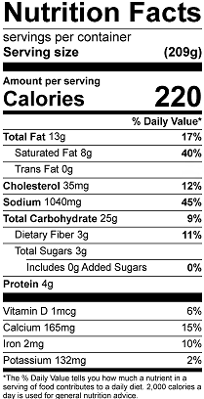
Vitamin C: 18.8mg

