Cast Iron Potato Bread
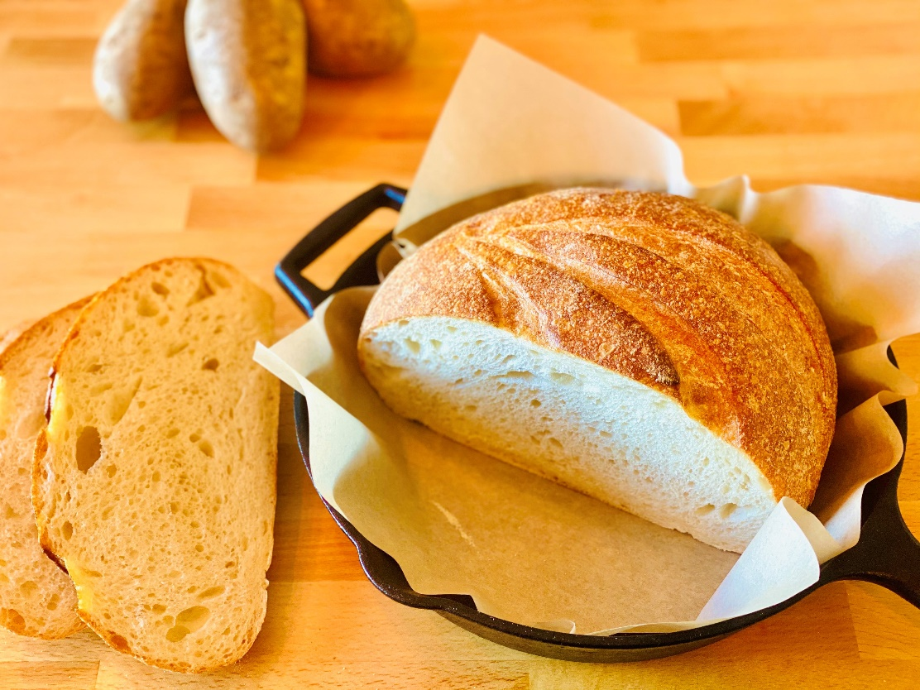
Description: Rustic and rich, this buttery and satisfying bread is made with America’s favorite vegetable, potatoes!
Servings: 8
Preparation Time: 15 minutes
Cooking Time: 55 minutes
Total Time: 70 minutes
Potato Type: Dehydrated Potato Flakes
Course: Bread, Baking

Ingredients
For the Potato Bread:
- 1-1/2 cups (225g) Prepared Mashed Potatoes
- 2 each (110g) Large Eggs
- 1/3 cup (80ml) Vegetable Oil
- ¾ cup (180ml) Whole Milk
- ½ cup (45g) Grated Irish Cheddar (White Cheddar can be subbed)
- ½ teaspoon (1g) Garlic Powder
- 3-1/4 cup (416g) All Purpose Flour
- 1-½ tablespoons (2g) Baking Powder
- 1 teaspoon (1g) Sea Salt
Preparation
- In a large bowl, combine the potatoes, eggs, oil, milk, cheese, and garlic powder.
- In a separate bowl combine the flour, baking powder, and salt.
- Combine the wet and dry ingredients until a dough is formed. Lightly flour the countertop and gently knead the dough.
- Gather the dough into a smooth ball and it into a lightly oiled cast-iron skillet.
- With a sharp knife cut a line down the top of the dough. Place the dough into the oven and bake for 45-55 minutes.
- Remove the bread from the oven and allow it to cool for 10 minutes on a wire rack.
- Allow the bread to cool for about 10 minutes.
- Serve with butter, fruit preserves, honey, whatever you like.

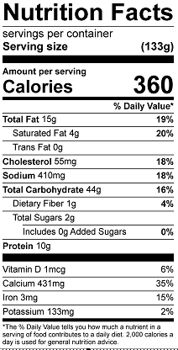
Vitamin C: 2.7mg

