Buffalo Chicken Dip on Potato Half Shells
Description: Creamy buffalo chicken dip served in crispy, oven baked potato half shells with crumbled blue cheese and ranch dressing.
Servings: 12
Preparation Time: 20 minutes
Cooking Time: 30 minutes
Total Time: 50 minutes
Potato Type: Russets
Course : Appetizer, Snack

Ingredients
For the Potato Half Shells:
- 2.2lbs (1 kg) Russet Potatoes, cut in half lengthwise
- As Needed Cold Water
- 1 teaspoon (1g) Kosher Salt
- 1 tablespoon (15 ml) Olive Oil
For the Buffalo Chicken Dip
- 4 cups (1 lb.) Shredded Chicken Breast, cooked, cooled
- 16 ounces (454g) Cream Cheese, softened
- ¾ cup (180ml) Buffalo Wing Sauce
- 1 cup (240 ml) Ranch Dressing
- ½ cup (90g) Blue Cheese Crumbles
Garnish
- ¼ cup Carrots, finely diced
- ¼ cup Celery, finely diced
- ½ cup Ranch Dressing
Preparation
- Preheat a fryer or a pot of oil to 350 °F (177 °C)
- Slice the russets in half lengthwise, immediately place them into a medium-sized pot with water and salt. Bring the pot to a boil over high heat. Cook the potatoes until they are just fork tender. About 15 minutes. Drain the potatoes and allow them to cool slightly.
- Preheat the oven to 400 °F.
- Carefully spoon some of the flesh out of the potatoes and reserve for another use. Drizzle the potato shells with the olive oil on a baking sheet. Bake the potato shells for 15 minutes or until they are golden brown and crispy. Remove from the oven and set aside until ready to use.
- To prepare the buffalo chicken dip, combine the chicken, cream cheese, buffalo wing sauce, and ranch in a medium bowl then stir to combine.
- Sprinkle the tops of the potatoes with the blue cheese and place the half shells in the oven. Bake for about 10 minutes until the buffalo dip is hot and the cheese is melted.
- Remove the half-shells from the oven and arrange them on a serving platter. Garnish the potato shells with the celery and carrots if desired. Then serve the dish with extra ranch or extra buffalo sauce.
- Serve immediately and enjoy.
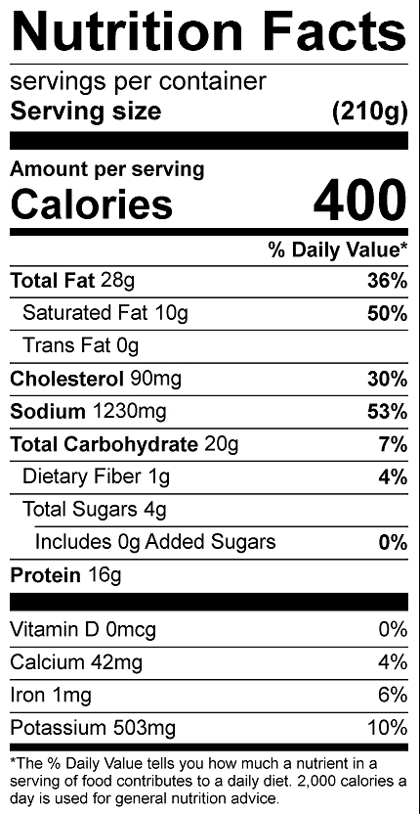

Vitamin C: 4.95mg

