Black Pepper Potato Scones with Whipped Herbed Butter
Description: Flakey savory potato biscuits studded with black pepper and served with whipped sweet cream and herb butter
Servings: 8
Preparation Time: 30 minutes
Cooking Time: 20 minutes
Total Time: 50 minutes
Potato Type: Dehydrated Potato Flakes
Course: Bread, Baking

Ingredients
For the Scones:
- 2 cups (240g) All Purpose Flour
- 2 tablespoons (25g) Granulated Sugar
- 1 teaspoon (1g) Sea Salt
- 2 teaspoons (3g) Baking Powder
- ¼ teaspoon (~1g) Baking Soda
- 1 tablespoon (3g) Freshly Cracked Black Pepper
- 4 ounces (120g) Unsalted Butter, Frozen
- 1/2 cups (75g) Prepared Mashed Potatoes using dehydrated potatoes
- ½ cup (120ml) Cultured Buttermilk
- 1 each (55g) Large Egg
- ¼ cup (60ml) Heavy Cream
- 1 teaspoon (1g) Flakey Sea Salt
For the Herb Butter:
- ½ cup (113g) Unsalted Butter, softened
- ¼ cup (4g) Fresh Tarragon, chopped
- ¼ cup (4g) Fresh Chives, chopped
- ¼ cup (4g) Fresh Parsley, chopped
- 1 teaspoon (~1g) Lemon Zest
- 2 teaspoons (10ml) Freshly Squeezed Lemon Juice
Preparation
- Preheat the oven to 425 °F (218.3 °C).
- In a large bowl whisk together the flour, sugar, salt, baking powder, baking soda, and pepper.
- Grate the frozen butter on the large hole side of a box grater directly into the flour. Mix the butter into the flour mixture with the tips of your fingers until it resembles a coarse meal.
- In a separate bowl mix together the potatoes, buttermilk, and egg. Once combined, gently stir the wet ingredients into the dry ingredients.
- Once a dough is formed gently fold it together, do not over mix.
- On a lightly floured work surface turn the dough out and roll to about a 1-1/2-inch thickness. Cut the scones into triangles and arrange them on a nonstick baking sheet. Refrigerate the scones for about 20 minutes. Brush the tops of the scones with the heavy cream and sprinkle them with the flakey salt.
- Bake the scones for about 20 minutes or until they are golden brown. Allow the scones to cool for about 10 minutes before enjoying.
- While the scones are cooling, mix the softened butter, tarragon, chives, parsley, lemon zest, and lemon juice.
- Serve the scones with the herb butter and enjoy.

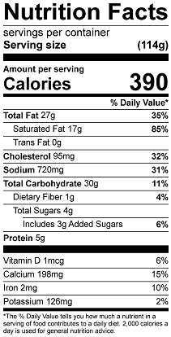
Vitamin C: 5.3mg

