Build Your Own Super Tater Bowl Station
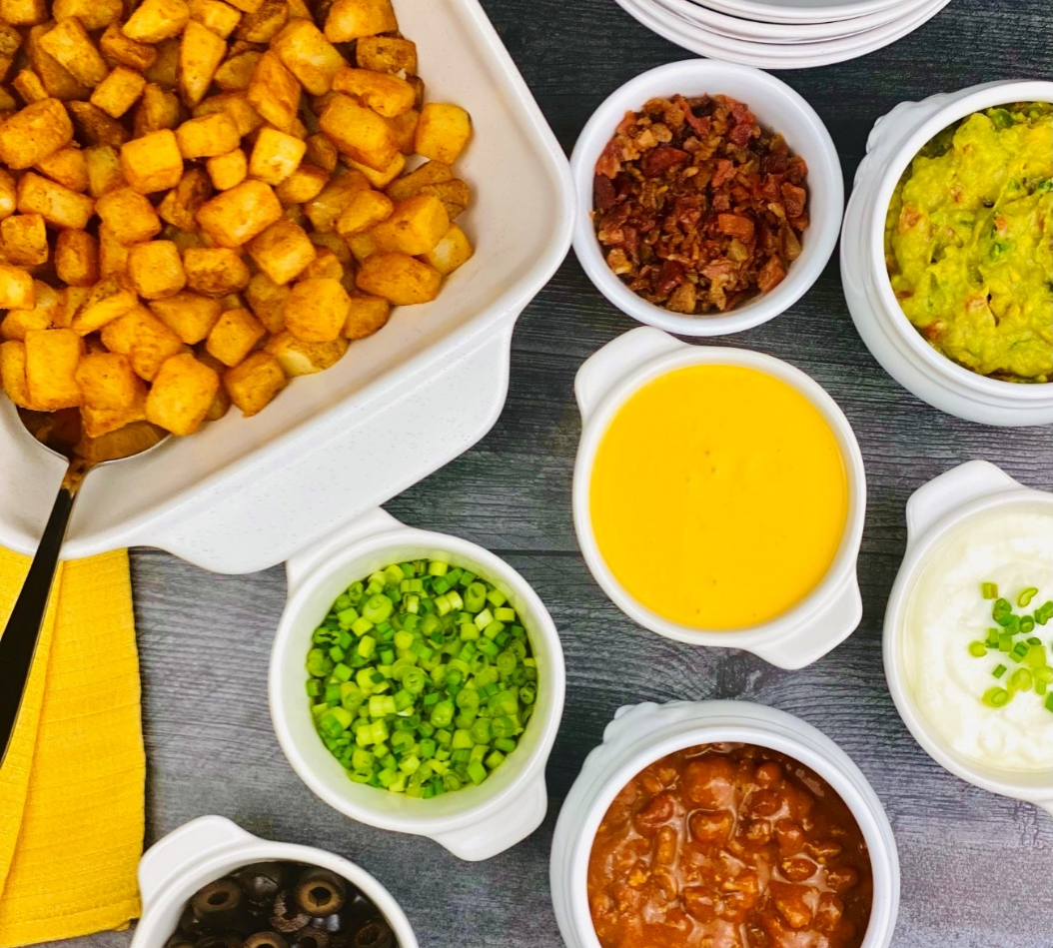
Description: Crispy oven baked diced potatoes, served with an assortment of toppings.
Servings: 12
Preparation Time: 15 minutes
Cooking Time: 30 minutes
Total Time: 45 minutes
Potato Type: Frozen Diced Potatoes
Course: Entree

Ingredients
- 2.2lbs (1 kg) Frozen Diced Potatoes
- 2/3 cup (180g) Bacon Bits
- 2/3 cup (180g) Sliced Black Olives
- 6 cups (1.4 kg) Prepared Chili
- 1 cup (240ml) Sour Cream
- 1 cup (240 ml) Prepared Queso Dip
- 1 cup (40g) Green Onions, sliced
- 1 cup (240 ml) Prepared Guacamole
Preparation
- Preheat the oven to 400 °F (204 °C)
- Place frozen diced potatoes on a baking sheet lined with aluminum foil and bake for 25-30 minutes or until golden and crisp.
- Assemble all the ingredients in separate bowls, heating the ingredients that require heating such as the queso and chili.
- When the potatoes are crispy and hot, transfer them to a serving dish. Portion the potatoes in the bottom of a bowl and top them with whatever toppings you so choose.
- Serve immediately and enjoy.
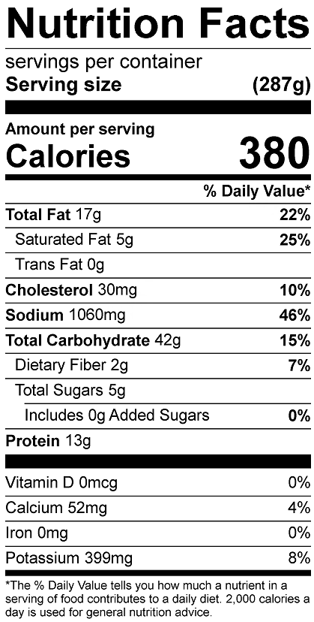
Vitamin C: 11.64mg

