Oven Crisped Potatoes with Grilled Brussels Sprouts, Oranges, Chilies and Smoked Paprika Honey
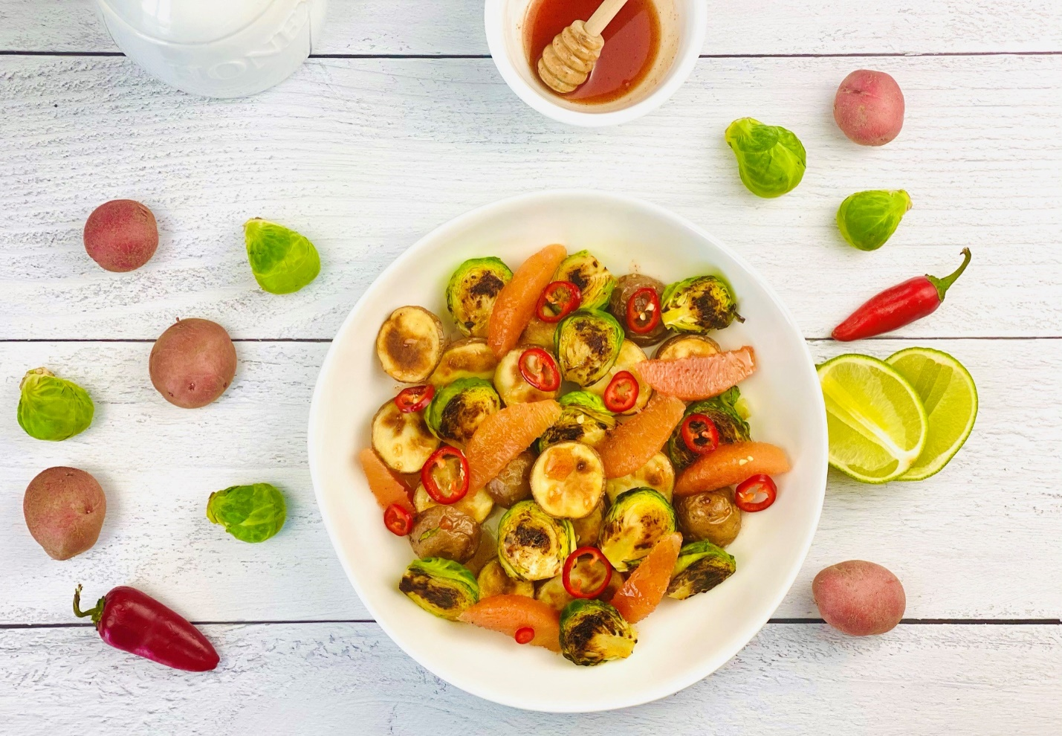
Description: Baby red potatoes tossed with grilled brussels sprouts and orange segments, then drizzled with a smoky paprika honey.
Servings: 8
Preparation Time: 20 minutes
Cooking Time: 30 minutes
Total Time: 50 minutes
Potato Type: Red Potatoes
Course: Appetizer, Side Dish

Ingredients
For the Roasted Potatoes:
- 2.2 pounds (1 kg) Petite Red Potatoes, cut in half
- As Needed Olive Oil Spray
- 1 tablespoon (4g) Sea Salt

For the Grilled Brussel Sprouts:
- 4 cups (480g) Brussel Sprouts, trimmed and cut in half
- As Needed Olive Oil Spray
- 1/2 tablespoon (2g) Sea Salt
- 1 teaspoon (1g) Freshly Ground Black Pepper

Smoked Paprika Honey:
- ½ cup (120ml) Honey
- 1-1/2 ounces (45ml) Fresh Lime Juice
- 1 tablespoon (4g) Smoked Paprika
To Plate:
- ¼ cup (30g) Fresno Chilies, sliced
- 2 cups (280g) Fresh Orange Segments (Cara Cara, Navel, Satsuma, etc.)

Preparation
- To roast the potatoes, preheat the oven to 400 F (204 C). Place the potatoes on a non-stick baking sheet or a regular baking sheet lined with aluminum foil. Spray the potatoes with the olive oil spray until lightly coated. Season the potatoes with the sea salt and cook the potatoes in the oven for 25-30 minutes or until they are golden and crispy. Remove from the oven and keep warm.
- To prepare the brussels sprouts, heat a cast iron skillet over high heat. In a large bowl add the brussels sprouts and spray with the olive oil spray until lightly coated. Place the brussels sprouts flat side down in the hot cast iron. Allow them to char for about 1-2 minutes then flip them to the round side. Turn the heat off, season the brussels sprouts in the pan and stir until well mixed. Remove the brussels sprouts from the pan and set aside until ready to use.
- To make the smoked paprika honey, combine the honey with the lime juice and paprika, set aside until ready to use.
- To finish the dish, combine the warm crispy potatoes with the charred brussels sprouts, and arrange them on a serving platter.
- Arrange some of the orange segments and chilies around the roasted and charred vegetables.
- Spoon some of the smoked paprika honey over the dish.
- Serve right away and enjoy!
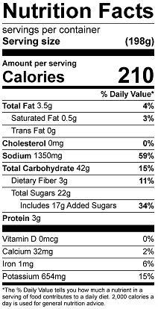
Vitamin C: 31.34mg

