Olive Oil and Yogurt Whipped Potatoes with Sunflower Seed Dukkah
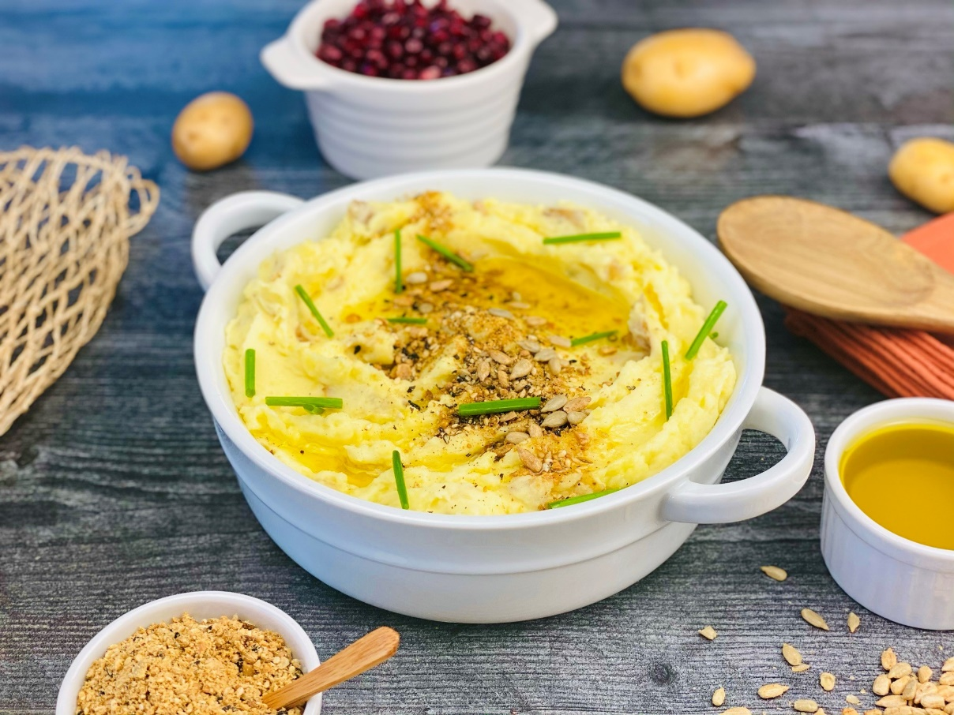
Description: Creamy and smooth mashed potatoes blended with Greek yogurt and olive oil before being topped with a fragrant and crunchy topping of Egyptian dukkah, a spice mix made with sesame and sunflower seeds.
Servings: 12
Preparation Time: 20 minutes
Cooking Time: 30 minutes
Total Time: 50 minutes
Potato Type: Yellow, Russet, White, or Red Potatoes
Course: Side Dish

Ingredients
For the Potatoes:
- 2.2 pounds (1kg) Potatoes (Russets, Reds, Yellows, or Whites), cut into 2-inch pieces
- As Needed Cold Water
- 1 tablespoon Kosher Salt
- 1-1/2 cups (360 ml) Plain Greek Yogurt
- ¼ cup (60 ml) Extra Virgin Olive Oil
- 2 teaspoons Kosher Salt
- 1-1/2 teaspoons Ground White Pepper

For the Sunflower Seed Dukkah:
- ½ cup (120g) Sunflower Seeds
- ¼ cup (60g) Sesame Seeds
- 2 tablespoons (25g) Coriander Seeds
- ½ tablespoon (3g) Cumin Seeds
- 1 tablespoon (2g) Fennel Seeds
- 1 teaspoon (1g) Smoked Paprika
- 1 teaspoon (1g) Fine Sea Salt
- 2 teaspoons (2g) Freshly Ground Black Pepper
- 2 tablespoons (4g) Black Sesame Seeds (optional)
To Plate:
- 2 tablespoons Extra Virgin Olive Oil
- 2 tablespoons Fresh Chives, cut 1-inch pieces

Preparation
- Wash and scrub the potatoes with a vegetable brush. Cut the potatoes into 2-inch pieces and place into a large pot, cover the potatoes with cold water and a tablespoon of kosher salt. Place the pot on the stove and turn the heat to high. Once the potatoes come to a boil, reduce the heat to a simmer. Cook the potatoes until they are fork tender but not falling apart (about 20-25 minutes). Remove from the heat and drain the potatoes. Return the potatoes back to the stove for about 30 seconds, just to ensure all the water is removed from the pan and the potatoes are dry.
- Remove the potatoes from the heat and add in the Greek yogurt and the olive oil. Mash the potatoes using a potato masher or a sturdy wire whisk. DO not over mix the potatoes or they can become gluey. Adjust the seasoning with the salt and white pepper. Hold the potatoes hot until ready to use.
- To make the dukkah. Toast sunflower seeds over medium heat in a dry pan. Once the seeds become fragrant (1-2 minutes) remove them from the heat and place into a bowl. Next toast the sesame seeds and whole spices.
- Place the remaining ingredients for the dukkah into a blender or food processor along with the toasted spices, seeds, and nuts. Pulse the dukkah until it resembles coarse meal. It should not be a fine powder. Transfer the dukkah to a baking sheet or large plate and allow to cool.
- The dukkah is now ready to use. Store the dukkah in an airtight container for 2-3 weeks, or place in the freezer for 2-3 months.
- To serve, spoon some of the warm mashed potatoes into a serving dish and drizzle the top with some extra virgin olive oil, followed by some of the sunflower seed dukkah, and chives.
- Serve along roasted meats, grilled fish, or roasted veggies.
- Enjoy!
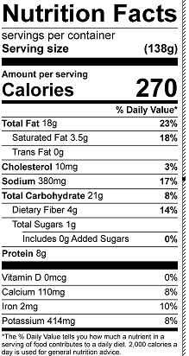
Vitamin C: 6.9mg

