Moroccan Potatoes with Roasted Cauliflower, Coriander and Harissa
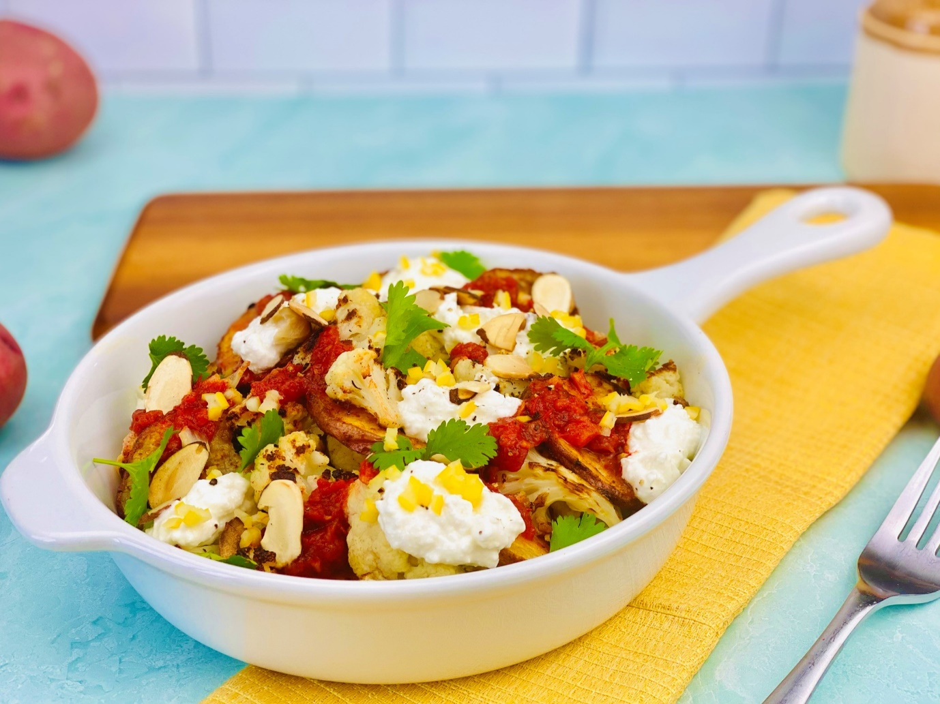
Description: Thick sliced oven-baked potato chips with roasted cauliflower, toasted almonds, farmer’s style cheese, preserved lemons and north African chili sauce.
Servings: 8
Preparation Time: 30 minutes
Cooking Time: 20 minutes
Total Time: 50 minutes
Potato Type: Red Potatoes
Course: Appetizer, Side Dish, Entrée, Lunch, Dinner

Ingredients
For the Potatoes:
- 2.2 pounds (1kg) Red Potatoes, washed, sliced into ¼ inch thick slices
- As Needed Olive Oil Spray
- 1-1/2 tablespoons (7g) Ras El Hanout Spiced (Smoked Paprika can be subbed if desired)
- 2 teaspoons (3g) Sea Salt
For the Cauliflower:
- 3 cups (450g) Cauliflower Florets
- 5 cups (1200ml) Cold Water
- 3 each (15g) Garlic Cloves, peeled and lightly crushed
- 2 teaspoons (4g) Crushed Red Chili Flakes
- As Needed Spray Olive Oil
To Plate:
- ½ cup (120ml) Harissa (North African Chili Paste) *Chili Garlic sauce can be subbed
- ¾ cup (180ml) Jben (North African Farmers Cheese) *Ricotta can be subbed
- 2 tablespoons (8g) Prepared Preserved Lemons, diced small (Optional)
- ½ cup (75g) Sliced Almonds, toasted
- ¼ cup (2g) Cilantro Leaves, torn

Preparation
- To make the Moroccan spiced potatoes, preheat the oven to 400 F (204 C). Arrange the red potato slices on a non stick baking sheet or a regular baking sheet lined with aluminum foil. Spray the potatoes with the olive oil spray. Season the potatoes generously with the ras el hanout spice and the sea salt.
- Bake the potatoes for 20-25 minutes or until they are crisp and golden. Remove the potatoes from the oven and keep warm.
- Turn the oven to broil while you prepare the cauliflower.
- Cover the cauliflower with the water in a large pot, the water should cover the cauliflower, if it doesn’t just add some water until the cauliflower is covered. Add the garlic, and chili flakes. On high heat, bring the water to a boil and reduce to a simmer. Cook the cauliflower for 8-10 minutes or until the florets are just fork tender. Drain the cauliflower very well and place onto a baking sheet. Spray the cauliflower with the olive oil, and place the cauliflower under the broiler for 3-5 minutes or until the cauliflower has a nice, toasted side. Flip the cauliflower and return it under the broiler for 2-3 minutes. Remove the cauliflower and allow it to cool slightly before plating.
- To plate arrange a bed of the potatoes and place some of the charred cauliflower throughout the dish. Spoon a little harissa on the potatoes and cauliflower, followed by a few dollops of the jben/ricotta cheese. Lastly garnish the dish with the preserved lemons if using, the toasted almonds, and the cilantro.
- Serve right away and enjoy!
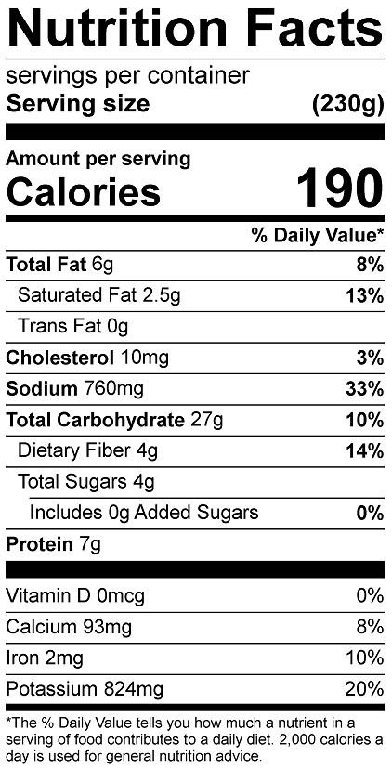
Vitamin C: 40.2mg

