Lemon Poached Potatoes with Asparagus, Artichokes, and Olives
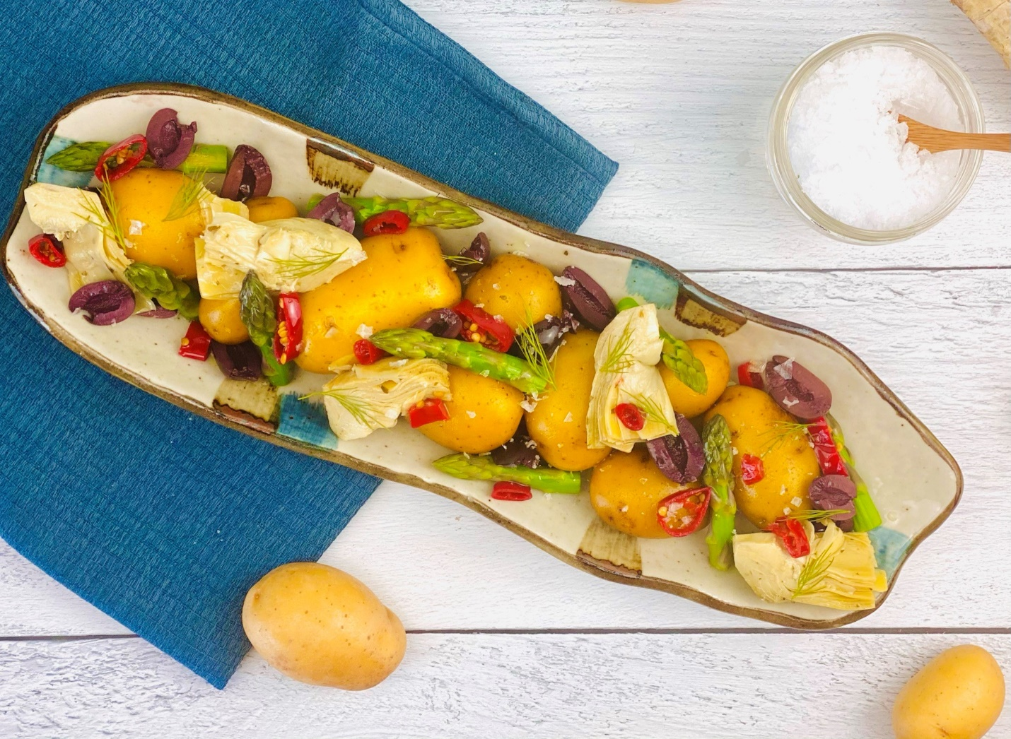
Description: Whole baby yellow potatoes poached in a flavorful lemon and turmeric broth, with chilies, artichoke hearts, Asparagus and Olives.
Servings: 8
Preparation Time: 15 minutes
Cooking Time: 20 minutes
Total Time: 35 minutes
Potato Type: Yellow Potatoes
Course: Appetizer, Side Dish, Entrée, Lunch

Ingredients
For the Potatoes:
- 2.2 pounds (1kg) Small Yellow Potatoes
- 1-1/2 tablespoons (7g) Turmeric
- 1/3 cup (80ml) Freshly Squeezed Lemon Juice
- 5 each (25g) Garlic Cloves
- 2 teaspoons (3g) Sea Salt

Lemon and Olive Oil Vinaigrette
- 2 tablespoons (30ml) Lemon Juice
- 1 tablespoon (15ml) White Wine Vinegar
- 2 teaspoons (10ml) Dijon Mustard
- 1 teaspoon (1g) Fresh Dill, chopped
- ¼ cup (60ml) Extra Virgin Olive Oil
- As Needed Sea Salt
- As Needed Freshly Ground Black Pepper
For the Asparagus:
- 2 cups (300g) Asparagus, cut into 1 inch pieces
- 5 cups (1200ml) Cold Water
- 1 tablespoon (4g) Sea Salt
To Plate:
- ½ cup (120g) Artichoke Hearts, canned, drained
- ½ cup (120g) Pitted Kalamata Olives, sliced in half lengthwise
- ¼ cup (60g) Calabrian Chilies (Optional)

Preparation
- To make the lemon poached potatoes, place the potatoes, into a large pot, cover the potatoes with enough water to cover them. Add the turmeric, lemon juice, garlic cloves and sea salt. Place the pot on the stove and over high heat bring the pot to a boil, reduce the heat to a simmer and cook the potatoes for 20-25 minutes or until the potatoes are fork tender.
- Drain the potatoes and keep slightly warm.
- To make the vinaigrette in a medium bowl, combine the lemon juice, vinegar, mustard and dill. Whisking constantly, slowly drizzle in the oil, once the mixture is slightly thickened and all the oil has been incorporated, adjust the seasoning with the salt and pepper.
- Take some of the vinaigrette (about half) and drizzle it over the warm potatoes, gently toss the potatoes to ensure the vinaigrette is coating the potatoes nicely. Keep the potatoes in a warm area until ready to use.
- To prepare the asparagus, bring a medium sized pot of water to a boil. While the water is boiling prepare a medium sized bowl with ice water. Add the salt and the asparagus to the boiling water. Allow the asparagus to boil for 45 seconds to 1 minute. Remove the asparagus from the boiling water and immediately place the asparagus into the ice water. After the asparagus cools down drain them and set aside.
- To plate up, arrange the potatoes on a serving plate or dish. Place some of the asparagus, artichoke hearts and olives around and on the potatoes. Garnish the top with some sliced Calabrian chilies, and spoon some of the reserved vinaigrette on top.
- Serve right away and enjoy!
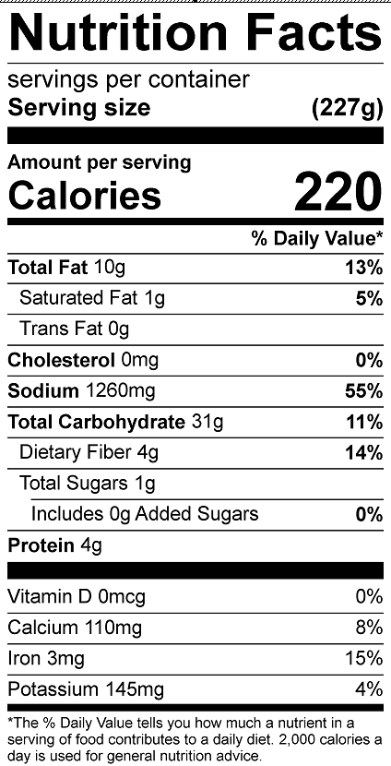
Vitamin C: 25.2

