Dashi Poached Potatoes with Blistered Shishito Peppers and Sesame Miso Vinaigrette
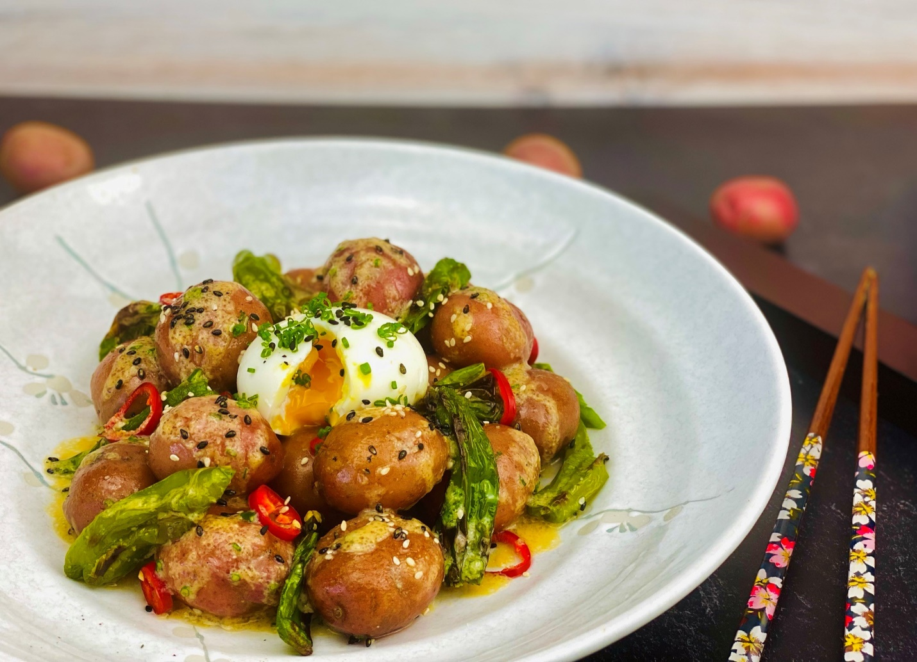
Description: Tender potatoes poached in a flavorful dashi broth, served with charred shishito peppers, a soft-boiled egg and sesame-miso vinaigrette.
Servings: 8
Preparation Time: 15 minutes
Cooking Time: 45 minutes
Total Time: 60 minutes
Potato Type: Red Potatoes
Course: Appetizer, Side Dish, Entrée, Breakfast

Ingredients
For the Kombu Dashi (optional):
- 1-ounce (30g) Kombu (Dried Kelp)
- 1 ounce (30g) Dried Shiitake Mushrooms
- 6 cups (1000ml) Cold Water

For the Potatoes:
- 6 cups (1500ml) Prepared Dashi Broth
- 1 inch (20g) Fresh Ginger Root
- 2 each (10g) Fresh Garlic Cloves
- 2 tablespoons (30ml) Soy Sauce (Tamari can also be subbed)
- 1-1/2 pounds (679g) Small Red Potatoes
For the Shishito Peppers:
- 1-pound (454g) Shishito Peppers
- ½ tablespoon (15ml) Vegetable Oil

For the Soft-Boiled Egg:
- 4 each Large Eggs, allow to come to room temp

Sesame Miso Vinaigrette:
- 1 each (5g) Fresno Chili, finely chopped
- ¼ cup (60ml) Vegetable Oil
- 2 tablespoons (30ml) Fresh Lime Juice
- 2 tablespoons (30ml) Shiro Miso
- 1 tablespoon (15ml) Lite Soy Sauce
- 1 tablespoon (15ml) Unseasoned Rice Vinegar
- 1 teaspoon (5ml) Toasted Sesame Oil
- 1 teaspoon (1g) Toasted Sesame Seeds
- ½ teaspoon (1g) Freshly Grated Ginger
To Plate:
- ¼ cup (30g) Fresno Chilies, sliced
- 2 tablespoons Fresh Chives, chopped
- 1 tablespoon Black Sesame Seeds

Preparation
- To make the dashi, cut the kombu into pieces that will fit in the pot. Add the kombu and the shiitakes to the pot and cover them with the cold water. Place on the heat over medium flame. Allow the dashi to come up to 170 F (76.7 C), steep the kombu for 15 minutes at this temperature, do not boil the dashi, think of it more as steeping tea. Strain the kombu and the mushrooms from the dashi, reserve them for another use. To get very clear dashi, strain the dashi through a coffee filter. Reserve the dashi for step 2.
- In a pot large enough to fit the potatoes, cover the potatoes with the dashi stock. Add the ginger, garlic, and soy sauce (or tamari). Gently poach the potatoes for 45 minutes or until they are fork tender. The temperature of the dashi shouldn’t exceed 180 F (82.2 C). The potatoes can be held in the hot dashi while the other ingredients are being made. Cooking times will vary depending on the size of the potatoes. Discard the ginger and garlic.
- For the shishito peppers, place them on a baking sheet. Drizzle the peppers with the oil, and place under the broiler for about 2-3 minutes. Flip the peppers over and broil for an additional 2-3 minutes. Remove from the oven and keep warm.
- To make the soft-boiled egg, bring a pot of water to a boil over high heat. Gently place the eggs in the water and set a timer for 6 minutes and 30 seconds.
- Remove the eggs from the water and immediately place into enough ice water to cover them. This will stop the eggs from cooking any longer.
- To prepare the vinaigrette; whisk all the ingredients together for the vinaigrette in a small both. This vinaigrette can be made up to a week before.
- To Plate: Place the potatoes and shishito peppers into a bowl and drizzle them with some of the vinaigrette. Give them a good toss and arrange them in the center of a serving dish. Top the potatoes and peppers with one of the peeled soft-boiled eggs. Arrange some of the fresno chilies around the plate. Sprinkle the eggs with the chives and black sesame seeds. Spoon a little more vinaigrette over the warm potatoes if desired.
- Serve right away and enjoy!
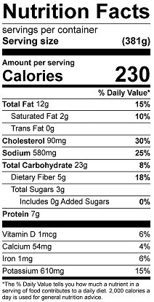
Vitamin C: 56mg

