Crispy Potato Wedges with Spanish Style Picadillo
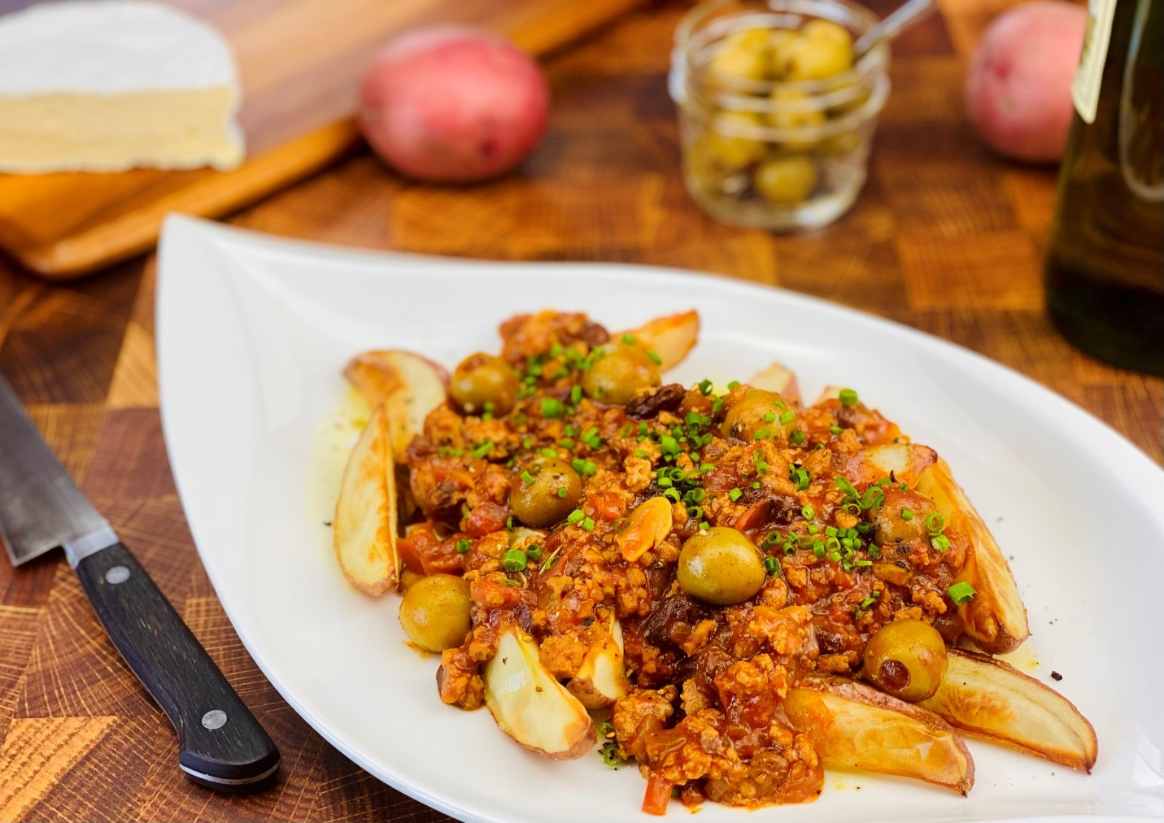
Description: A sauce of ground Turkey, Smoked Paprika, Tomatoes, Olives and Garlic, cooked down with Olive Oil and served over a bed of crispy oven-roasted potato wedges.
Servings: 8
Preparation Time: 10 minutes
Cooking Time: 30 minutes
Total Time: 40 minutes
Potato Type: Red Potatoes
Course: Appetizer, Side Dish, Entrée, Lunch, Dinner

Ingredients
For the Potatoes:
- 2.2 pounds (1kg) Red Potatoes cut into wedges
- As Needed Olive Oil Spray
- 1-1/2 teaspoons (2g) Sea Salt

For the Picadillo:
- 1 tablespoon Olive Oil
- 1 pound (453.6g) Lean Ground Turkey
- 1 cup (150g) Yellow Onions, chopped
- 3 cloves (15g) Garlic, sliced thin
- 10 ounces (300ml) Tomato Puree
- 3 tablespoons (15g) Smoked Paprika
- 2 cups (480ml) Chicken Stock
- ½ tablespoon (5g) Ground Cumin
- 1 teaspoon (3g) Ground Coriander
- ½ teaspoon (1g) Ground Cinnamon
- ¼ cup (60g) Raisins
- ½ cup (80g) Spanish Olives, sliced
- 1 teaspoon (4g) Sea Salt
- ½ teaspoon (2g) Cayenne Pepper
- 1 teaspoon (3g) Ground Black Pepper
To Plate:
- ¼ cup (13g) Chives, chopped fine

Preparation
- Preheat the oven to 400 F (204 C).
- Place the potato wedges on a baking sheet and spray the potatoes with the olive oil spray. Season the potatoes with the salt and roast them in the oven for 20-25 minutes or until the potatoes are golden and crisp. Remove from the oven and keep warm until ready to use.
- While the potatoes are cooking, prepare the picadillo. Start by heating the olive oil and browning the turkey in a large heavy bottomed pot, such as an enamel dutch oven over medium high heat.
- When the turkey is brown reduce the heat to medium and add the yellow onions, and garlic. Stirring regularly cook the mixture until the onions are translucent, be careful not to brown the onions.
- Add the tomato puree and the smoked paprika. Cook this until the tomato sauce reduces by half (about 10 minutes). Add the chicken stock, cumin, coriander, cinnamon, and raisins. Allow the picadillo to simmer for about 15 minutes. Add the olives, salt, cayenne, and black pepper. Allow the mixture to simmer for another 5 minutes.
- To serve, arrange the crispy potato wedges on a plate or a platter, and then spoon some of the picadillo on top. Garnish with chopped chives.
- Serve right away and enjoy!
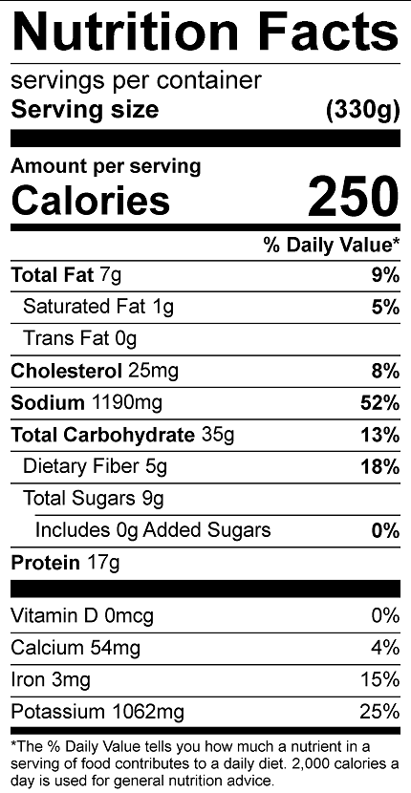
Vitamin C: 18.5mg

