Sweet and Sour Chicken and Waffle Fries
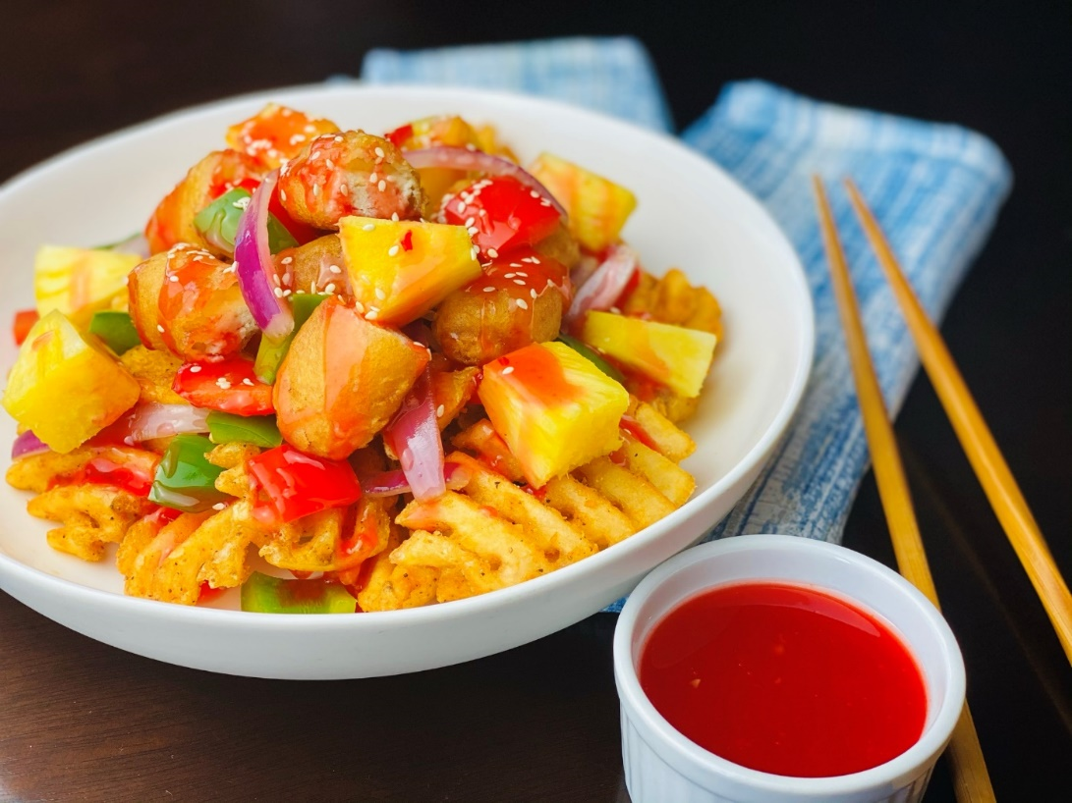
Description: Crispy chicken in a sweet and sour sauce with ripe pineapples, peppers and red onions, all served on a bed of crunchy waffle fries.
Servings: 12
Preparation Time: 15 minutes
Cooking Time: 20 minutes
Total Time: 35 minutes
Potato Type: Frozen waffle fries
Course: Entrée, Shareable Appetizer

Ingredients
For the Sweet and Sour Chicken:
- 2.2 lbs. (1kg) Breaded Frozen Popcorn Chicken
- 1 tablespoon (15ml) Sesame Oil
- 2 cups (300g) Red Bell Pepper, diced ½ inch pieces
- 1 cup (150g) Green Bell Pepper, diced ½ inch pieces
- 1 cup (150g) Red Onions, sliced into ¼ inch strips
- 2 cups (300g) Diced Pineapple
- ¾ cup (180ml) Sweet and Sour Sauce (prepared)For the Waffle Fries
- As Needed Vegetable Oil for Frying
- 2.2 lbs. (1 kg) Frozen Waffle Fries
- 1 tablespoon Sea Salt
To Plate:
- 1 tablespoon (2g) White Sesame Seeds

Preparation
- Preheat a fryer to 350 °F (176 °C), fry the popcorn chicken for 7-8 minutes or until the internal temp is 165 F (74 °C) and golden. Drain the chicken pieces and keep warm.
- To stir fry the vegetables, heat the sesame oil in a large sauté pan or a wok over high heat. Add the peppers and onions and stir constantly for about 3-5 minutes or until the vegetables are just tender. Stir in the pineapple and keep warm.
- Heat the sweet and sour sauce and keep warm.
- To fry the waffle fries, fry the fries in the vegetable oil preheated to 375 °F (190 °C) for 4-6 minutes or until they are golden brown and crispy. Drain the fries and place them into a large bowl. Season them with the salt and toss to combine. Arrange the fries in a serving bowl or on a platter.
- Top the fries with the stir-fried vegetables and pineapple, and the crispy pieces of chicken. Ladle the sweet and sour sauce over the chicken and vegetables and garnish with the sesame seeds. Serve immediately. Enjoy!
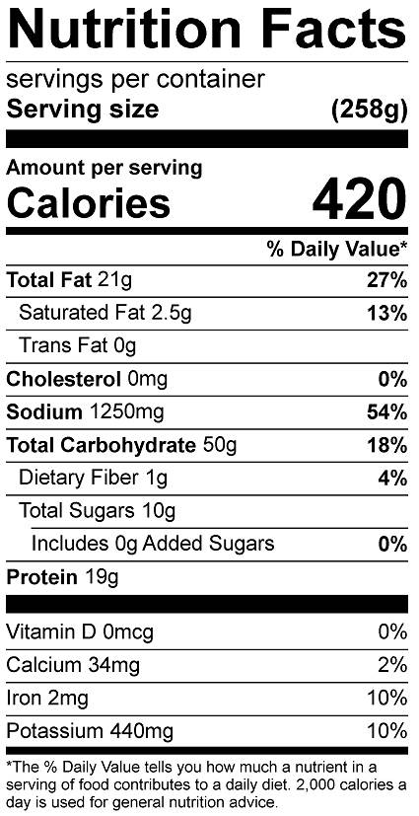
Vitamin C: 58 mg

