Surf’s Up! Baja Shrimp Loaded Fries
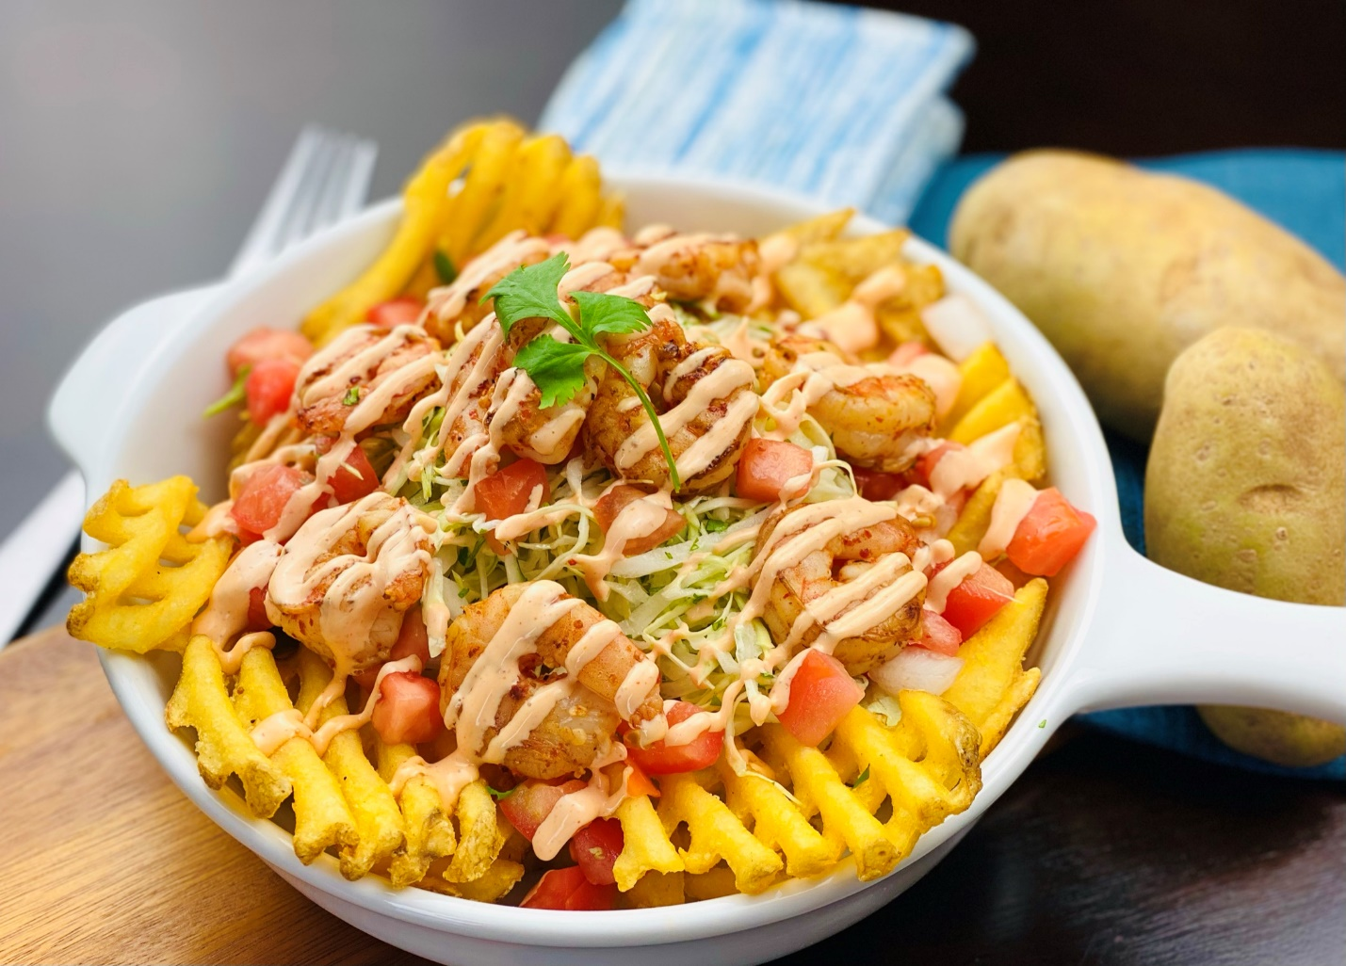
Description: Crunchy golden waffle fries, topped with fresh salsa, chili lime marinated shrimp, shredded cabbage slaw, and spicy mayo.
Servings: 12
Preparation Time: 15 minutes
Cooking Time: 15 minutes
Total Time: 30 minutes
Potato Type: Frozen waffle fries
Course: Entrée, Appetizer

Ingredients
Pico de Gallo (fresh Salsa)
- 2 cups (300g) Tomatoes, diced ¼ inch
- 1 cup (150g) White Onions, diced ¼ inch
- ¼ cup (37.5g) Jalapeno, finely chopped
- ½ cup (7g) Cilantro, chopped
- 2 tablespoons (30ml) Olive Oil
- 1 teaspoon (1g) Sea Salt
- 1 teaspoon (1g) Freshly Ground Black Pepper

Chili Lime Shrimp
- 2 lbs. (907g) Shrimp, peeled and deveined
- 1 tablespoon (10g) Chili Lime Seasoning
- 2 tablespoons (30ml) Olive Oil

Spicy Mayo
- 1 cup (240ml) Mayonnaise
- 1/4 cup (60ml) Hot Sauce

Cabbage Slaw
- 3 cups (450g) Green Cabbage, thinly shredded
- 1/4 cup (60ml) Olive Oil
- ¼ cup (4g) Chopped Parsley
- ½ tablespoon (3g) Sea Salt
- 1 teaspoon (1g) Freshly Ground Black Pepper

Fries
- 2.2 lbs. (1kg) Frozen Waffle Fries
- As Needed Peanut Oil (any neutral oil can be subbed)

Preparation
- To make the Pico de Gallo (fresh salsa), simply combine the tomatoes, onions, jalapenos, cilantro, olive oil, salt, and pepper in a medium sized bowl and stir until it is just combined. Set aside until ready to use.
- In a large bowl toss the prepared shrimp in the chili lime seasoning along with the olive oil. Set aside in the refrigerator for about an hour.
- To make the spicy mayo, in a squeeze bottle combine the mayo and the hot sauce and shake until combined.
- To make the cabbage slaw, combine the cabbage, olive oil, parsley, sea salt, and black pepper in a large bowl and stir until combined. Make sure this is done close to the point in which you intend to serve the fries.
- To assemble and plate the fries, preheat a fryer to 375 °F (190 °C). Fry the fries for 4-6 minutes or until they are golden brown and crispy. Remove from the hot oil, and place into a large bowl, season the fries with salt and pepper. Meanwhile sauté the shrimp in a large sauté pan over medium high heat. The shrimp will turn pink and opaque when fully cooked and should have some slight char on the outside.
- To plate up, arrange a layer of the crispy waffle fries, followed by the cabbage slaw, then the fresh tomato salsa, then the sauteed chili lime shrimp, and lastly a drizzle of the spicy mayo. Enjoy!
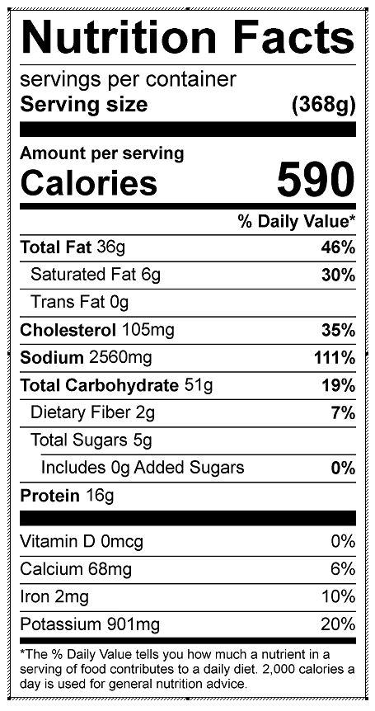
Vitamin C: 37.77 mg

