Steakhouse Hasselback Potato
Description: Completely over the top, but decadent and transcendent. This loaded hasselback potato has caramelized onions, smoky bacon, melted cheddar jack, crème fraiche, and fresh chives. A steakhouse potato that is fantastic with or without a steak.
Servings: 8
Preparation Time: 20 minutes
Cooking Time: 90 minutes
Total Time: 110 minutes
Potato Type: Russets
Course: Entrée, Side Dish, Lunch, Dinner

Ingredients
For the Hasselback Potatoes:
- 4 each 40 ct. Russets (About 1 pound each or 460g)
- 4 tablespoons (60 ml) Olive Oil
- 2 tablespoons (4g) Kosher Salt
For the Caramelized Onions:
- 2.2 lbs. (1 kg) Yellow Onions, sliced thin
- 2 tablespoons (30g) Unsalted Butter
- 2 teaspoon (2g) Kosher Salt
- ¼ cup Cognac or Brandy (optional)
To Plate:
- 1 cup (113g) Shredded Cheddar Jack Cheese
- 12 ounces (360g) Hickory Smoked Bacon, cooked and cut into 2-inch pieces
- ½ cup (120ml) Crème Fraiche or Sour Cream
- 2 tablespoons (1g) Fresh Chives, chopped

Preparation
- Preheat the oven to 400 °F (204 °C)
- To prepare the russet, first wash and scrub the potato with a vegetable brush. Dry the russets very well and place on a cutting board. Take two wooden spoons and arrange the handles of the spoons so they are along the sides of one of the potatoes, this will prevent the knife from slicing all the way through the potatoes. Make several cuts down the potato about ¼ inch (6.35 mm) apart. Repeat this with all the potatoes. Once the potatoes are sliced arrange them on a baking sheet fitted with a wire rack.
- Drizzle each potato with ½ tablespoon (8 ml) of olive oil, making sure to get some of the oil in the slices you made. Then sprinkle ½ teaspoon of salt on each potato.
- Place the potatoes in the oven for 90 minutes or until the potatoes are crispy on the outside and fluffy in the center, a great way to ensure they are done is to use an instant read thermometer making sure the internal temperature is at 205 °F. Remove from the oven and allow to cool slightly.
- While the potatoes are baking, it’s a great time to make the caramelized onions. To do this slice the onions about 1/8th inch (3.15mm) thick. Melt the butter in a heavy bottomed shallow pan over medium heat. Add the onions and season with salt. Continue to cook the onions, stirring regularly until the onions are deep brown and caramelized. Deglaze the pan with the cognac or brandy if desired, scraping the caramelized bits off the bottom of the pan. This is flavor country don’t skip this step if you want to achieve maximum taste. Remove from the heat and set aside until ready to use.
- Crisp the bacon either in the oven on a sheet pan or on the stove top in a skillet. Drain the fat and use it for another great potato dish. Cut the bacon pieces about 2-3 inches or how ever wide your potatoes are. Set the bacon aside until ready to use.
- To assemble the spuds here’s what you need to do. Sprinkle the potatoes with the cheese, about ¼ cup per spud, make sure you get some of the cheese in between the potato slices. Place the bacon in some of the slices as well. Return the potatoes to the oven for about 5 minutes just long enough to heat the potatoes slightly and melt the cheese. Place the potatoes on a serving platter and garnish them with the caramelized onions, some of the crème fraiche or sour cream, and a sprinkling of the chopped chives. Serve these immediately.
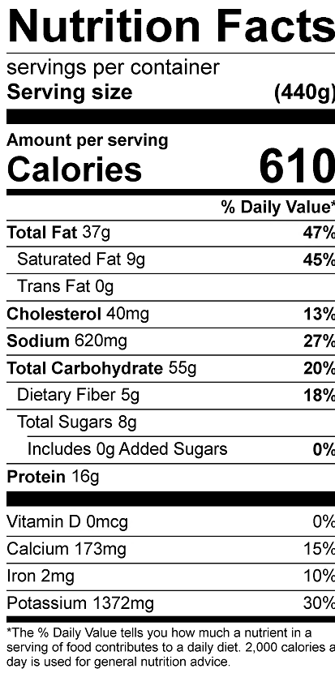
Vitamin C: 28.9mg

