Shrimp Pad Thai Loaded Curly Fries
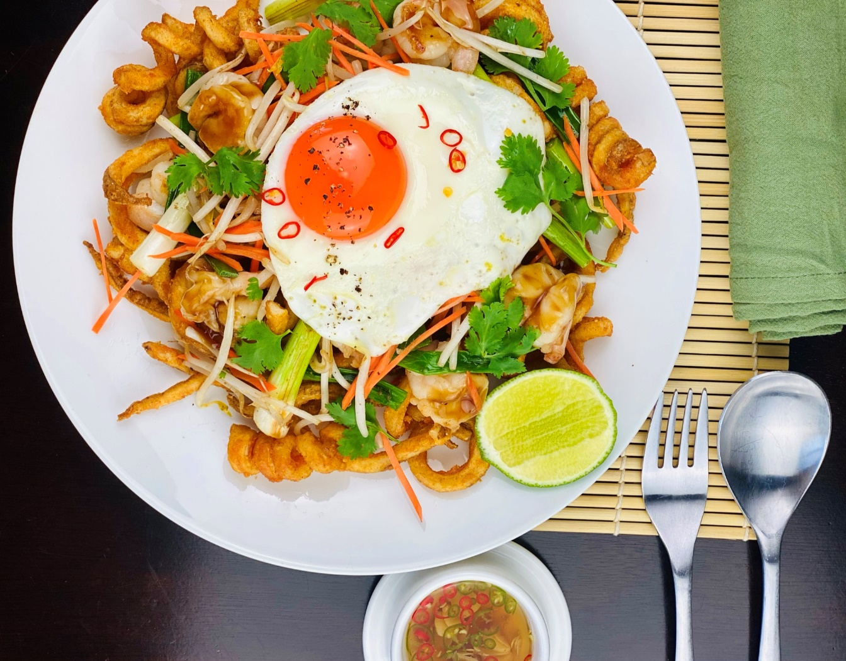
Description: Crispy curly fries topped with a fresh farm egg, tender shrimp, scallions, bean sprouts, carrots, coriander, peanuts, and chilies in a sweet and sour tamarind glaze.
Servings: 12
Preparation Time: 20 minutes
Cooking Time: 30 minutes
Total Time: 50 minutes
Potato Type: Frozen curly fries
Course: Entrée, Shareable Appetizer

Ingredients
For the Pad Thai Sauce
- 1/3 cup (80ml) Tamarind Paste
- 2/3 cup (150g) Brown Sugar
- ¼ cup (60ml) Fish Sauce
- 1/3 cup (80ml) Oyster Sauce
For the Pad Thai Shrimp:
- 2.2 lbs. (1kg) Shrimp, Peeled and Deveined
- 1 tablespoon (15ml) Peanut Oil (Vegetable Oil can be subbed)
- 1-1/2 cups (200g) Yellow Onions, sliced
- 2 cups (300g) Bean Sprouts
- 1 cup (150g) Green Onions, cut into 2-inch pieces
- 1 cup (150g) Carrots, cut into julienne strips
- ½ cup (100g) Chopped Peanuts
Nam Pla Prik (Fish Sauce Vinaigrette)
- 1/4 cup (60ml) Fish Sauce
- 1/3 cup (80ml) Lime Juice
- 2 tablespoons (25g) Granulated Sugar
- 3 each (3g) Thai Chilies
- 3 each (15g) Garlic Cloves, sliced
For the Curly Fries
- As Needed Vegetable Oil for Frying
- 2.2 lbs. (1 kg) Frozen Curly Fries
To Plate:
- 12 each Large Eggs, fried sunny side
- ½ cup (4g) Coriander (Cilantro) leaves, picked
- 6 each Limes, cut in half

Preparation
- Begin by making the Pad Thai sauce. Stir together the tamarind paste, brown sugar, fish sauce and oyster sauce.
- To make the shrimp pad Thai; start by peeling and deveining the shrimp. In a large sauté pan or a wok heat the peanut oil over high heat. Add the shrimp and cook for 3-5 minutes or until they are opaque and pink. Remove the shrimp and set aside. Add the onions to the pan and cook for 3-5 minutes or until they are lightly browned. Add the bean sprouts, scallions, and carrots. Stir fry the vegetables for 3-4 minutes or until they are just tender. Add the pad Thai sauce, and the peanuts and stir till combined and slightly thick.
- To make the Nam Pla Prik, combine the fish sauce, lime juice, sugar, chilies, and garlic. Set aside to use as a condiment for the fries.
- To make the fries, preheat a fryer to 375 °F (190°C) and fry the fries for 4-6 minutes or until they are golden and crisp. Drain the fries well, and place into a bowl. Season the fries with salt and toss to combine. Place the fries on the serving plates and top with the pad Thai shrimp. Garnish the fries with the fried eggs, coriander, and the lime halves. Serve immediately. Enjoy!

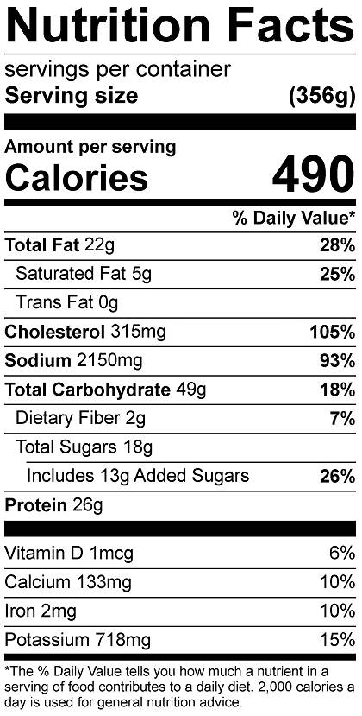
Vitamin C: 24 mg

