Pub Style Fries
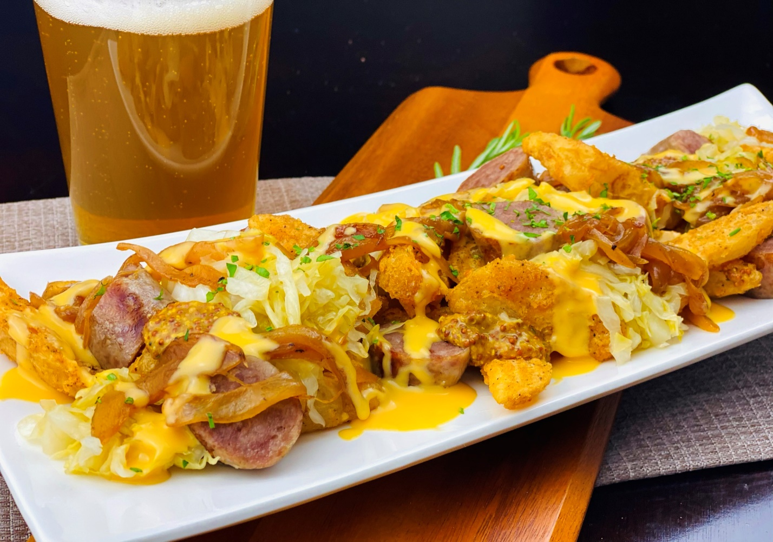
Description: Batter wedge cut fries, topped with grilled bratwurst, sauerkraut, caramelized onions, gooey cheese sauce, and whole grain mustard.
Servings: 12
Preparation Time: 30 minutes
Cooking Time: 60 minutes
Total Time: 90 minutes
Potato Type: Frozen Wedge Cut Fries
Course: Entrée, Shareable Appetizer

Ingredients
For the Caramelized Onions:
- 2.2 pounds (1 kg) Yellow Onions, sliced thin
- 2 tablespoons (30g) Unsalted Butter
- 2 teaspoon (4g) Sea Salt
For the Beer Cheese Sauce:
- 2 tablespoons (30g) Unsalted Butter
- 2 tablespoons (30g) All Purpose Flour
- 12 fluid ounces (360ml) Mild Lager or IPA Beer
- 1 cup (240ml) Chicken Stock
- 1 teaspoon (3g) Dry Mustard
- ¼ cup (60ml) Heavy Cream
- 2 teaspoons (20ml) Worcestershire Sauce
- ¼ teaspoon (1g) Cayenne Pepper
- 1 cup (80g) Shredded Cheddar Cheese
For the Grilled Brats:
- 2.2 pounds (1 kg) Bratwurst Sausage
For the Wedge Cut Fries:
- 2.2 pounds (1kg) Frozen Wedge Cut Fries
- As Needed Vegetable Oil for Frying
- 2 teaspoons (8g) Sea Salt
To Plate Up:
8 ounces (227g) Sauerkraut
½ cup (120ml) Stoneground Mustard
2 tablespoons Fresh Rosemary, chopped

Preparation
- To prepare the caramelized onions, melt the butter in a heavy bottomed shallow pan over medium heat. Add the onions and season with salt. Continue to cook the onions, stirring regularly until the onions are deep brown and caramelized. Remove from the heat and set aside until ready to use.
- To make the cheese sauce, melt the butter in a medium sauce pan. Add the flour and stir until a wet paste is formed. Cook the mixture for 2-3 minutes to remove the raw flour taste. Whisk in the beer and cook until it is slightly thickened. Add the chicken stock and stir until well combined. Bring the sauce to a simmer and cook for 8-10 minutes. Add the dry mustard, the heavy cream, Worcestershire sauce, cayenne. Remove the sauce from the heat and stir in the cheese. Set aside and until ready to use.
- Grill the brats over a medium high grill until fully cooked and an internal temperature reaches 165 F. Allow the sausages to rest for 5-6 minutes before slicing.
- To fry the fries, drop the fries into preheated 375 F (190 C) oil. Cook the fries until they are crispy and golden brown. Drain the fries and transfer them to a large bowl, then season with salt. Arrange the fries on a serving platter.
- Slice the brats and arrange them on the fries. Follow the brats with the caramelized onions, sauerkraut, and cheese sauce. Add a few dollops of whole grain mustard around the plate and garnish with the chopped rosemary. Serve immediately.
- Enjoy!
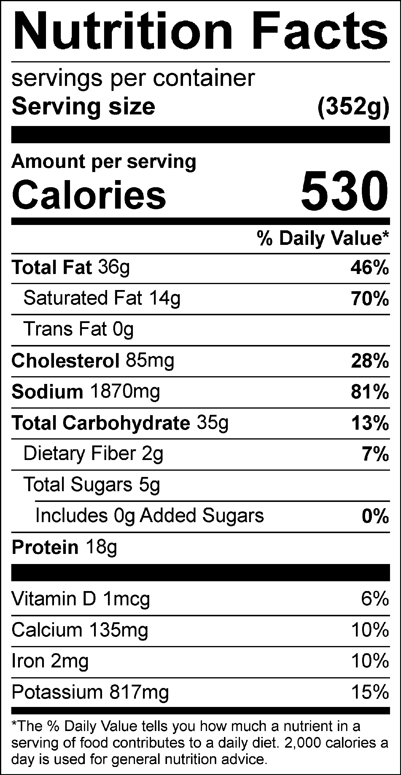
Vitamin C: 18.43mg

