Potato Toasts
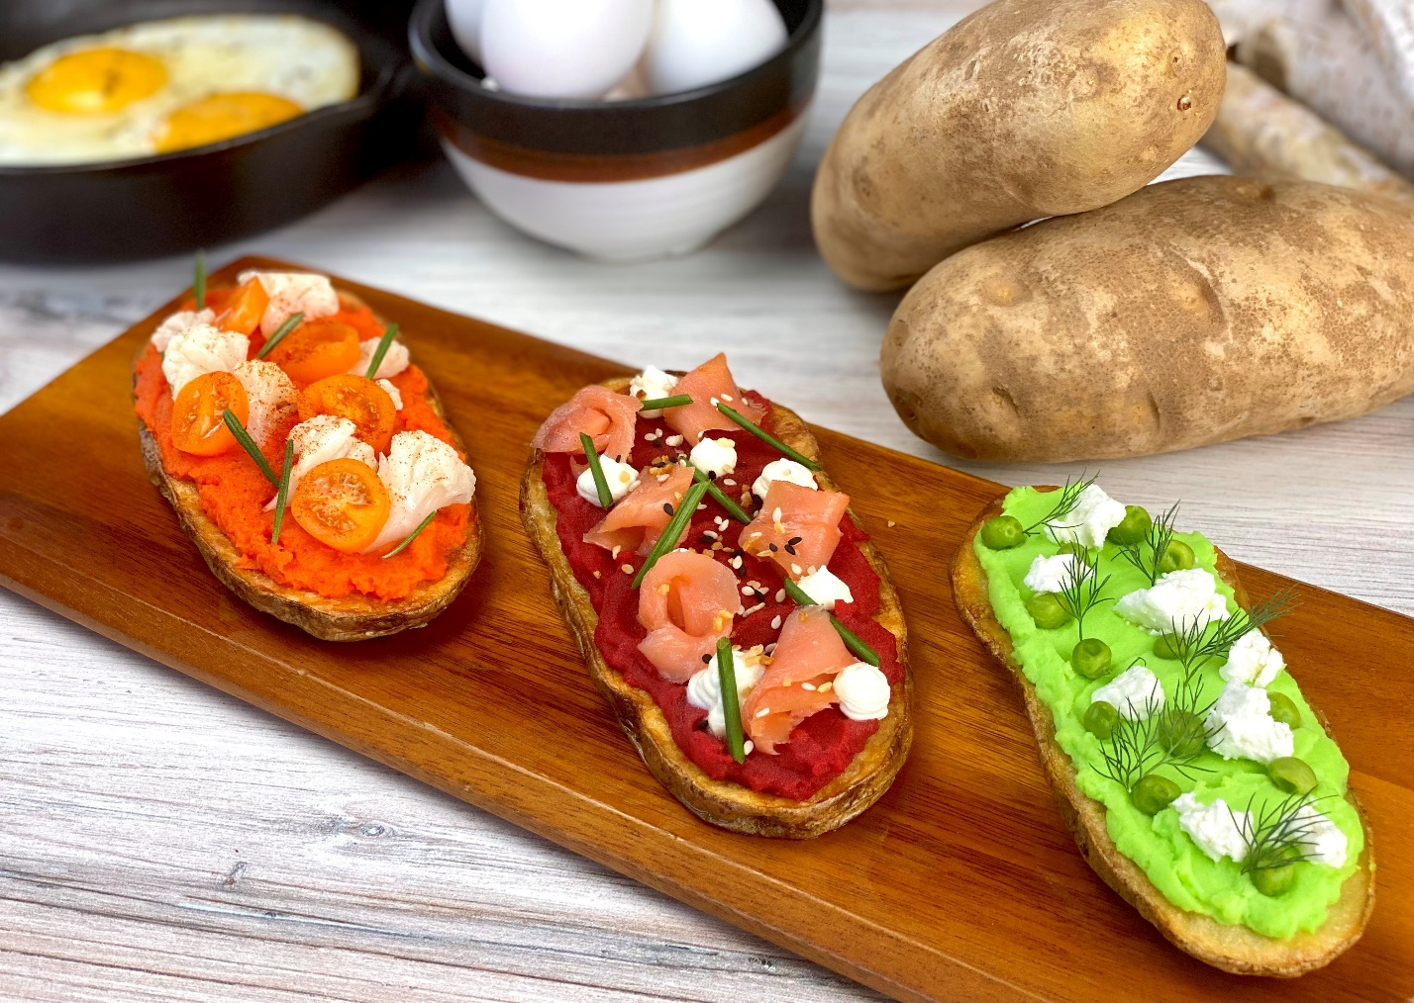
Description: Thick slices of roasted potatoes, topped with assorted vegetable spreads.
Servings: 8
Preparation Time: 20 minutes
Cooking Time: 20 minutes
Total Time: 40 minutes
Potato Type: Russet Potatoes
Course: Breakfast, Lunch, Dinner, Side Dish, Appetizer

Ingredients
Potato Toasts:
- 2 each *16 ounce* (1.8kg) Russet Potatoes, sliced 1” thick
- 2 tablespoons (30ml) Extra Virgin Olive Oil
- ½ tablespoon (1g) Kosher Salt
- 1 teaspoon (1g) Freshly Ground Black Pepper
Moroccan Carrot Puree:
- 1 cup (150g) Carrots, peeled, chopped 1-½ inch pieces
- 3 cups (720ml) Cold Water
- 1 each Star Anise
- 1 tablespoon Honey
- 1 teaspoon Ras El Hanout
- 1 teaspoon Ground Ginger
- ½ teaspoon Cinnamon
- 1 teaspoon Kosher Salt
Pickled Cauliflower:
- 1 cup (150g) Cauliflower Florets
- ½ cup (120ml) Rice Wine Vinegar
- ¼ cup (45g) Kosher Salt
- ¼ cup (45g) Granulated Sugar
- 1 teaspoon (1g) Crushed Red Chili Flakes
- 4 cups (960ml) Crushed Ice
Roasted Beet Puree:
- 1 cup (150g) Roasted Beets, peeled, cut 1 inch pieces
- ¼ cup (60ml) Water
- 1 tablespoon (3g) Freshly Grated Horseradish
- 1 teaspoon (1g) Kosher Salt
Edamame Puree:
- 1 cup (150g) Frozen Shelled Edamame, thawed
- 1 teaspoon (1g) Kosher Salt
- ¼ cup (60ml) Water
- 1 tablespoon (15ml) Greek Yogurt
- ½ teaspoon (1g) Ground White Pepper
Garnishes:
- ½ teaspoon (1g) Smoked Paprika
- ¼ cup (40g) Sliced Yellow Cherry Tomatoes
- 1 teaspoon (1g) Fresh Rosemary Leaves
- 4 ounces (120g) Smoked Salmon or Gravlax
- 2 ounces (60g) Sour Cream
- 1 tablespoon (3g) Everything Bagel Seasoning
- 2 tablespoons (3g) Fresh Chives, cut into ½ inch pieces
- ½ cup (30g) Fresh Feta, crumbled
- ¼ cup (40g) Frozen English Peas, thawed
- 2 tablespoons (1g) Fresh Dill
Preparation
- Preheat the oven to 400 F (204 C), line a baking sheet with aluminum foil. Slice the potatoes lengthwise and brush them lightly with the olive oil. Season them with the salt and pepper. Then place them in the oven and roast for 18-20 minutes, flipping once after about 10-12 minutes in the oven. Remove from the oven and keep warm until ready to use.
- To prepare the carrot puree, place the carrots and star anise in the cold water and bring to a boil over medium high heat. Reduce the heat and allow the water to simmer. Once the carrots are cooked (fork tender), drain the water and reserve. Discard the star anise. Place the carrots in a blender and puree, you may have to use some of the reserved liquid to adjust the consistency. Once the puree is smooth, transfer the puree to a small bowl, whisk in the honey, ras el hanout, ginger, cinnamon, and salt. Set aside until ready to use.
- To make the pickled cauliflower, begin by cutting the cauliflower into small florets. In a small pot, combine the vinegar, salt, sugar, and chili flakes. Bring this mixture to a boil and add the cauliflower. Cook the cauliflower for about 8-10 minutes or until they are tender. Remove from the heat and immediately add the ice. Allow the cauliflower to cool in the pickling liquid. Keep cold until ready to use.
- To make the roasted beet puree, roast the beets in a 400 F (240 F) oven until they are tender, this should take about 30-45 minutes, roasted beets from the refrigerated section of the produce aisle can be subbed to reduce prep time.
- Peel and cut the beets into 1-inch pieces. Discard the peels and puree the beets. Use the water to adjust the consistency if need be. Add the horseradish and adjust the seasoning with the salt. Transfer to a small bowl and set aside until ready to use.
- To make the edamame puree, combine the edamame, salt, water, yogurt and pepper in a blender and puree until smooth. Transfer to a small bowl and set aside until ready to use.
- To assemble the toasts, spread some of each of the vegetable purees on each potato toast. Top the carrot one with the pickled Cauliflower, sliced cherry tomatoes, smoked paprika, and rosemary. Top the beet puree with the smoked salmon, sour cream, everything bagel seasoning and chives. Top the edamame puree with the English peas, feta, and dill.
- You can choose to make one of these, all three, or create your own potato toast using veggies that you like. Hummus makes a great spread, salsa is fantastic, baba ghanoush or pureed eggplant is wonderful. Have fun with it!
Notes
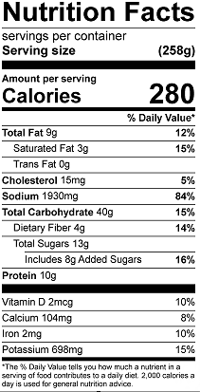
Vitamin C: 18.6mg

