Peri Peri Shrimp Fries
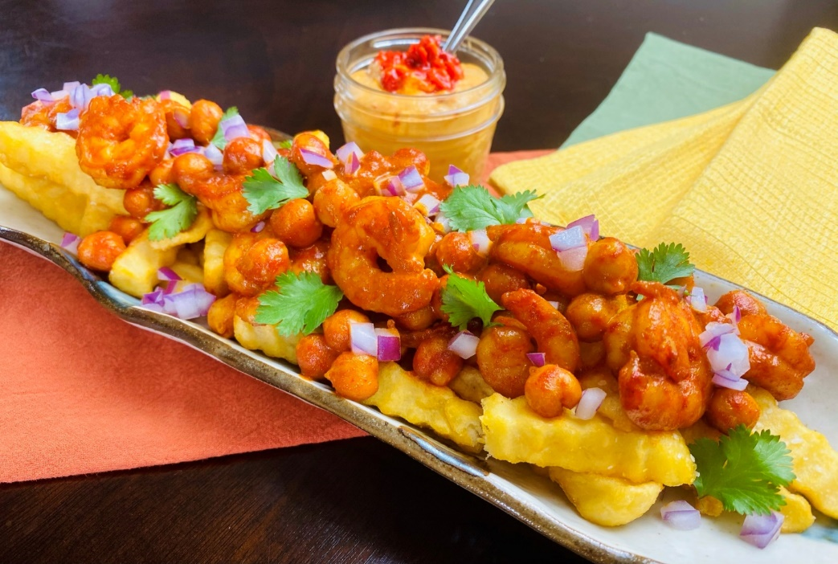
Description: Crinkle cut fries topped with smoky and spicy shrimp and chickpeas.
Servings: 8
Preparation Time: 30 minutes
Cooking Time: 20 minutes
Total Time: 50 minutes
Potato Type: Frozen Crinkle Cut Fries
Course: Entrée, Shareable Appetizer

Ingredients
Peri Peri Shrimp and Chickpeas:
- 1 cup (240g) Roasted Red Bell Pepper, chopped
- 2 each (10g) Bird’s Eye Chilies (more can be used if desired)
- 8 each (40g) Garlic Cloves, chopped
- ½ cup (120ml) Extra Virgin Olive Oil
- 3 tablespoons (45ml) Red Wine Vinegar
- ½ teaspoon (4g) Smoked Paprika
- 2 teaspoons (4g) Sea Salt
- 1.5 lbs. (680g) Peeled and Deveined Shrimp
- 1 cup (240g) Canned Chickpeas, drained
Crinkle Cut Fries:
- 2.2 lbs. (1kg) Frozen Crinkle Cut Fries
- As Needed Vegetable Oil for Frying
- 2 teaspoons (8g) Sea Salt
To Plate:
½ cup (75g) Red Onions, diced
¼ cup (3g) Cilantro, picked
1 cup (240ml) Roasted Red Pepper Hummus (Prepared)

Preparation
- To make the peri peri shrimp and chickpeas, puree the red peppers, chilies, garlic, olive oil, vinegar, paprika, and sea salt until smooth. Marinate the shrimp for 1-2 hours. Sauté the shrimp along with the sauce and the chickpeas until the shrimp are pink and slightly opaque. Keep warm until ready to use.
- To fry the fries, drop the fries into the preheated oil set at 375 °F (190 °C). The fries should cook for 4-6 minutes or until they are golden and crispy.
- Transfer the fries to a large bowl, and season them with sea salt. Arrange the fries on a serving plate or shareable platter. Top the fries with the Peri Peri shrimp, and garnish with diced red onion, cilantro and serve with roasted red hummus on the side. Enjoy!
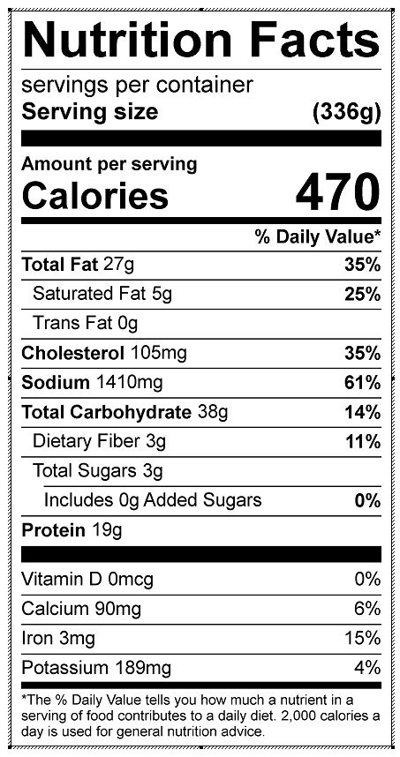
Vitamin C: 20.42 mg

