**Lebanese Shawarma Loaded Fries**

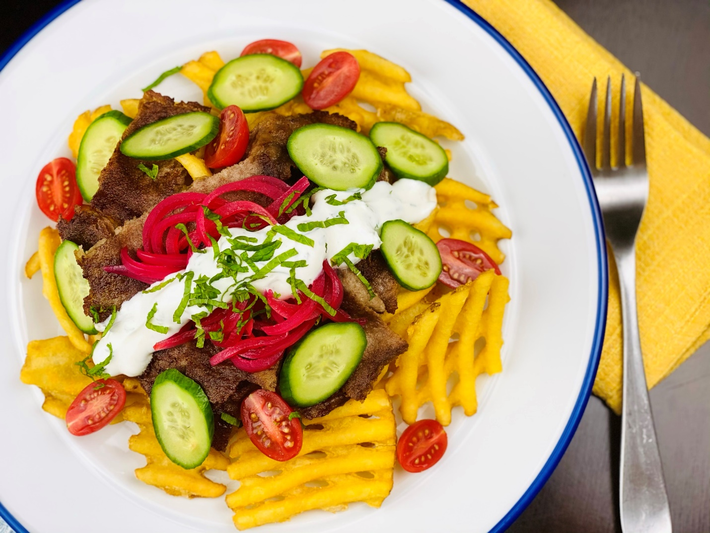

**Description:** Waffle fries topped with roasted beef shawarma, cucumbers, tomatoes, pickled red onions, and a lemon yogurt sauce.

**Servings:** 12

**Preparation Time:** 40 minutes

**Cooking Time:** 180 minutes

**Total Time:** 220 minutes

**Potato Type:** Frozen Waffle Fries

**Course:** Entrée, Shareable Appetizer

**Ingredients**

*Pickled Red Onions:*

* ¼ cup (60g) Granulated Sugar
* ¼ cup (16g) Sea Salt
* ¼ cup (60ml) Beet Juice (Optional)
* ¾ cup (180ml) Rice Wine Vinegar (Apple Cider Vinegar can be subbed)
* 1 tablespoons (4g) Black Peppercorns
* 1-1/2 cups (300g) Red Onions, Sliced

*For the Lemon Yogurt Sauce:*

* 1 cup (240ml) Plain Greek Yogurt
* 2 tablespoons (30ml) Lemon Juice
* 2 tablespoons (2g) Fresh Dill, chopped
* 2 tablespoons (2g) Fresh Mint, chopped
* 1 teaspoon (1g) Cumin
* 2 each (10g) Garlic Cloves, chopped
* ½ teaspoon (2g) Sea Salt
* 1 teaspoon (4g) Freshly Ground Black Pepper

*For the Lebanese Shawarma:*

* 2.2 pounds (1 kg) Beef Ribeye, sliced thin
* 5 each (25g) Garlic, chopped
* ½ cup (120ml) Lemon Juice
* ¼ cup (60ml) Apple Cider Vinegar
* ¼ cup (60ml) Olive Oil
* 1 teaspoon (1g) Ground Cloves
* 1 teaspoon (2g) Sea Salt
* ½ teaspoon (1g) Ground Cumin
* ½ teaspoon (1g) Caraway Seeds, ground
* ½ teaspoon (1g) Oregano
* ½ teaspoon (1g) Ground Cinnamon
* ½ teaspoon (1g) Ground Nutmeg
* ½ teaspoon (1g) Freshly Ground Black Pepper
* ¼ teaspoon (1g) Cayenne Pepper

*For the Waffle Fries:*

* 2.2 pounds (1kg) Frozen Waffle Fries
* As Needed Vegetable Oil for Frying
* 2 teaspoons (8g) Sea Salt

*To Plate Up:*

1 cup (150g) Cherry Tomatoes, sliced in half

1 cup (150g) Cucumbers, sliced

¼ cup (2g) Fresh Mint, chopped

**Preparation**

1. To make the pickled red onions, combine the sugar, salt, beet juice, vinegar, and peppercorns in a medium non-reactive saucepan. Place the pan over medium high heat until the vinegar reaches a boil and the sugar/salt have dissolved. Add the onions and allow them to simmer for 2-3 minutes. Remove from the heat and immediately add 4 cups of crushed ice. Once the mixture cools, allow the onions to sit for at least 30 minutes before using.
2. To make the shawarma, mix the garlic, lemon juice, apple cider vinegar, olive oil, cloves, salt, cumin, caraway, oregano, cinnamon, nutmeg, black pepper and cayenne. Pour the marinade over the thinly sliced ribeye and allow it to marinate for 3 hours. Grill the beef over high heat for about 3-4 minutes a side. Allow to rest 5-10 minutes before slicing. Keep warm.
3. To make the yogurt sauce, combine the yogurt, lemon juice, cumin, dill, mint, garlic, salt and pepper. Hold the sauce in the refrigerator until ready to use.
4. To fry the fries, lower the fries into preheated 375 F (190 C) oil. Fry the fries until they are golden brown and crisp. Drain the fries and transfer them to a large bowl. Season the fries with salt and arrang them on a platter.
5. Top the fries with the thinly sliced beef shawarma. Top the beef with the pickled onions, cucumbers, and tomatoes. Add a spoonful of the yogurt sauce over the meat and garnish with the chopped mint.
6. Serve immediately, enjoy!

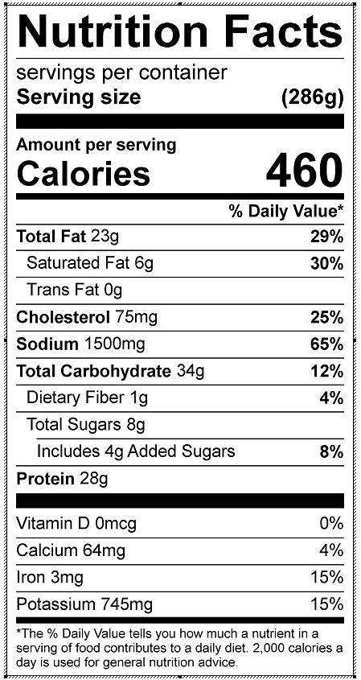

Vitamin C: 12.9mg